Microservices architecture

Infrastructure edition

Hands-on lab step-by-step

March 2018

Information in this document, including URL and other Internet Web site references, is subject to change without notice. Unless otherwise noted, the example companies, organizations, products, domain names, e-mail addresses, logos, people, places, and events depicted herein are fictitious, and no association with any real company, organization, product, domain name, e-mail address, logo, person, place or event is intended or should be inferred. Complying with all applicable copyright laws is the responsibility of the user. Without limiting the rights under copyright, no part of this document may be reproduced, stored in or introduced into a retrieval system, or transmitted in any form or by any means (electronic, mechanical, photocopying, recording, or otherwise), or for any purpose, without the express written permission of Microsoft Corporation.

Microsoft may have patents, patent applications, trademarks, copyrights, or other intellectual property rights covering subject matter in this document. Except as expressly provided in any written license agreement from Microsoft, the furnishing of this document does not give you any license to these patents, trademarks, copyrights, or other intellectual property.

The names of manufacturers, products, or URLs are provided for informational purposes only and Microsoft makes no representations and warranties, either expressed, implied, or statutory, regarding these manufacturers or the use of the products with any Microsoft technologies. The inclusion of a manufacturer or product does not imply endorsement of Microsoft of the manufacturer or product. Links may be provided to third party sites. Such sites are not under the control of Microsoft and Microsoft is not responsible for the contents of any linked site or any link contained in a linked site, or any changes or updates to such sites. Microsoft is not responsible for webcasting or any other form of transmission received from any linked site. Microsoft is providing these links to you only as a convenience, and the inclusion of any link does not imply endorsement of Microsoft of the site or the products contained therein.

© 2018 Microsoft Corporation. All rights reserved.

Microsoft and the trademarks listed at <https://www.microsoft.com/en-us/legal/intellectualproperty/Trademarks/Usage/General.aspx> are trademarks of the Microsoft group of companies. All other trademarks are property of their respective owners.

Contents

Microservices architecture – infrastructure edition hands-on lab step-by-step 1

Abstract and learning objectives 1

Overview 2

Azure resource map 3

Requirements 4

Before the hands-on lab 5

Task 1: Provision Service Fabric Cluster 5

Task 2: Provision a lab virtual machine (VM) 10

Task 3: Connect to your lab VM 14

Task 4: Install Chrome on LabVM 18

Task 5: Install Service Fabric SDK for Visual Studio 20

Task 6: Validate Service Fabric ports 23

Exercise 1: Environment setup 27

Task 1: Download and open the ContosoEventsPoC starter solution 27

Task 2: API Management 30

Task 3: Azure Active Directory B2C 31

Task 4: Web app 33

Task 5: Function app 35

Task 6: Storage account 37

Task 7: Cosmos DB 39

Exercise 2: Placing ticket orders 44

Task 1: Run the solution 44

Task 2: Test the application 47

Task 3: Service Fabric Explorer 51

Task 4: Set up the Ticket Order Sync queue 52

Task 5: Set up the functions 58

Task 6: Test order data sync 70

Exercise 3: Publish the Service Fabric Application 74

Task 1: Publish the application 74

Task 2: Test an order from the cluster 76

Exercise 4: API Management 79

Task 1: Import API 79

Task 2: Retrieve the user subscription key 81

Task 3: Configure the Function App with the API Management key 82

Exercise 5: Configure and publish the web application 85

Task 1: Configure the Web App settings 85

Task 2: Running the web app and creating an order 86

Task 3: Publish the web app 90

Exercise 6: Upgrading 93

Task 1: How upgrade works 93

Task 2: Update an actor state 94

Task 3: Perform a smooth upgrade 95

Task 4: Submit a new order 99

Exercise 7: Rollback 102

Task 1: Add health checks 102

Task 2: Perform a troubled upgrade 102

Exercise 8: Load testing 106

Task 1: Simulate a 50-order request 106

BONUS Exercise 9: Load testing w/ partitions 107

Task 1: Setting up for load testing 107

Task 2: Using the current partition count, simulate 100 orders 109

Task 3: Using a partition count of 10, simulate 100 orders 113

Task 4: Using a partition count of 15, simulate 100 orders 113

Task 5: Using a partition count of 20, simulate 100 orders 114

Task 6: Determine the performance variations among the different load tests 115

BONUS Exercise 10: Secure the web application 118

Task 1: Configure the Azure Active Directory B2C 118

Task 2: Configure the web app Settings 137

Task 3: Add security features to the web application 138

Task 4: Running the web app and signing in 139

After the hands-on lab 141

Task 1: Delete the resource group 141

# Microservices architecture – infrastructure edition hands-on lab step-by-step

## Abstract and learning objectives

This whiteboard design session is designed to help attendees gain a better understanding of implementing architectures leveraging aspects from microservices and serverless architectures, by helping an online concert ticket vendor survive the first 5 minutes of crushing load. They will handle the client's scaling needs through microservices built on top of Service Fabric, and apply smooth updates or roll back failing updates. Finally, students will design an implementation of load testing to optimize the architecture for handling spikes in traffic.

Attendees will learn how to:

* Implement scale and resiliency with Service Fabric
* Enable serverless solutions with Azure Functions
* Control API access with API Management
* Provide query flexibility with Cosmos DB

## Overview

Contoso Events is an online service for concerts, sporting and other event ticket sales. They are redesigning their solution for scale with a microservices strategy and want to implement a POC for the path that receives the most traffic: ticket ordering.

In this hands-on lab, you will construct an end-to-end POC for ticket ordering. You will leverage Service Fabric, API Management, Function Apps, Web Apps, and Cosmos DB.

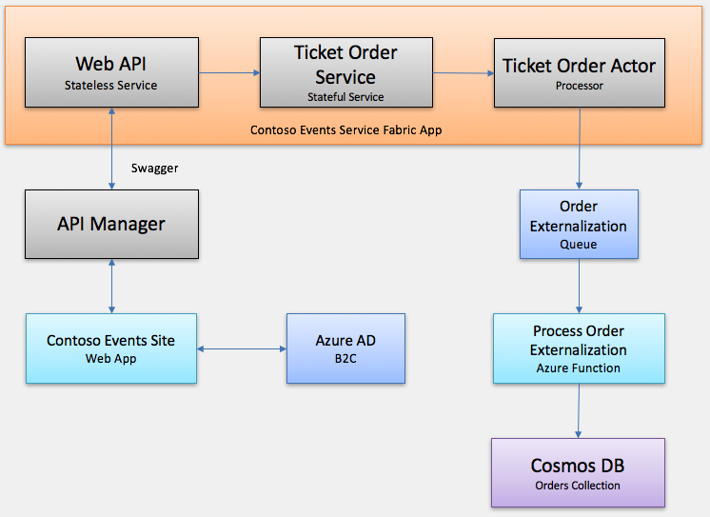

## Solution architecture

The following figures are intended to help you keep track of all the technologies and endpoints you are working with in this hands-on lab. The first figure is the overall architecture, indicating the Azure resources to be employed. The second figure is a more detailed picture of the key items you will want to remember about those resources as you move through the exercises.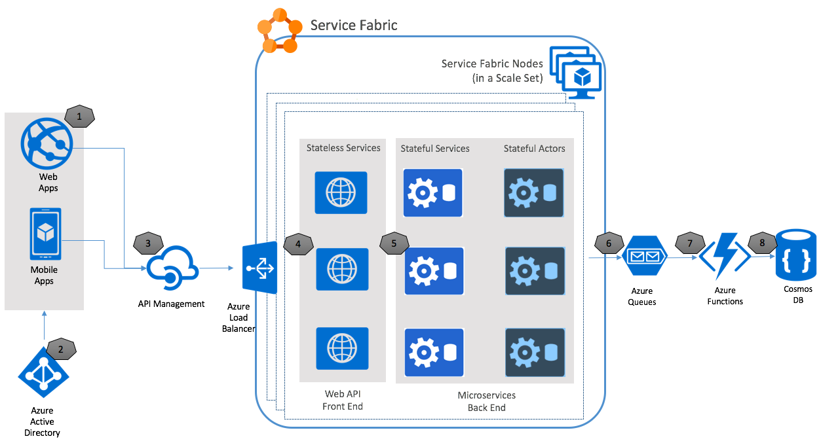

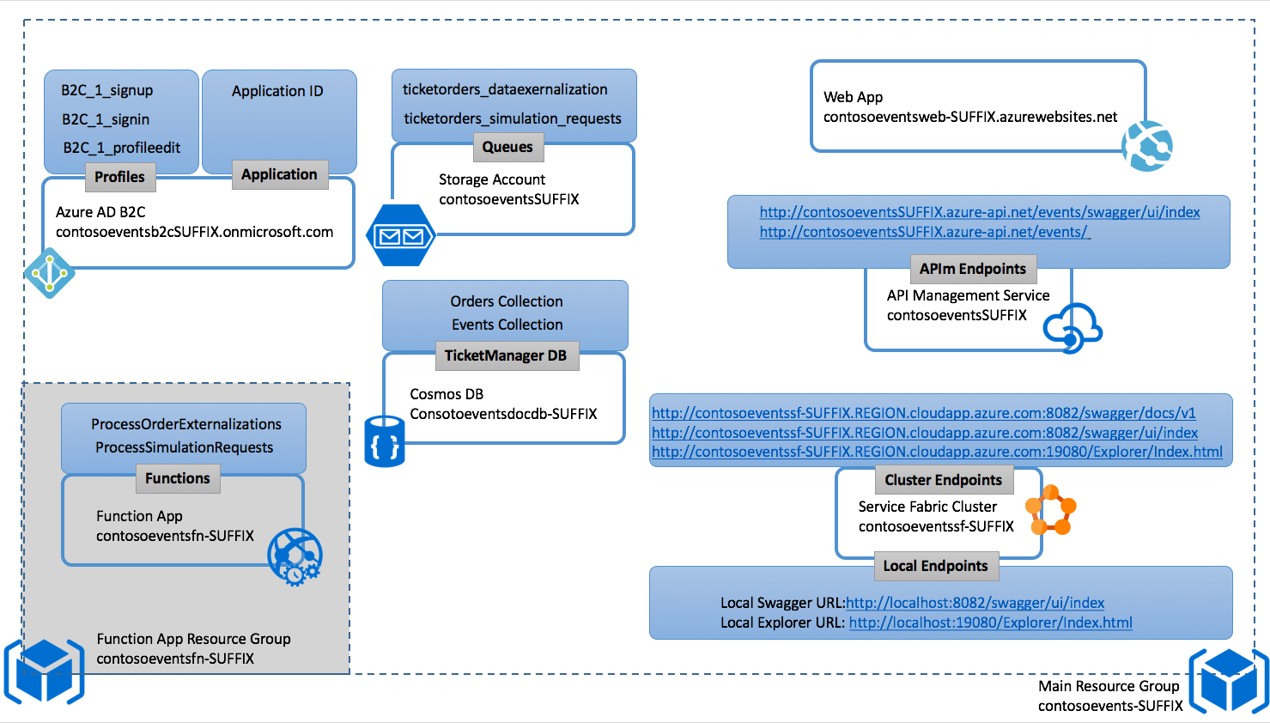

## Requirements

1. Microsoft Azure subscription must be pay-as-you-go or MSDN.
   1. Trial subscriptions will not work.
2. A virtual machine configured with (see Before the hands-on lab):
   1. Visual Studio 2017 Community edition, or later
   2. Azure Development workload enabled in Visual Studio 2017 (enabled by default on the VM)
   3. Service Fabric SDK 2.7 or later for Visual Studio 2017
   4. Google Chrome browser (Swagger commands do not work in IE)
   5. PowerShell 3.0 or higher (v5.1 already installed on VM)

## Before the hands-on lab

Duration: 45 minutes

Synopsis: In this exercise, you will set up your environment for use in the rest of the hands-on lab. You should follow all the steps provided in the Before the hands-on lab section to prepare your environment before attending the hands-on lab.

IMPORTANT: Most Azure resources require unique names. Throughout these steps, you will see the word “SUFFIX” as part of resource names. You should replace this with your Microsoft alias, initials, or other value to ensure the resource is uniquely named.

#### Task 1: Provision Service Fabric Cluster

In this task, you will provision the Service Fabric Cluster in Azure.

1. In the Azure portal, select +New, then type “Service Fabric” into the Search the Marketplace box. Select Service Fabric Cluster from the results. 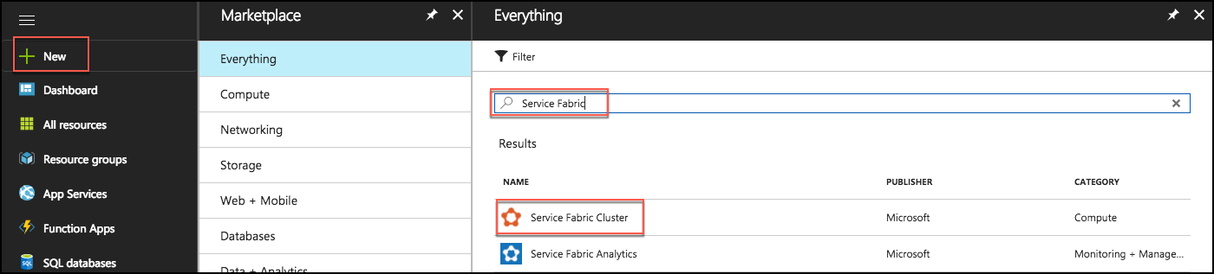
2. On the Service Fabric Cluster blade, select Create.
3. On the Basics blade of the Create Service Fabric cluster screen, enter the following:
   1. Cluster name: Enter contosoeventssf-SUFFIX, replacing SUFFIX with your alias, initials, or another value to make the name unique (indicated by a green check in the text box).
   2. Operating system: Leave set to WindowsServer 2016-Datacenter
   3. User name: Enter holuser
   4. Password: Enter Password.1!!
   5. Subscription: Select the subscription you are using for this lab
   6. Resource Group: Select Create new, and enter hands-on-labs for the resource group name. You can add -SUFFIX, if needed to make resource group name unique. This is the resource group you will use for all resources you create for this hands-on lab.
   7. Location: Select the region to use.
   8. Select OK.

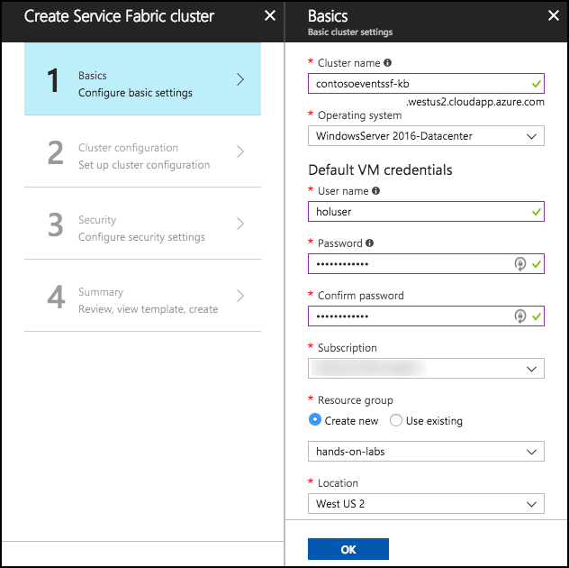

1. On the Cluster configuration blade, set the following:
   1. Node type count: Select 1
   2. Node type 1 (Primary): Select to configure required settings. On the Node type configuration blade enter:
      1. Node type name: Enter Web
      2. Durability tier: Leave Bronze selected
      3. Virtual machine size: Select a VM size of D1_V2 Standard and select Select on the Choose a size blade. 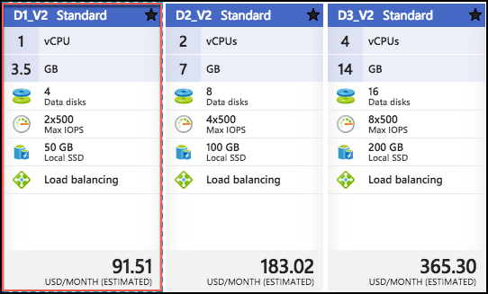
      4. Single node cluster: Leave unchecked
      5. Initial VM scale set capacity: Leave set to 5
      6. Custom endpoints: Enter 8082. This will allow the Web API to be accessible through the cluster.
      7. Enable reverse proxy: Leave unchecked
      8. Configure advanced settings: Leave unchecked
      9. Select OK on the Node type configuration blade.
   3. Select OK on the Cluster configuration blade. 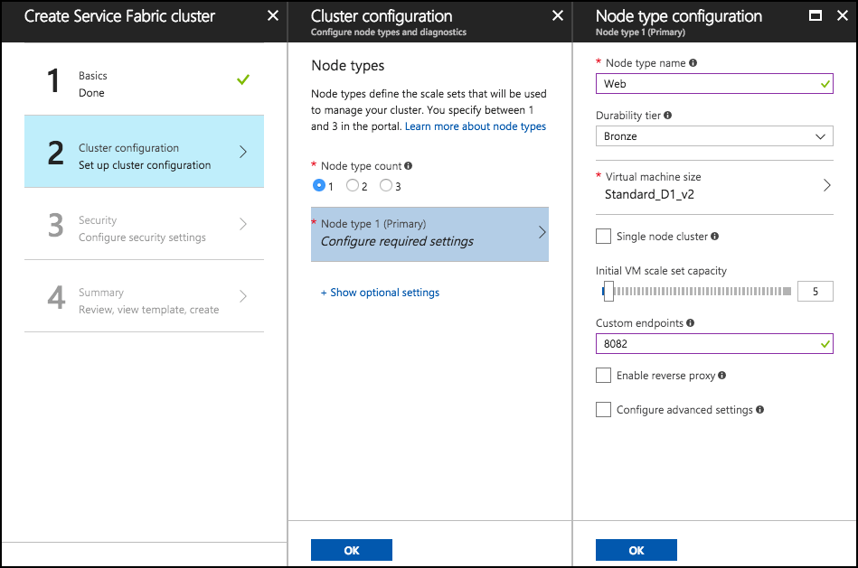
2. On the Security blade, you can provide security settings for your cluster. This configuration is completed up front, cannot be changed later. Set the following:
   1. Configuration Type: select “Basic”
   2. Key vault: Select to configure required settings. On the Key vault configuration blade click “Create a new vault”.
   3. On the “Create key vault” configuration blade enter:
      1. Name: hands-on-lab-SUFFIX
      2. Resource Group: hands-on-lab2-SUFFIX
      3. Location: Use the same location as the first resource group you created.

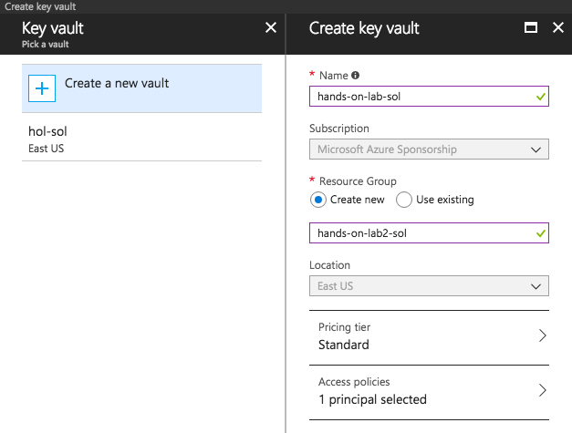

* 1. Click “Create” on the Create key vault configuration blade. Wait for the key vault deployment to complete.
  2. When the key vault deployment completes you will return to the Security configuration blade. You will see a warning that the key vault is not enabled for deployment. Follow these steps to resolve the warning:
     1. Click “Edit access policies for hands-on-lab-SUFFIX”
     2. In the Access policies configuration blade, click the link “Click to show advanced access policies”
     3. Check the “Enable access to Azure Virtual Machines for deployment” checkbox.
     4. Click “Save”. When the key vault update completes, close the Access policies blade.

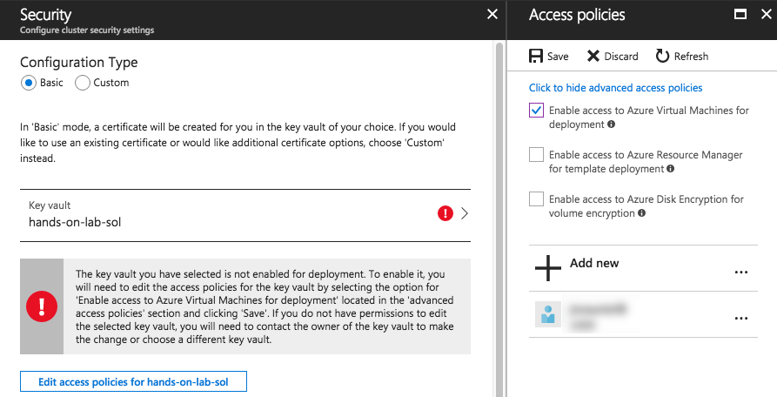

* 1. Enter “hands-on-lab-sol” as the certificate name. Then click Ok on the Security configuration blade.

1. On the Summary blade, review the summary, and select Create to begin provisioning the new cluster. 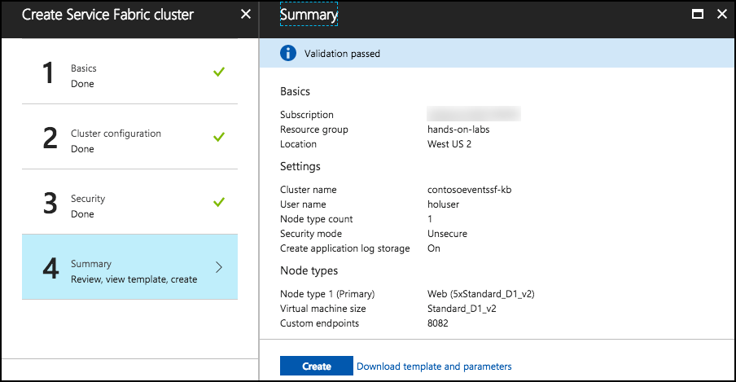
2. It can take up to 30 minutes or more to provision your Service Fabric Cluster. You can move on to the next task while you wait.
3. **Note**: If you experience errors related to lack of available cores, you may have to delete some other compute resources, or request additional cores be added to your subscription, and then try this again.

#### Task 2: Provision a lab virtual machine (VM)

In this task, you will provision a virtual machine (VM) in Azure. The VM image used will have Visual Studio Community 2017 installed.

1. Launch a web browser and navigate to the [Azure portal](https://portal.azure.com/).
2. Select +New, then type “Visual Studio” into the search bar. Select Visual Studio Community 2017 (latest release) on Windows Server 2016 (x64) from the results. 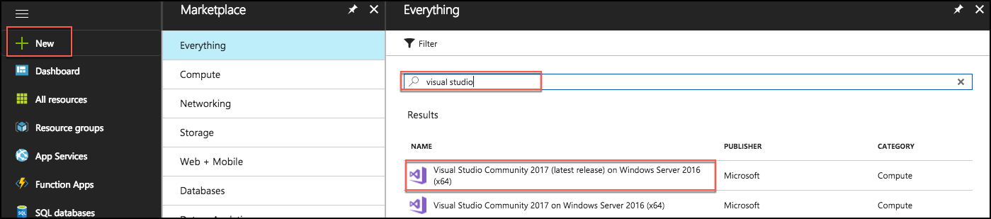
3. On the blade that comes up, ensure the deployment model is set to Resource Manager and select Create.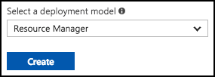
4. Set the following configuration on the Basics tab.
   1. Name: Enter LabVM
   2. VM disk type: Select SSD
   3. User name: Enter holuser
   4. Password: Enter Password.1!!
   5. Subscription: Select the subscription group you are using for this lab
   6. Resource group: Select Use existing, and select the hands-on-labs resource group created previously.
   7. Location: Select the region you are using for resources in this lab.
   8. Select OK to move to the next step. 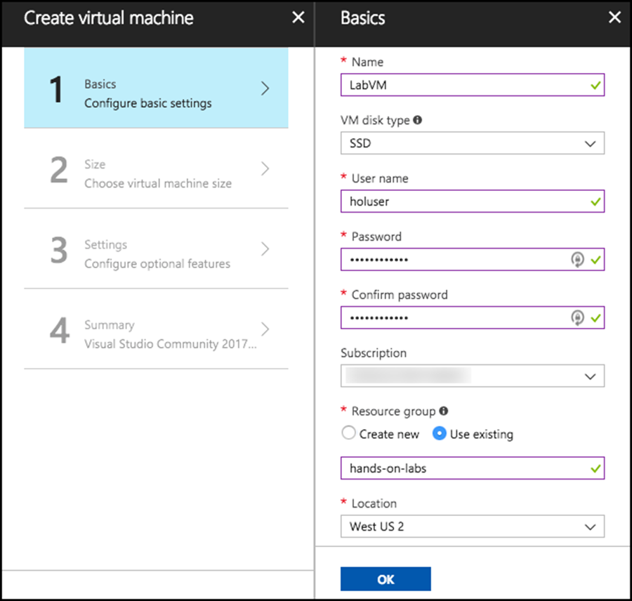
5. On the Choose a size blade, ensure the Supported disk type is set to SSD, and select View all. This machine won’t be doing much heavy lifting, so selecting D2S_V3 Standard is a good baseline option. 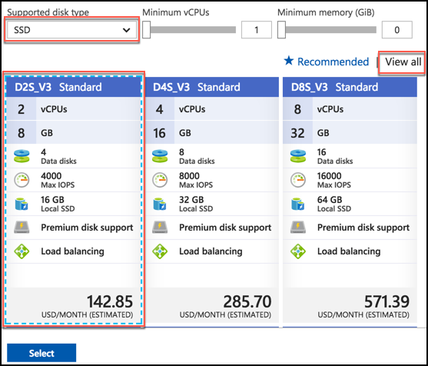
6. Select Select to move on to the Settings blade.
7. Accept all the default values on the Settings blade and select OK.
8. Select Create on the Create blade to provision the virtual machine. 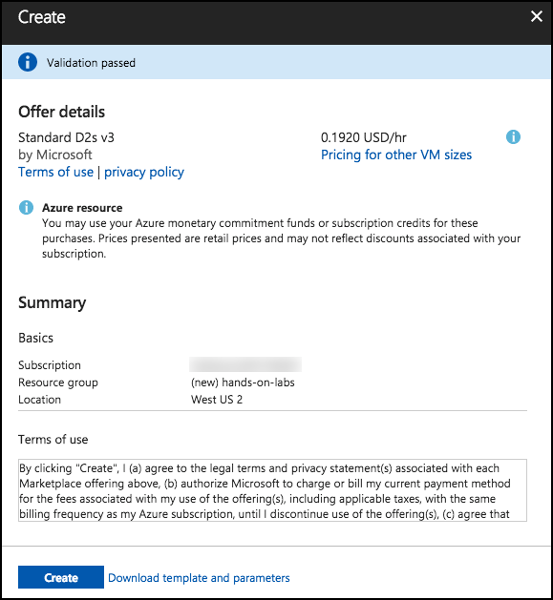
9. It may take 10+ minutes for the virtual machine to complete provisioning.

#### Task 3: Connect to your lab VM

In this step, you will open an RDP connection to your Lab VM and disable Internet Explorer Enhanced Security Configuration.

1. Connect to the Lab VM. (If you are already connected to your Lab VM, skip to Step 9.)
2. From the left side menu in the Azure portal, select Resource groups, then enter your resource group name into the filter box, and select it from the list. 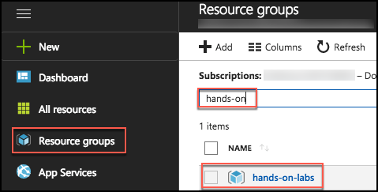
3. Next, select your lab virtual machine, LabVM, from the list. 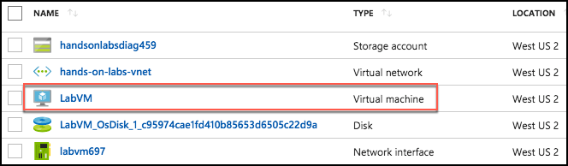
4. On your Lab VM blade, select Connect from the top menu. 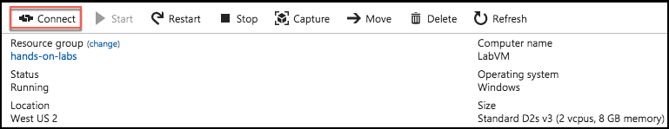
5. Download and open the RDP file.
6. Select Connect on the Remote Desktop Connection dialog. 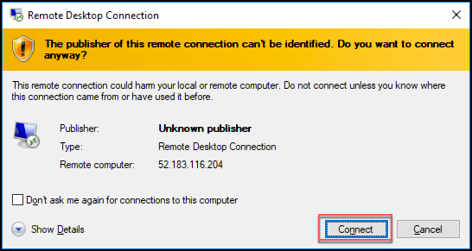
7. Enter the following credentials (or the non-default credentials if you changed them):
   1. User name: holuser
   2. Password: Password.1!!

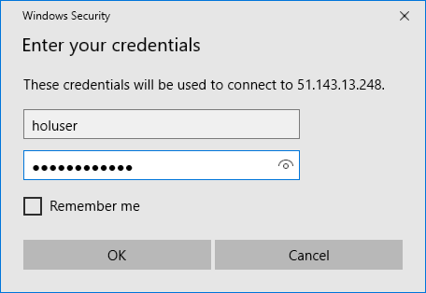

1. Select Yes to connect, if prompted that the identity of the remote computer cannot be verified. 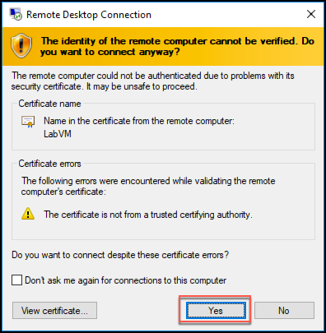
2. Once logged in, launch the Server Manager. This should start automatically, but you can access it via the Start menu if it does not start. 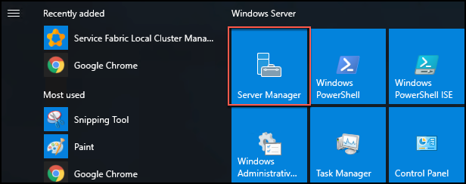
3. Select Local Server, the select On next to IE Enhanced Security Configuration. 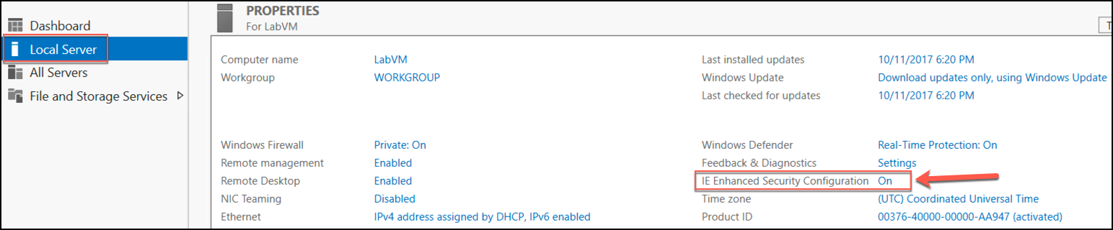
4. In the Internet Explorer Enhanced Security Configuration dialog, select Off under Administrators, then select OK. 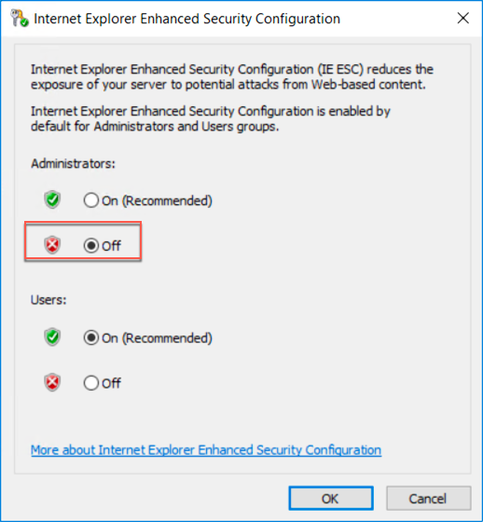
5. Close the Server Manager.

#### Task 4: Install Chrome on LabVM

In this task, you will install the Google Chrome browser on your Lab VM.

1. On your Lab VM, open a web browser, and navigate to <https://www.google.com/chrome/browser/desktop/index.html>, and select Download Chrome. 
2. Select Accept and Install on the terms of service screen. 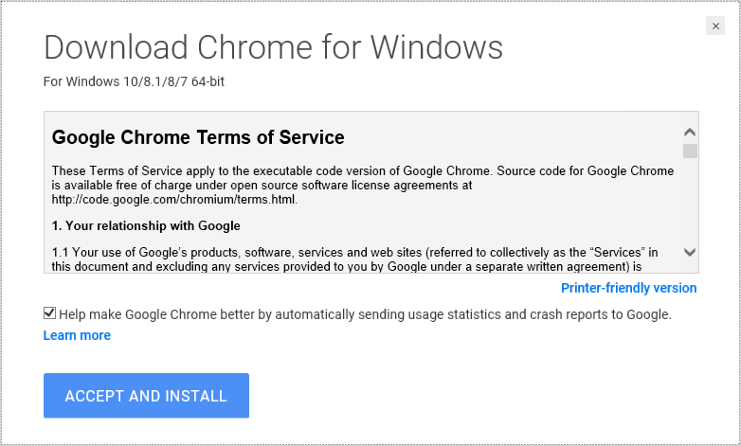
3. Select Run on the Application Run – Security Warning dialog. 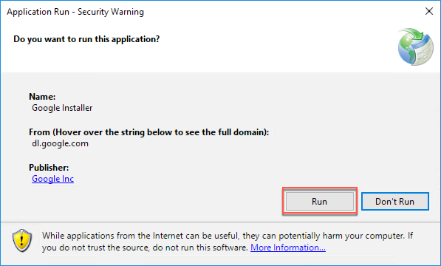
4. Select Run again, on the Open File – Security Warning dialog. 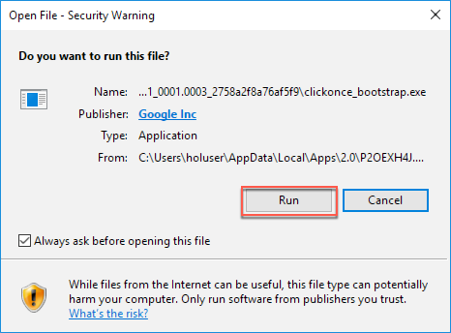
5. Once the Chrome installation completes, a Chrome browser window should open. For ease, you can use the instructions in that window to make Chrome your default browser.

#### Task 5: Install Service Fabric SDK for Visual Studio

In this task, you will install the latest Service Fabric SDK for Visual Studio 2017 on your Lab VM.

1. On your Lab VM, open a browser, and navigate to <https://docs.microsoft.com/azure/service-fabric/service-fabric-get-started>.
2. Scroll down on the page to the Install the SDK and tools section and select Install the Microsoft Azure Service Fabric SDK under the To use Visual Studio 2017 heading. 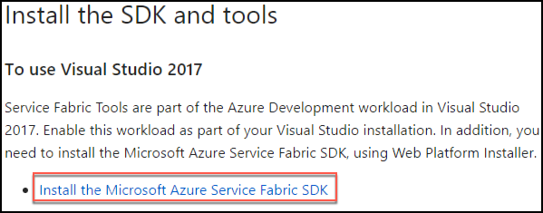
3. Run the downloaded executable and select Install in the Web Platform Installer screen. 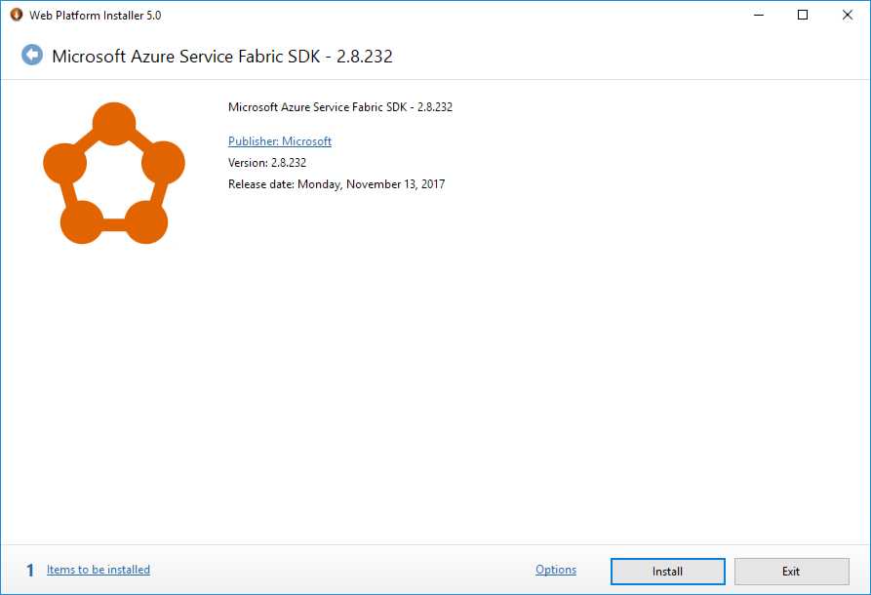
4. On the Prerequisites screen, select I Accept. 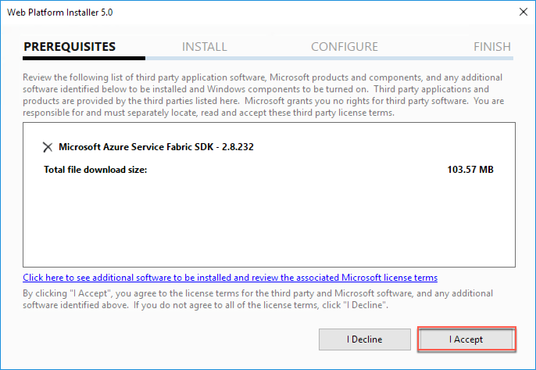
5. Select Finish when the install completes. 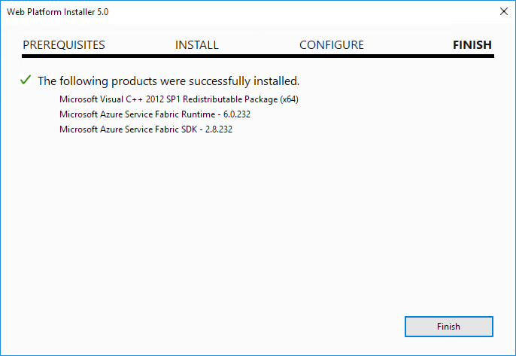
6. Select Exit on the Web Platform installer to close it.
7. Restart the VM to complete the installation and start the local Service Fabric cluster service.

#### Task 6: Validate Service Fabric ports

Occasionally, when you create a new Service Fabric Cluster using the portal, the ports that you requested are not created. This will become evident when you try to deploy and run the Web App, because the required ports will not be accessible through the cluster.

In this task, you will validate that the ports are open and if not, fix the issue.

1. In the Azure portal, navigate to the Resource Group you created previously, and where you created the cluster. If your Service Fabric cluster is still deploying, do not proceed to the next step until the deployment is completed.
2. Select the load balancer from the list of resources in the resource group. 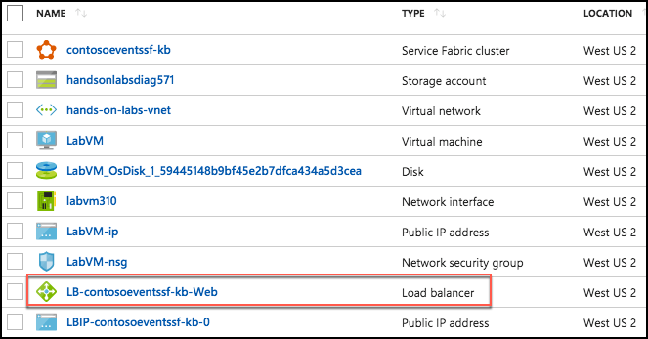
3. Under the Settings category in the left-hand menu, select Health Probes.

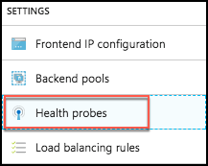

1. Verify if a probe exists for port 8082, and that it is “Used By” a load balancing rule. If both of these are true, you can skip the remainder of this task. Otherwise, proceed to the next step to create the probe and load-balancing rule.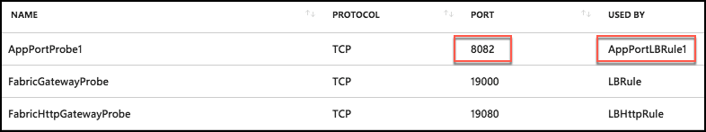
2. Select +Add on the Health Probes blade.



1. On the Add health probe blade, enter the following:
   1. Name: Enter WebApiPortProbe
   2. Protocol: Select TCP
   3. Port: Enter 8082
   4. Interval: Leave the default value
   5. Unhealthy threshold: Leave the default value
   6. Select OK to create the probe. 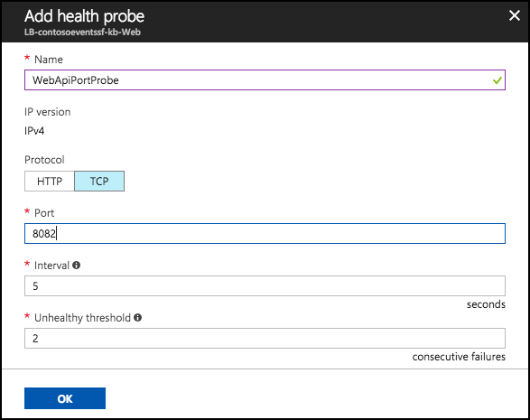
2. Once the Health probe is added (this can take a few minutes to update), you will create a rule associated with this probe. Under the Settings block in the left-hand menu, select Load balancing rules. 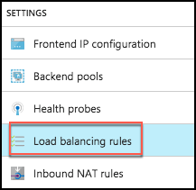
3. Select +Add on the Load balancing rules blade.



1. On the Add Load balancing rules blade, enter the following:
   1. Name: Enter LBWebApiPortRule
   2. IP Version: Leave IPv4 selected
   3. Frontend IP address: Leave the default value selected
   4. Protocol: Leave as TCP
   5. Port: Set to 8082
   6. Backend port: Set to 8082
   7. Backend pool: Leave the default value selected
   8. Health Probe: Select the WebApiPortProbe you created previously
   9. Leave the default values for the remaining fields, and Select OK. 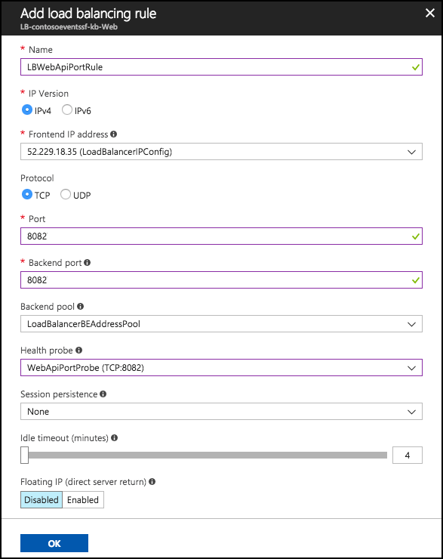
2. If you get an error notification such as “Failure to create probe”, ignore this, but just go check that the probe indeed exists. It should. You now have a cluster ready to deploy to and expose 8082 as the Web API endpoint / port.

## Exercise 1: Environment setup

Duration: 30 minutes

Contoso Events has provided a starter solution for you. They have asked you to use this as the starting point for creating the Ticket Order POC solution with Service Fabric.

Because this is a “born in Azure” solution, it depends on many Azure resources. You will be guided through creating those resources before you work with the solution in earnest. The following figure illustrates the resource groups and resources you will create in this exercise.

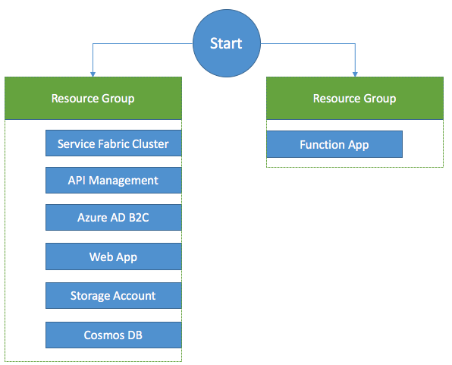

#### Task 1: Download and open the ContosoEventsPoC starter solution

1. On your Lab VM, download the starter project from <http://bit.ly/2gQHYSQ>. (Note: the URL is case sensitive, so you may need to copy and paste it into your browser’s address bar.)
2. Unzip the contents to the folder C:\handsonlab.
3. Locate the solution file (C:\handsonlab\src\ContosoEventsPOC.sln), and double-click it to open it with Visual Studio 2017.
4. If prompted about how you want to open the file, select Visual Studio 2017, and select OK. 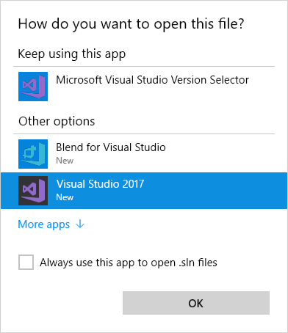
5. Log into Visual Studio or set up an account, when prompted. 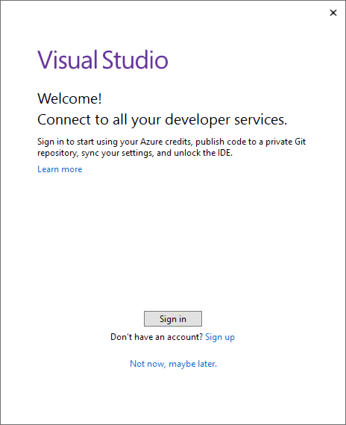
6. If presented with a security warning, uncheck Ask me for every project in this solution, and select OK. 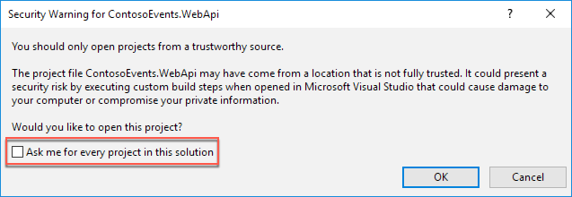
7. If you are missing any prerequisites (listed under Requirements above), you may be prompted to install these at this point.
8. Before you attempt to compile the solution, set the configuration to x64 by selecting it from the Solution Platforms drop down in the Visual Studio toolbar. 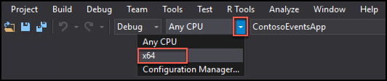
9. Build the solution, by selecting Build from the Visual Studio menu, then selecting Build Solution. 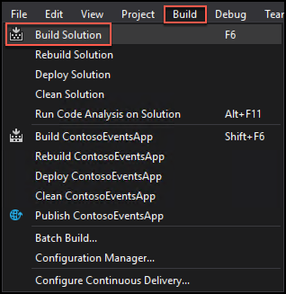
10. You will have some compile-time errors at this point. These are expected, and will be fixed as you proceed with the hands-on lab.

#### Task 2: API Management

In this task, you will provision an API Management Service in the Azure portal.

1. In the Azure portal, select +New, enter “API Management” into the Search the Marketplace box, then select API management from the results. 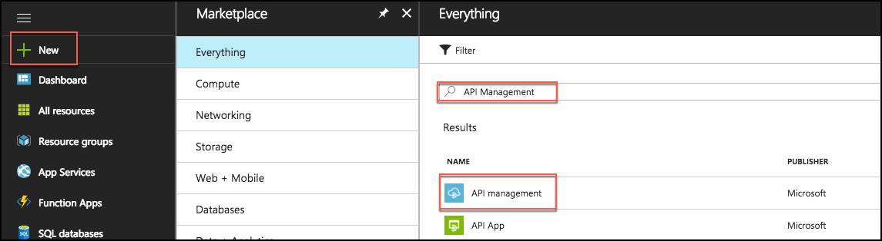
2. In the API Management blade, select Create.
3. In the API Management service blade, enter the following:
   1. Name: Enter a unique name, such as contosoevents-SUFFIX
   2. Subscription: Choose your subscription
   3. Resource group: Select Use existing, and select the hands-on-labs resource group you created previously.
   4. Location: Select the same region used for the hands-on-labs resource group
   5. Organization name: Enter Contoso Events
   6. Administrator email: Enter your email address
   7. Pricing tier: Select Developer (No SLA)
   8. Select Create 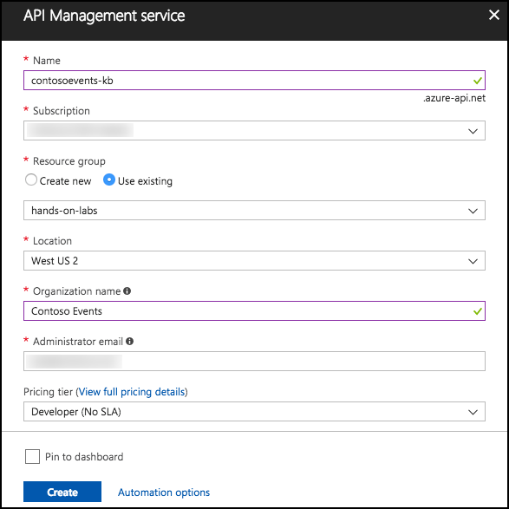
4. After the API Management service is provisioned, the service will be listed in the Resource Group. This may take up to 10-15 minutes, so move to Task 3 and return later to verify.

#### Task 3: Azure Active Directory B2C

In this section, you will provision an Azure Active Directory B2C tenant. You will use this if you do Bonus Exercise 10, so it is best to set it up in advance to avoid having to wait for provisioning.

1. In the Azure portal, select +New, and enter “Azure Active Directory” into the Search the Marketplace box, then select Azure Active Directory B2C from the results. 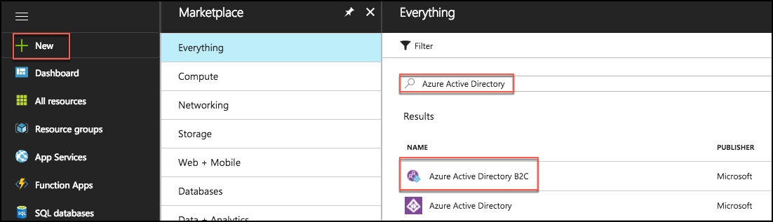
2. Select Create in the Azure Active Directory B2C blade.
3. In the Create new B2C Tenant… blade, select Create a new Azure AD B2C Tenant. 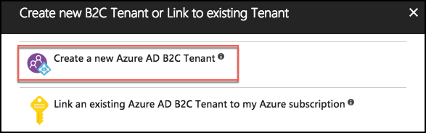
4. In the Azure AD B2C Create Tenant blade, enter:
   1. Organization name: Enter a unique name, such as contosoeventsb2cSUFFIX
   2. Initial domain name: Enter the same name as was entered for Organization name
   3. Country or region: Select United States
   4. Select Create

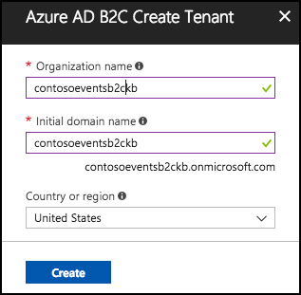

1. When the tenant finishes provisioning, you can switch to your new tenant by select the manage your new directory link which will appear in the Azure AD B2C Create Tenant blade.



1. It may take a few minutes to provision the new directory. In the meantime, feel free to move on to Task 4, and return later to verify. To find the directory later, you may need to refresh the portal. The directory can be found by clicking your logged in user name in the upper-right corner of the page.

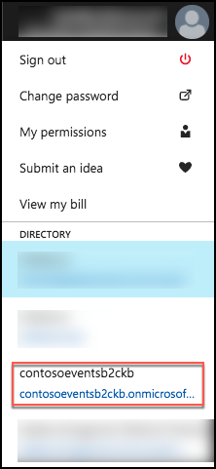

#### Task 4: Web app

In these steps, you will provision a web app in a new App Service Plan.

1. Select +New in the Azure portal, select Web + Mobile, then select Web App.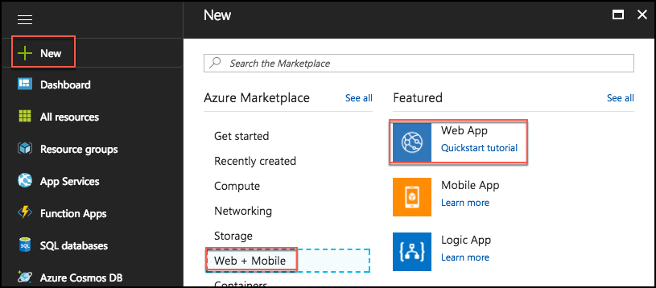
2. On the Create Web App blade, enter the following:
   1. App name: Enter a unique name, such as contosoeventsweb-SUFFIX
   2. Subscription: Select your subscription
   3. Resource group: Select Use existing, and select the hands-on-labs resource group created previously.
   4. OS: Select Windows
   5. App Service plan/location: Select this, select Create new
      1. App service plan: Enter contosoeventsplan-SUFFIX
      2. Location: Select the same location you have been using for other resources in this lab
      3. Pricing tier: Select S1 Standard
      4. Select OK
   6. Select Create to provision the web app 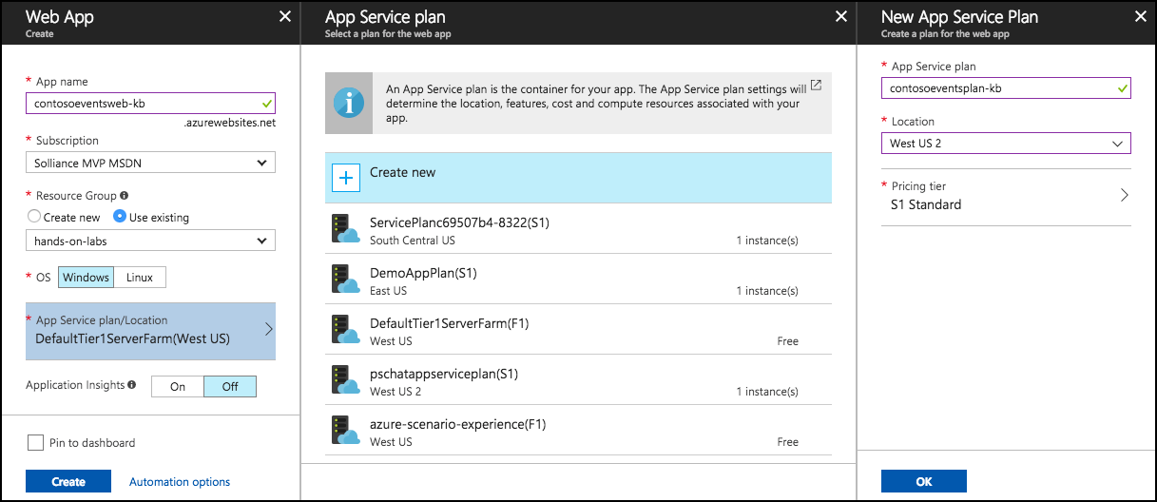
3. You will receive a notification in the Azure portal when the web app deployed completes. From this, select Go to resource.

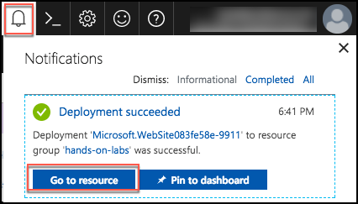

1. On the Web Apps Overview blade, you can URL used to access your web app. If you select this, it will open an empty site, indicating your App Services app is up and running. 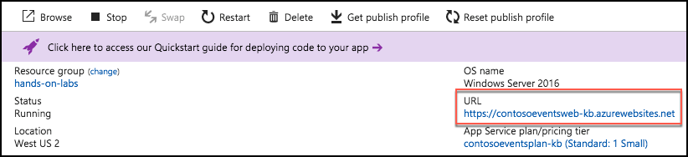

#### Task 5: Function app

In this task, you will provision a Function app using a Consumption Plan. By using a Consumption Plan, you enable dynamic scaling of your Functions.

1. Select +New in the Azure portal, and enter “Function App” in the Search the Marketplace box, then select Function App from the results. 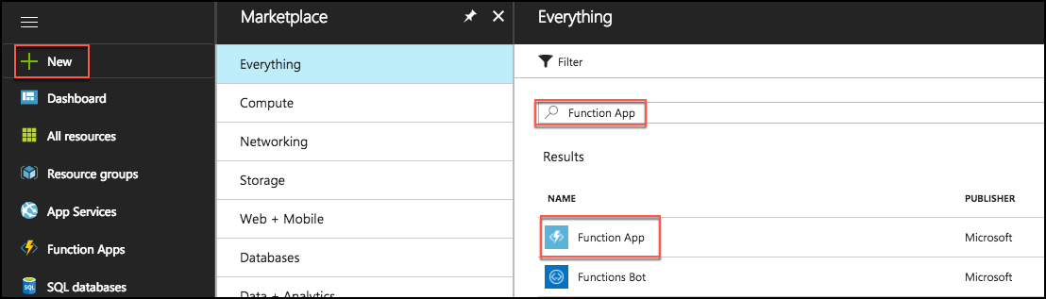
2. Select Create on the Function App blade.
3. On the Create Function App blade, enter the following:
   1. App name: Enter a unique name, such as contosoeventsfn-SUFFIX
   2. Subscription: Select your subscription
   3. Resource group: Select Use existing, and select the hands-on-labs resource group created previously
   4. OS: Select Windows
   5. Hosting Plan: Select Consumption Plan
   6. Location: Select the same location as the hands-on-labs resource group
   7. Storage: Leave Create new selected, and accept the default name
   8. Select Create to provision the new function app

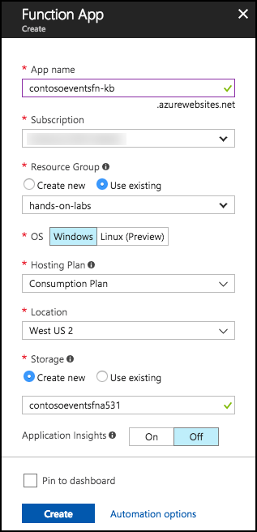

#### Task 6: Storage account

In this section, you will create a Storage account for the application to create and use queues required by the solution.

1. In the Azure portal, select +New, Storage, then select Storage account – blob, file, table, queue under Featured. 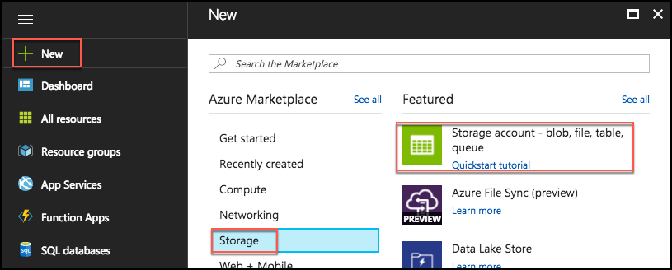
2. In the Create Storage account blade, enter the following:
   1. Name: Enter a unique name, such as contosoeventsSUFFIX
   2. Deployment model: Select Resource manager
   3. Account kind: Select Storage (general purpose v1)
   4. Performance: Select Standard
   5. Replication: Select Locally-redundant storage (LRS)
   6. Secure transfer required: Leave Disabled
   7. Subscription: Select your subscription
   8. Resource group: Select Use existing, and select the hands-on-labs resource group created previously
   9. Location: Select the same region used for the hands-on-labs resource group
   10. Virtual networks (Preview): Leave Disabled
   11. Select Create

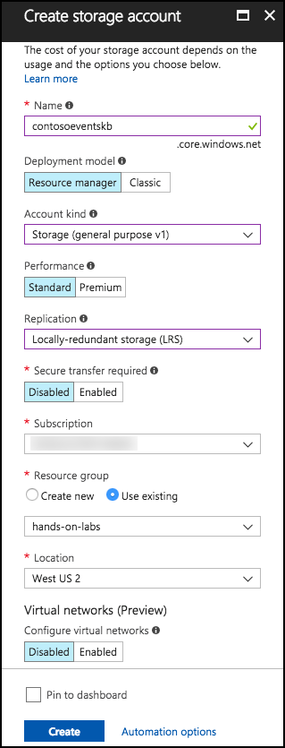

#### Task 7: Cosmos DB

In this section, you will provision a Cosmos DB account, a Cosmos DB Database, and a Cosmos DB collection that will be used to collect ticket orders.

1. In the Azure portal, select +New, Databases, then select Azure Cosmos DB.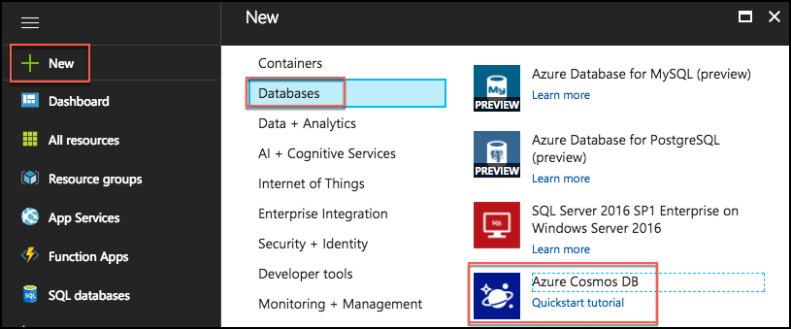
2. On the Azure Cosmos DB blade, enter the following:
   1. ID: Enter a unique value, such as contosoeventsdb-SUFFIX
   2. API: Select SQL
   3. Subscription: Select your subscription
   4. Resource group: Select Use existing, and select the hands-on-labs resource group previously created
   5. Location: Select the location used for the hands-on-lab resource group. If this location is not available, select one close to that location that is available.
   6. Enable geo-redundancy: Leave checked
   7. Select Create to provision the Cosmos DB

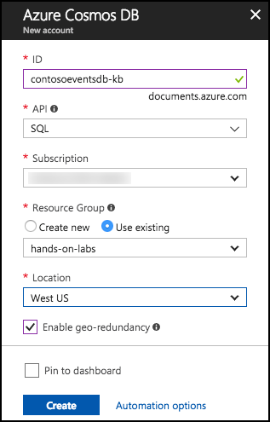

1. When the Cosmos DB account is ready, navigate to the hands-on-labs Resource Group, and select your Cosmos DB account from the list. 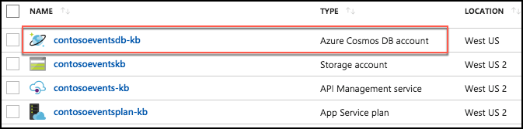
2. On the Cosmos DB account blade, under Collections in the left-hand menu, select Browse. 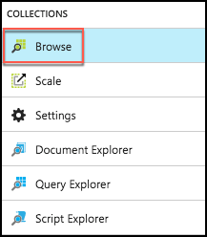
3. On the Browse blade, select +Add Collection. 
4. On the Add Collection dialog, enter the following:
   1. Database id: Enter TicketManager
   2. Collection id: Enter Orders
   3. Storage capacity: Select Fixed (10 GB)
   4. Throughput: Enter 2500
   5. Select OK to create the new collection 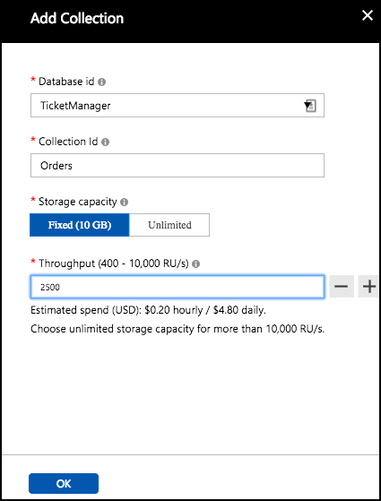
5. Select New collection from the new screen that appears.

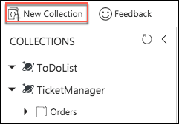

1. In the Add Collection dialog, enter the following:
   1. Database id: Enter TicketManager
   2. Collection id: Enter Events
   3. Storage capacity: Select Fixed (10 GB)
   4. Throughput: Enter 2500
   5. Select OK to create the new collection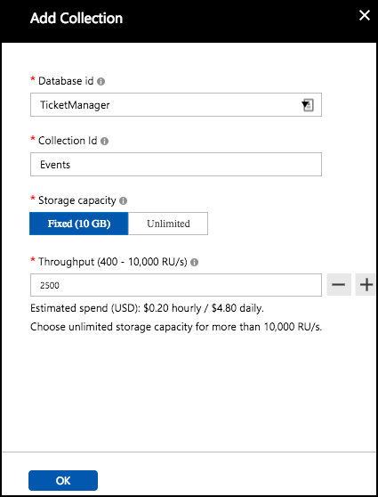
2. You will be able to see that the two collections exist in the new database. 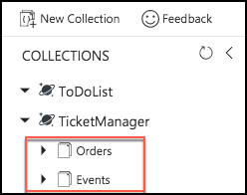

## Exercise 2: Placing ticket orders

Duration: 30 minutes

The agreed-upon design with Contoso Events involves queuing ticket orders, and executing them asynchronously. A stateless Web API service receives the request, and queues it to a stateful service. An actor processes the request, and persists the order in its state.

The design also calls for saving the state of the ticket order to a Cosmos DB collection for ad hoc queries. This exercise will guide you through adding configurations that will light up the actor code that externalizes its state to a storage queue. In addition, you will set up the Function App to read from the queue, and persist the order to the Orders collection of the Cosmos DB instance you created.

**Note**: The code to write to the storage queue is already in place within the actor, so setting up configuration keys is the only requirement to lighting up that feature.

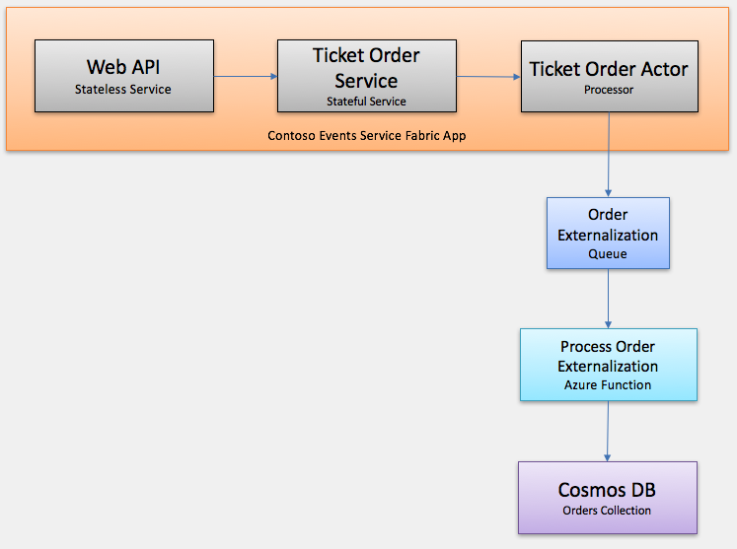

#### Task 1: Run the solution

The purpose of this task is to make sure that the source code compiles, and that you can publish to a local cluster. To make sure that the app is running flawlessly, you will run some API tests and access the Service Fabric explorer.

Note: Not all features are in place, but you will be able to see that the application can run.

1. On the Lab VM, make sure the local Service Fabric environment is running by selecting the arrow in the system tray, and checking for the appearance of the Service Fabric icon. Note: You may need to restart your VM if you’ve recently installed the Service Fabric Local Cluster Manager, for the icon to appear.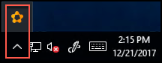
2. If it is not there, you will need to start the local Service Fabric cluster. To do this, select the Start menu, scroll down to the apps listed under “S,” and select Service Fabric Local Cluster Manager. The icon (Step 1) should now appear.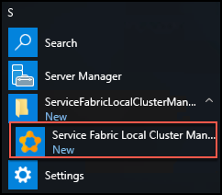
3. Right-click the system tray icon, and select Setup Local Cluster, 1 Node. 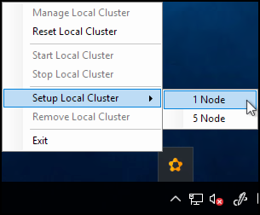
4. You should see a message that the local cluster is setting up. **Note**: Sometimes you will see an error message appear indicating the cluster setup is retrying.

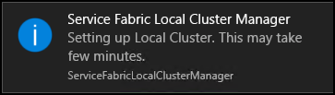

1. Open the ContosoEventsPoc solution in Visual Studio, if it is not still open from the previous exercise.
2. Rebuild the solution to resolve all NuGet packages, and to make sure there are no compilation errors, by selecting Build from the menu, then selecting Rebuild Solution. 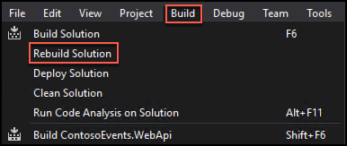
3. After the rebuild, you should see a Rebuild All succeeded message in the bottom left corner of Visual Studio, and that there are 0 Errors. Note: You may see some warnings, but these can be safely ignored. 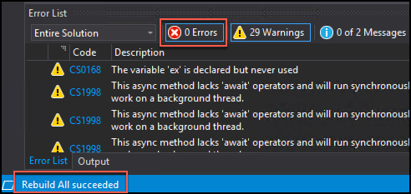
4. Now, you will Publish the Service Fabric app to the local cluster.
5. In Solution Explorer, right-click the Service Fabric Application, ContosoEventsApp, and select Publish. 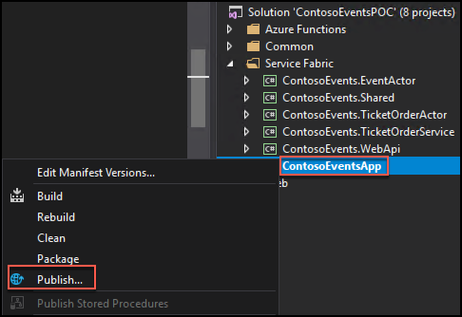
6. In the Public Service Fabric Application dialog, select PublishProfiles\Local.1Node.xml for the Target profile, ensure the correct account is selected, and select Publish. 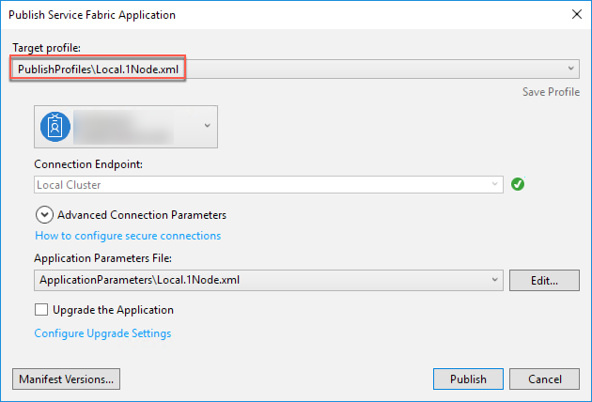

**Note**: If you have an error such as: “The project does not have a package action set.” you can restart Visual Studio, re-open the solution, and this will resolve the problem.

1. You can see the publish status in the Visual Studio output pane, at the bottom of the window. When the publish process is complete, you will see a success message in the output pane. The application is ready to be used. 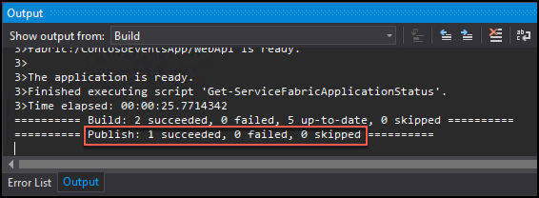

#### Task 2: Test the application

The Service Fabric Application includes a front-end Web API as the public-facing window to internal stateful services. In this task, you will check that you can call the Web API now that you have the application published to the local cluster. Because the app is not yet fully configured, not all Web API methods will be fully functional.

1. On the Lab VM, open a Chrome browser, navigate to the Swagger endpoint for the Web API at: <http://localhost:8082/swagger/ui/index>. Note the three API endpoints: Admin, Events, and Orders.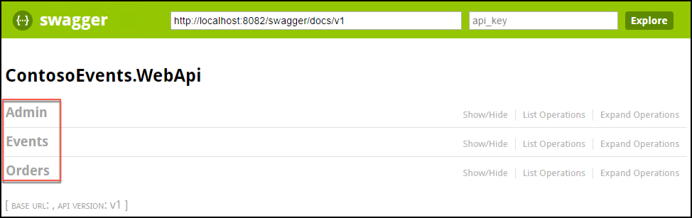
2. Select the Admin API, and observe the list of methods available. 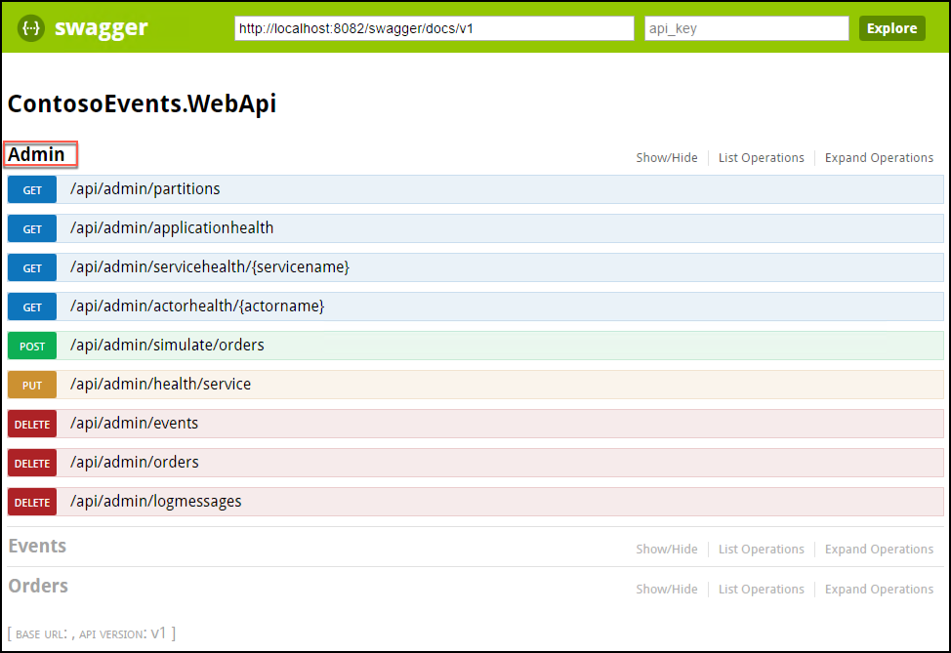
3. Select /api/admin/partitions, then select Try it out. 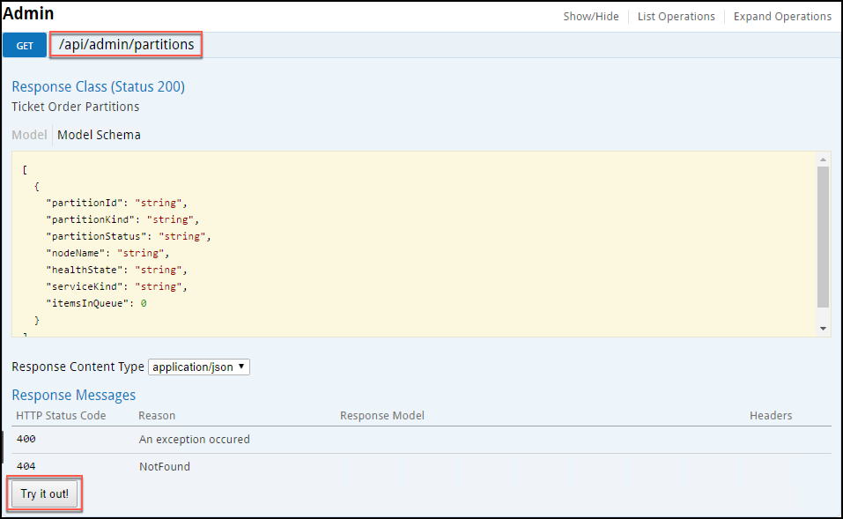
4. Make sure it returns a Response Code of 200, as shown in the following screen shot. This API endpoint returns the number of tickets queued across all partitions. 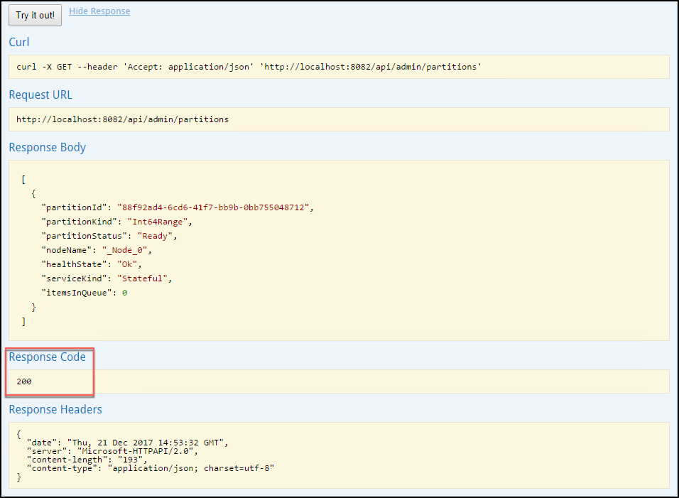
5. After viewing the Swagger definition, and receiving a success response code from the partitions method, your environment is in a good state to continue.

#### Task 3: Service Fabric Explorer

In this task, you will browse to the Service Fabric Explorer, and view the local cluster.

1. On your Lab VM, open a new tab in your Chrome browser, and navigate to the Service Fabric Explorer for the local cluster at <http://localhost:19080/Explorer/index.html>. 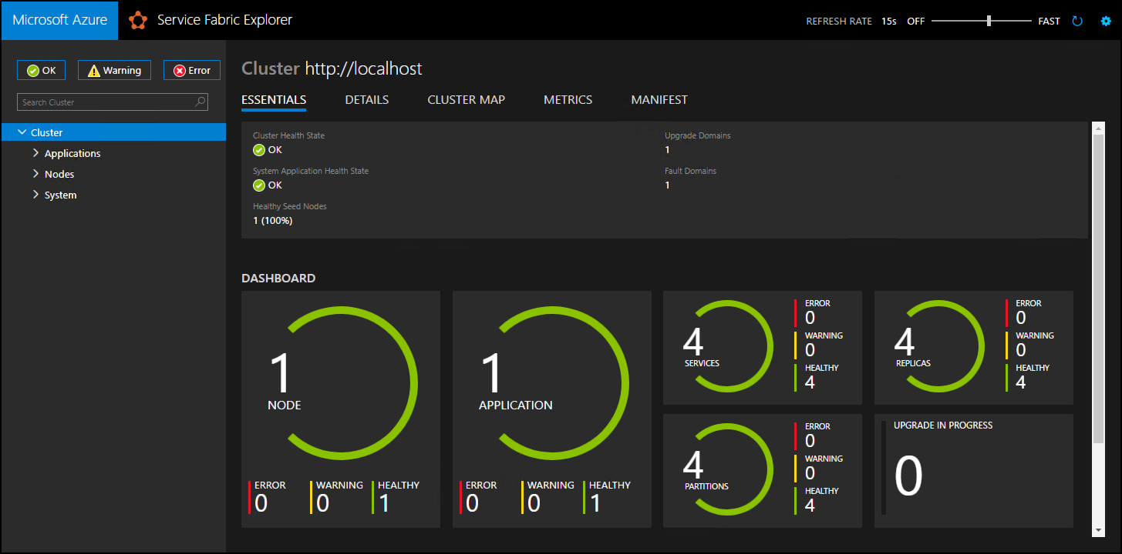
2. Observe that the ContosoEventsApp is deployed with the following services:
   1. fabric:/ContosoEventsApp/EventActorService
   2. fabric:/ContosoEventsApp/TicketOrderActorService
   3. fabric:/ContosoEventsApp/TicketOrderService
   4. fabric:/ContosoEventsApp/WebApi 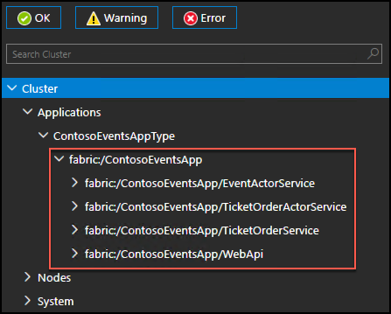

#### Task 4: Set up the Ticket Order Sync queue

In this task, you will complete features of the Contoso Events POC so that placing an order also syncs with the back-end data store. You will also update the configuration settings to reference the Azure resources you previously created correctly.

1. Return to Visual Studio, and from Solution Explorer, open Local.1Node.xml, located in the ApplicationParameters folder under the ContosoEventsApp project in the Service Fabric folder. 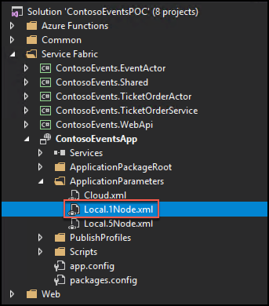
2. Locate the following Parameter block in the file. In the steps below, you will retrieve the values needed to update Local.1Node.xml with your own configuration parameters.

<Parameter Name="DataStorageEndpointUri" Value="" />

<Parameter Name="DataStoragePrimaryKey" Value="" />

<Parameter Name="DataStorageDatabaseName" Value="TicketManager" />

<Parameter Name="DataStorageEventsCollectionName" Value="Events" />

<Parameter Name="DataStorageOrdersCollectionName" Value="Orders" />

<Parameter Name="StorageConnectionString" Value="" />

<Parameter Name="ExternalizationQueueName" Value="contosoevents-externalization-requests"/>

<Parameter Name="SimulationQueueName" Value="contosoevents-simulation-requests" />

###### Cosmos DB settings:

1. In the Azure Portal, browse to the Azure Cosmos DB account you created in Exercise 1, Task 7, and select Keys, under Settings in the left-hand menu. 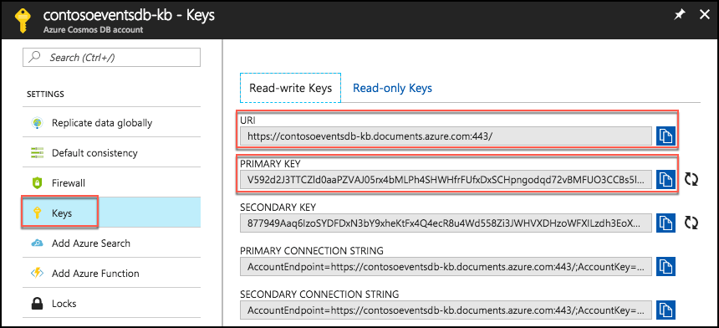
2. Select the Copy button next to the URI value, return to the Local.1Node.xml file in Visual Studio, and paste the URI value into the value for the DataStorageEndpointUri parameter.
3. Now, on your Cosmos DB keys blade, copy the Primary Key value, return to the Local.1Node.xml file in Visual Studio, and paste the Primary Key value into the value for the DataStoragePrimaryKey parameter.
4. Back in the Azure portal, select Browse under Collections in the left-hand menu for your Cosmos DB. The database (TicketManager) and collection (Orders and Events) names are pre-set in the Local.1Node.xml file, so verify these match the collection and database names you see in the Azure portal. 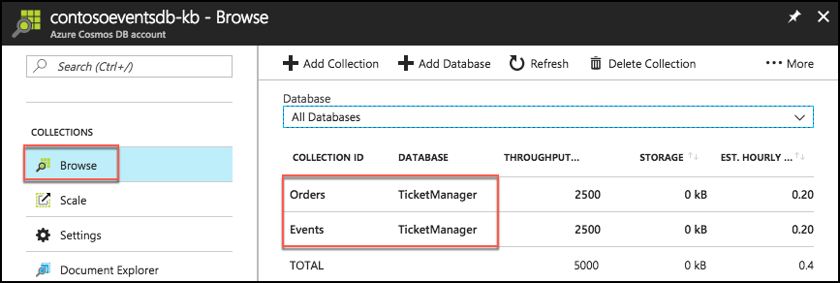
5. If you used a different database name, modify the value of the DataStorageDatabaseName parameter to reflect the Cosmos DB database name.
6. If you used a different collection names for the Orders or Events collections, modify the values of the DataStorageEventsCollectionName and DataStorageOrdersCollectionName parameters to match your names.
7. Save the Local.1Node.xml file. The Cosmos DB parameters should now resemble the following: 

###### Storage settings:

1. In the Azure Portal, browse to the Storage account you created in Exercise 1, Task 6, and select Access keys under Settings in the left-hand menu.
2. Select the copy button to the right of key1 Connection String to copy the value. 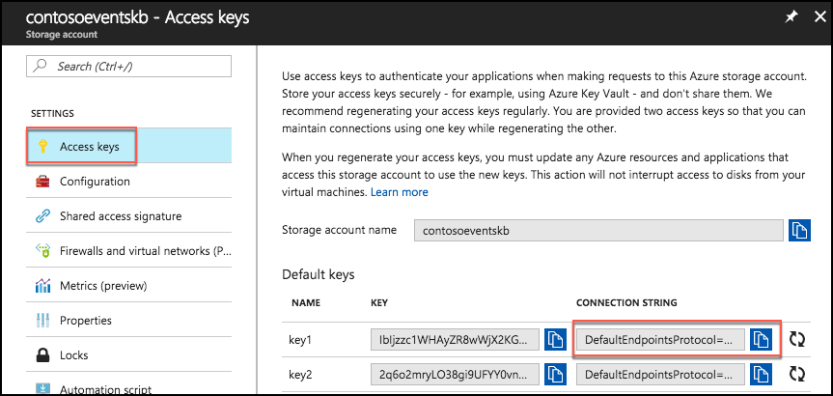
3. Return to the Local.1Node.xml file in Visual Studio, and paste the key 1 Connection String into the value for the StorageConnectionString parameter, and save Local.1Node.xml.

###### Test configurations:

1. In Visual Studio, rebuild and publish the application to the local cluster using the steps you followed previously.
2. After the application is fully published, use Chrome to browse to the Swagger endpoint at <http://localhost:8082/swagger/ui/index>.
3. Select the Orders API methods, and select the POST operation for /api/orders: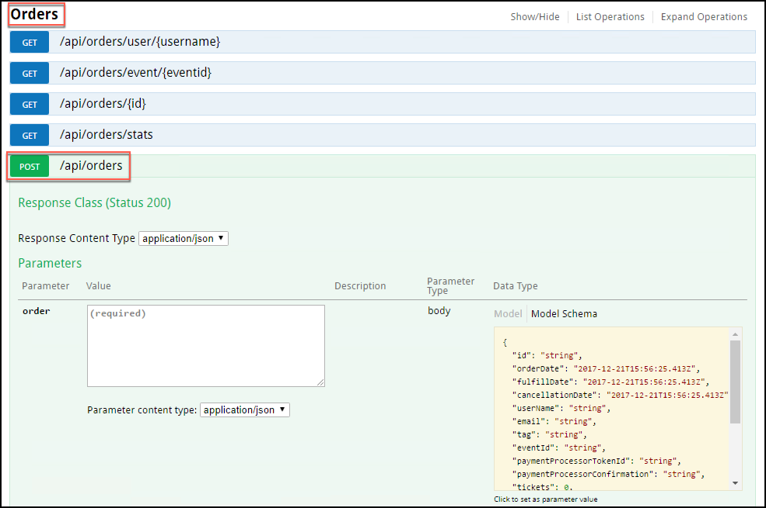
4. POST an order to the Contoso Events application. Copy the order request JSON below into the order value box, and select Try it out.

{

"UserName": "johnsmith",

"Email": "john.smith@gmail.com",

"EventId": "EVENT1-ID-00001",

"PaymentProcessorTokenId": "YYYTT6565661652612516125",

"Tickets": 3

}

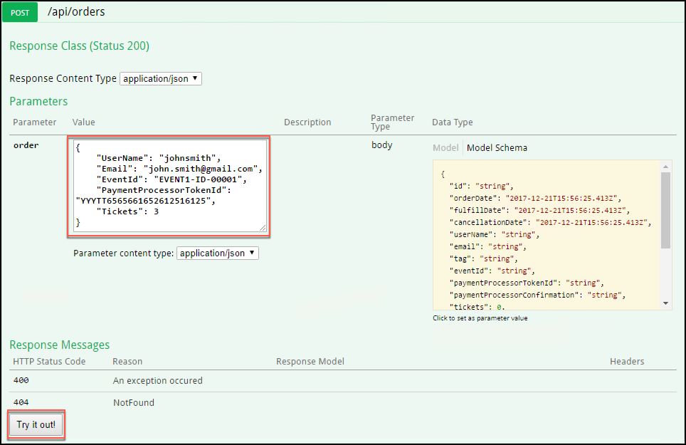

1. This should return successfully, with an HTTP 200 response code. The Response Body contains a unique order id that clients could use to track the order. 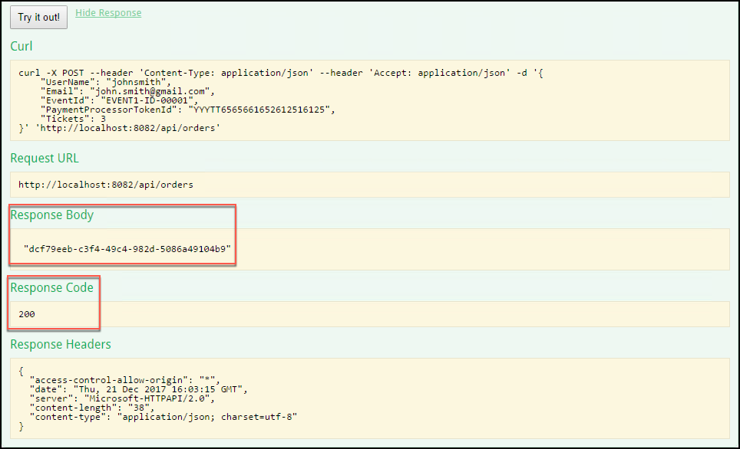

**Note**: This sends the order to the Web API, which in turn queues the order with the Ticket Order Processing queue. Ultimately, the Ticket Order Actor will pick up the message and process the order.

1. Now, you should have an order in the Service Fabric App, and it is being processed. In addition, the Ticket Order Actor should have sent the order to the externalization queue you set up in configuration earlier. The actor has pre-existing logic in place to write to this queue.
2. To verify that the order is in the queue, select View -> Cloud Explorer from the menu in Visual Studio. 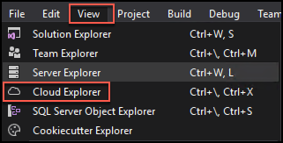
3. In the Cloud Explorer, select the Account Management icon, and select the check box next to the subscription you are using for this lab, then select Apply. You may need to re-enter your account credentials to see the resources under the subscription.

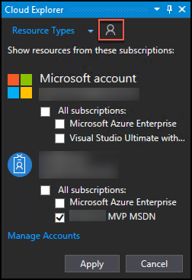

1. Now, expand Storage Accounts under your subscription in Cloud Explorer, and locate the Storage account you set up in Exercise 1, Task 6. You may need to select Load more at the bottom of the list, if you don’t see the storage account. Expand the storage account, then expand Queues.

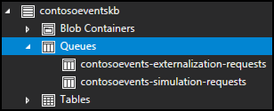

1. Double-click on the externalization queue, and you should see the message you just sent from Swagger in the document window. 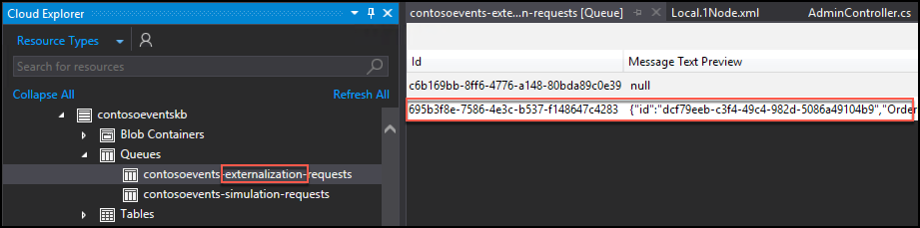
2. Now, double-click on the message, and you will see the contents of the message including the JSON representation of the order. Select OK to close the View Message dialog. 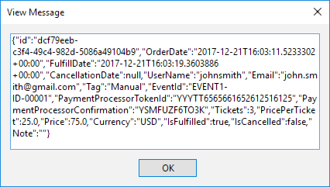

#### Task 5: Set up the functions

In this task, you will create a function that will be triggered by the externalization queue we created for the app. Each order that is deposited to the queue by the TicketOrderActor type will trigger the ProcessOrderExternalizations function. The function then persists the order to the Orders collection of the Cosmos DB instance.

You will also create a second function that will be used to generate load against the system at runtime. Overall, the ContosoEvents app has the following queue and function architecture. This should help you visualize how the queues and functions are related.

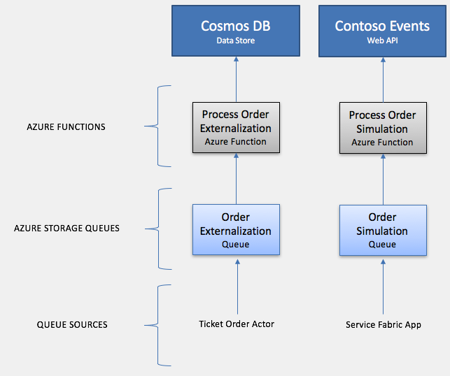

1. There appears to be an issue with Azure Functions detecting Storage accounts, so before creating your function, you will manually add your Storage account connection string to the Application Settings for your Function App.
2. In the Azure portal, browse to the Storage Account you created in Exercise 1, Step 6, then select Access keys under Settings on the left-hand menu, and copy the key1 Connection String value, as you did previously. 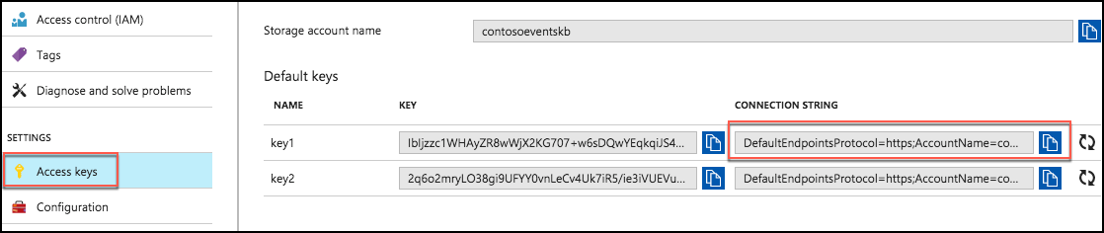
3. Now, browse to the Function App you created in Exercise 1, Step 5.
4. Select your Function App in the left-hand menu, then select Application settings under Configured features. 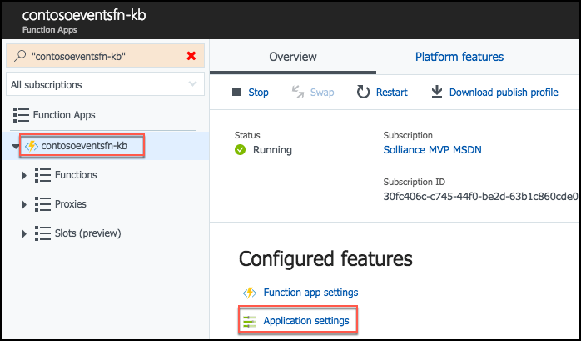
5. On the Application Settings tab, scroll down and select +Add new setting under Application Settings, then enter contosoeventsstore in the name textbox, and paste the key1 Connection String value you copied from your Storage account into the value textbox. 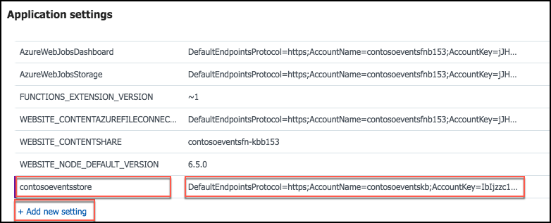
6. Scroll back to the top of the Application Settings tab, and select Save to apply the change. 
7. From the left-hand menu, place your mouse cursor over Functions, then select the + to the right of Functions. 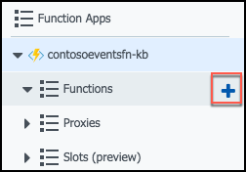
8. Select Data processing under the Get started quickly… header, leave CSharp selected for the language, and select the Create this function button. 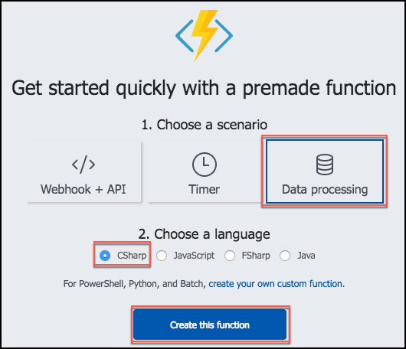
9. First, let’s rename the function, so it has a more meaningful name.
10. In the left-hand menu, select your Function app, then select the Platform features tab, and select Console under Development Tools. 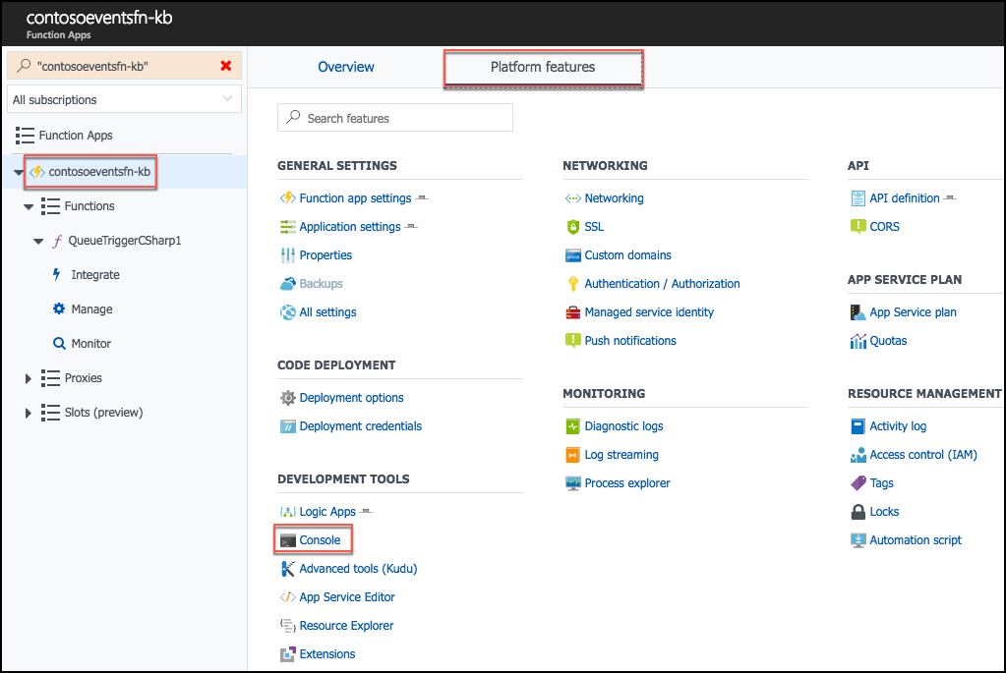
11. At the Console command prompt, type “ls” to view the list of functions and files in the wwwroot folder. 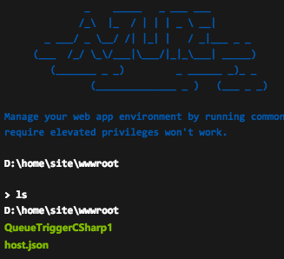
12. Next, paste the following command into the console to rename the QueueTriggerCSharp1 function to ProcessOrderExternalizations.

rename QueueTriggerCSharp1 ProcessOrderExternalizations

1. Typing “ls” at the command prompt again will show the function has been renamed. 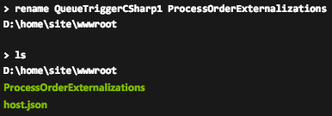
2. Exit the Console window by selecting the X in the top right corner, just below your account name. 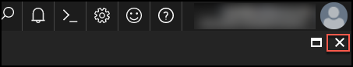
3. Back on the Function app page, move your mouse cursor over your function app in the left-hand menu, and select the Refresh icon. Note the function name is still QueueTriggerCSharp1 before refreshing.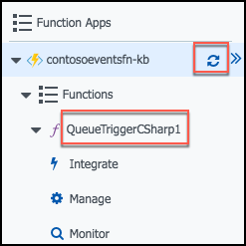
4. After the refresh, the function name will change in the display to ProcessOrderExternalizations. 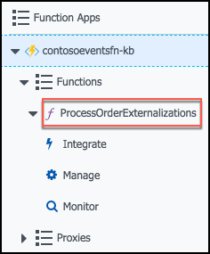
5. Under the ProcessOrderExternalizations function, select Integrate.

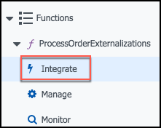

1. On the Integrate screen, set the following:
   1. Message parameter name: Enter orderItem
   2. Storage account connection: Select the arrows in the box, then select the contosoevents-store connection from the list. This is the Application Setting you added above. 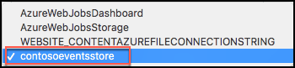
   3. Queue name: Enter the name of your externalization queue (from Cloud explorer in Visual Studio). This should be contosoevents-externalization-requests. 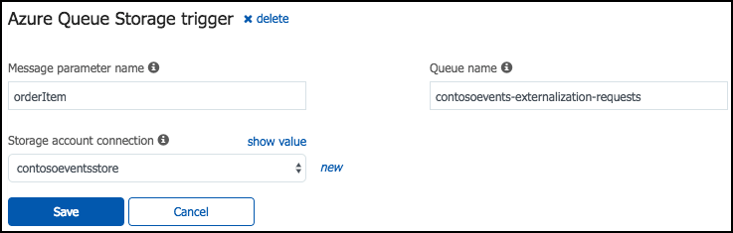
   4. Select Save.
2. While still on the Integrate screen, select +New Output. 
3. In the outputs box, locate and select Azure Cosmos DB, then select. 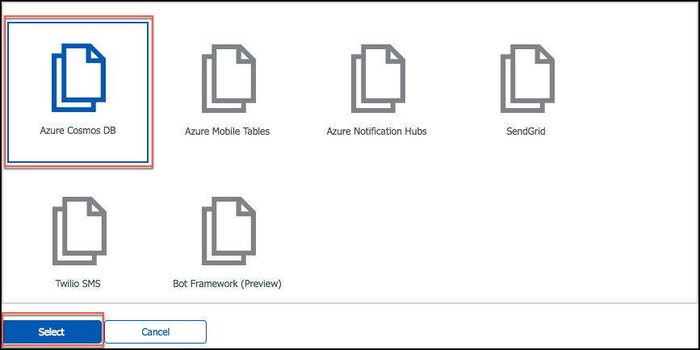
4. On the Azure Cosmos DB output screen, enter the following:
   1. Document parameter name: Enter orderDocument
   2. Collection name: Enter Orders
   3. Partition key: Leave empty
   4. Database name: Enter TicketManager
   5. Azure Cosmos DB account connection: Select new next to the text box, and select the Cosmos DB you created in Exercise 1, Task 7. 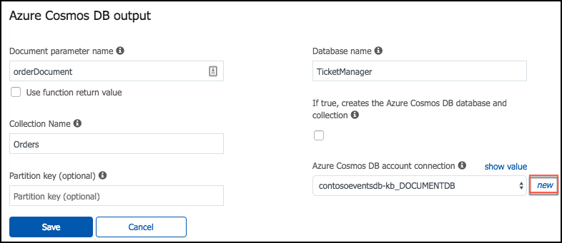
   6. Select Save. You should now see an Azure Queue Storage trigger and an Azure Cosmos DB output on the Integrate screen. 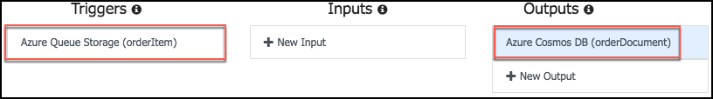
5. Next, select your function from the left-hand menu.

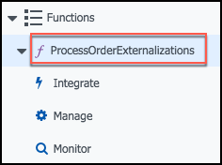

1. Now, you will retrieve the code for the function from a file in Visual Studio.
2. In Visual Studio, go to Solution Explorer, and locate ProcessTicketOrderExternalizationEvent.cs in the Azure Functions folder.

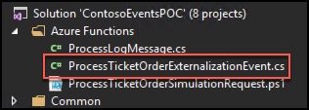

1. Select all the code in that file (CTRL+A) and copy (CTRL+C) it.
2. Return to your function’s page in the Azure portal, and replace the code in the run.csx block with the code you just copied from Visual Studio, and select Save. The run.csx code should now look like the following. Note: The ProcessOrdersExternalization function will enable you to process another order, and see that it is saved to the Orders collection of the Cosmos DB. 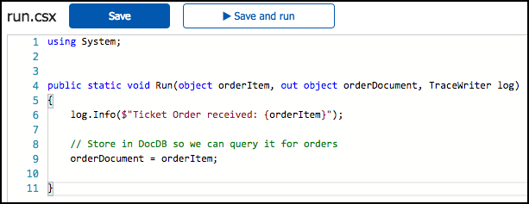
3. You will now create another function for the load simulation you will use later in this hands-on lab.
4. As before, select + next to Functions in the left-hand menu.



1. In the Choose a template… screen that appears, locate the Queue trigger box, and select PowerShell. 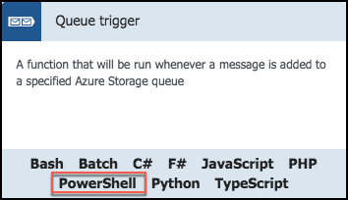
2. In the Queue trigger dialog, enter the following:
   1. Language: Leave PowerShell selected
   2. Name: Enter ProcessSimulationRequests
   3. Queue name: Enter your simulation queue name, from Cloud explorer in Visual Studio. The value should be contosoevents-simulation-requests.
   4. Storage account connection: Select contosoeventsstore from the drop down
   5. Select Create to create the new function

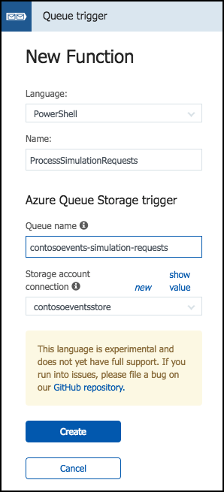

1. Select Integrate under the new ProcessSimulationRequests function in the left-hand menu. 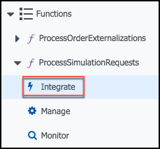
2. Make sure Azure Queue Storage is selected under Triggers, then enter the following:
   1. Message parameter name: Enter simulationRequest
   2. Storage account connection: Leave set to contosoeventsstore
   3. Queue name: Leave as contosoevents-simulation-requests
   4. Select Save. 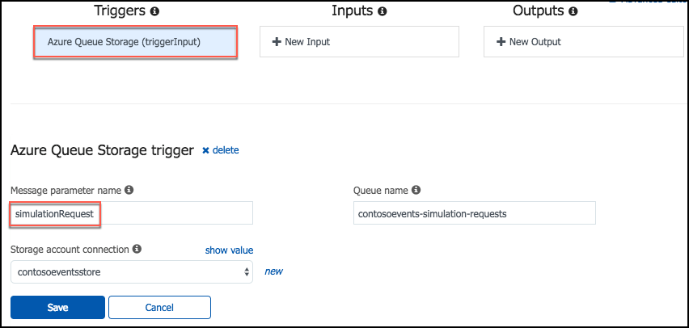
3. Select the ProcessSimulationRequests function in the left-hand menu.

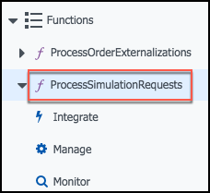

1. Return to Visual Studio, and open the ProcessTicketOrderSimulationRequest.ps1 file in the Azure Functions folder. 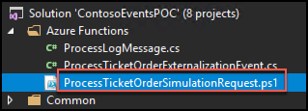
2. Copy all the contents of this file (CTRL+A, then CTRL+C), then return to your function page in the Azure portal, and paste the code into the run.ps1 code block.
3. Select Save.
4. The final setting to update is the API Management key. You will return to set this up when you set up the API Management service.

#### Task 6: Test order data sync

In this task, you will test the ticket order processing back-end, to validate that orders are queued and processed by the ProcessOrderExternalizations function – ultimately saving the order to the Orders collection of the Cosmos DB instance.

1. In the Azure portal, navigate to the Function App.
2. Select the ProcessOrderExternalizations function (may be listed as the default QueueTriggerCSharp1 name if you did not rename it), and select Logs at the bottom of the screen. Leave the window open with the Logs visible. 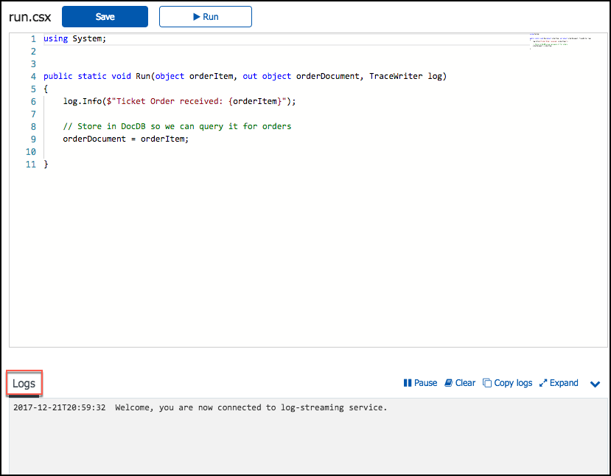
3. Repeat the steps to post an order via Swagger to the /api/orders endpoint (Task 4, Test configurations, Steps 2 – 5).
4. As orders are processed, you will see activity in the function logs in the Azure portal. 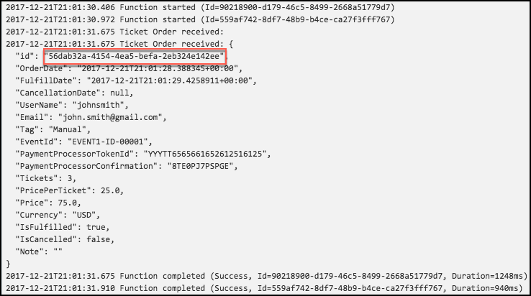
5. Copy the order id of the function just processed. You will use this information below to verify the order was persisted to the Orders collection in Cosmos DB.
6. If logs are not appearing in this view, click the Monitor tab under the ProcessOrderExternalizations function, then select a log item that has an “id” parameter value passed to the function, as shown below: 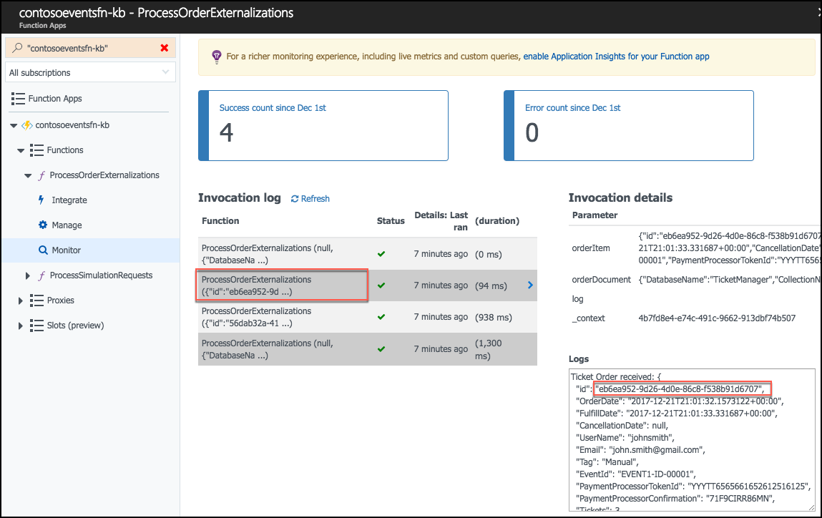
7. In the Azure portal, navigate to your Cosmos DB account, and from the top menu of the Overview blade, select Data Explorer. 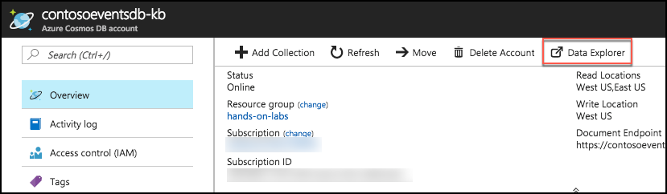
8. In Cosmos DB Data Explorer, select Orders under the TicketManager database, then select New SQL Query from the toolbar, and enter the following query into the Query 1 window, replacing the ID in red with the order id you copied above.

SELECT * FROM c WHERE c.id = '56dab32a-4154-4ea5-befa-2eb324e142ee'

1. Select Execute Query. 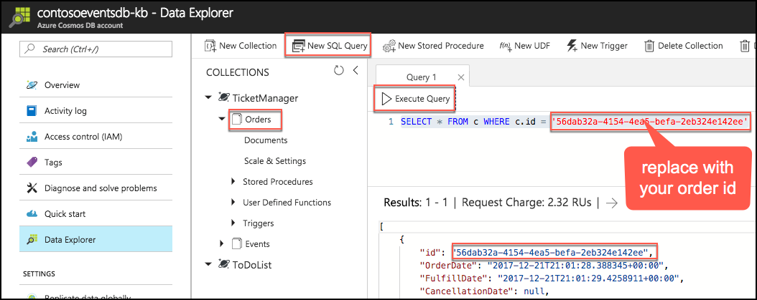
2. If the Cosmos DB query returns the order id specified, the order has been fully processed through to the Cosmos DB.

## Exercise 3: Publish the Service Fabric Application

Duration: 15 minutes

In this exercise, you will publish the Service Fabric Application to the Azure cluster you created previously. After it is deployed, you will validate it by sending orders through the Web API endpoints exposed from the cluster.

#### Task 1: Publish the application

In this task, you will deploy the application to a hosted Service Fabric Cluster.

1. In Visual Studio on your Lab VM, within Solution Explorer, open Cloud.xml from the ApplicationParameters folder of the ContosoEventsApp project, under the Service Fabric folder. This file contains parameters we can use for publishing to the hosted cluster, as opposed to the local cluster. 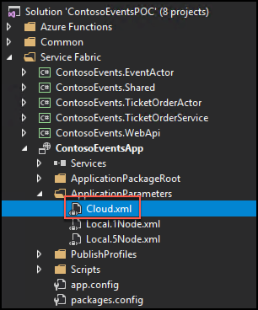
2. Open Local.1Node.XML from the same folder.
3. To make sure you are using the same parameters you setup earlier for the Local cluster, copy just the following parameters from Local.1Node.xml to Cloud.xml, overwriting the existing parameters in Cloud.xml, then save Cloud.xml.

<Parameter Name="DataStorageEndpointUri" Value="" />

<Parameter Name="DataStoragePrimaryKey" Value="" />

<Parameter Name="DataStorageDatabaseName" Value="TicketManager" />

<Parameter Name="DataStorageEventsCollectionName" Value="Events" />

<Parameter Name="DataStorageOrdersCollectionName" Value="Orders" />

<Parameter Name="DataStorageLogMessagesCollectionName" Value="LogMessages" />

<Parameter Name="StorageConnectionString" Value="" />

<Parameter Name="ExternalizationQueueName" Value="contosoevents-externalization-requests"/>

<Parameter Name="SimulationQueueName" Value="contosoevents-simulation-requests" />

1. Review the settings related specifically to cloud publishing.
2. In Cloud.xml, verify the WebAPi_InstanceCount parameter is set to -1. This instructs the cluster to create as many instances of the Web API as there are nodes in the cluster.
3. In Cloud.xml, verify the TicketOrderService_PartitionCount parameter is set to 5. You will look more closely at this in the load test section.

<Parameter Name="TicketOrderService_PartitionCount" Value="5" />

<Parameter Name="TicketOrderService_MinReplicaSetSize" Value="3" />

<Parameter Name="TicketOrderService_TargetReplicaSetSize" Value="3" />

<Parameter Name="WebApi_InstanceCount" Value="-1" />

<Parameter Name="TicketOrderActorService_PartitionCount" Value="5" />

<Parameter Name="EventActorService_PartitionCount" Value="1" />

1. From Solution Explorer, right-click the ContosoEventsApp project and select Publish.
2. In the Publish Service Fabric Application dialog, set the Target profile to Cloud.xml, and select your Service Fabric Cluster endpoint from the Connection Endpoint drop down, then select Publish. 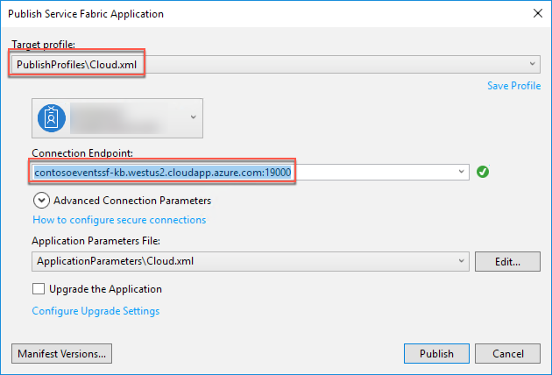
3. Publishing to the hosted Service Fabric Cluster takes about 5 minutes. It follows the same steps as a local publish step with an alternate configuration. The Visual Studio output window keeps you updated of progress.
4. From the Visual Studio output window, validate that the deployment has completed successfully before moving on to the next task.

#### Task 2: Test an order from the cluster

In this task, you will test an order against your application deployed to the hosted Service Fabric Cluster.

1. In a Chrome browser on your Lab VM, navigate to the Swagger endpoint for the Web API exposed by the hosted Service Fabric cluster. The URL is made of: http://<your-cluster-name>.<your-region>.cloudapp.azure.com:8082/swagger/ui/index. For example: <http://contosoeventssf-SUFFIX.eastus.cloudapp.azure.com:8082/swagger/ui/index>
2. Expand the Orders API and expand the POST method of the /api/orders endpoint. 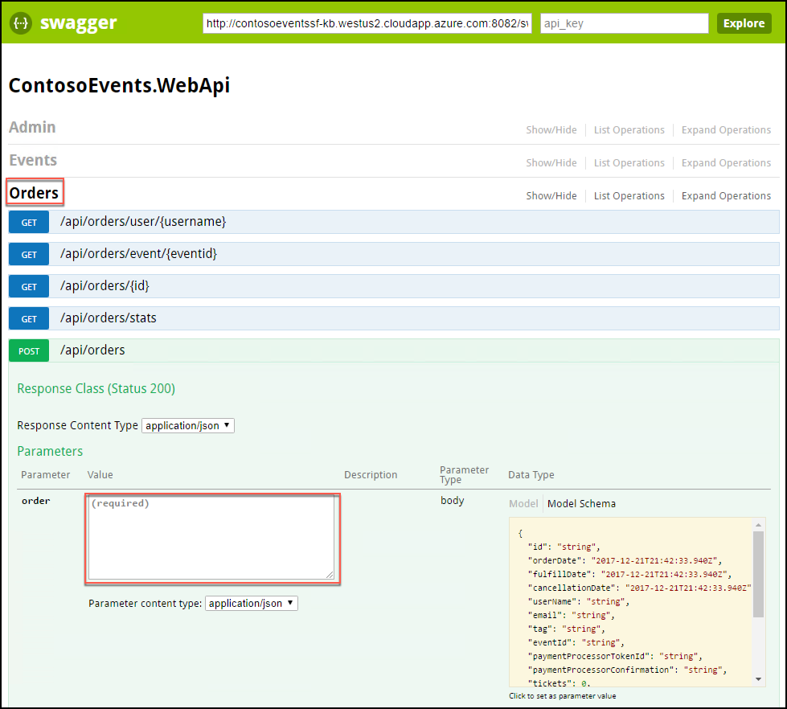
3. Copy the JSON below, and paste it into the order field, highlighted in the screen shot above, then select Try it out.

{

"UserName": "johnsmith",

"Email": "john.smith@gmail.com",

"Tag": "Manual",

"EventId": "EVENT1-ID-00001",

"PaymentProcessorTokenId": "YYYTT6565661652612516125",

"Tickets": 3

}

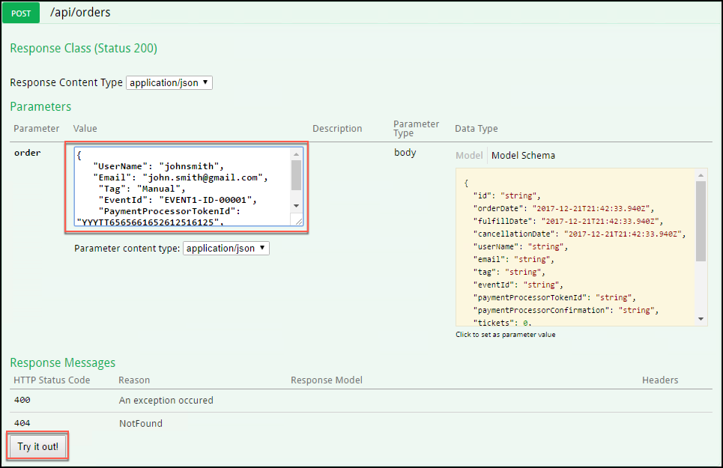

1. This should return with HTTP 200 response code. The Response Body includes a unique order id that can be used to track the order. Copy the Response Body value. It will be used to verify the order was persisted in Cosmos DB.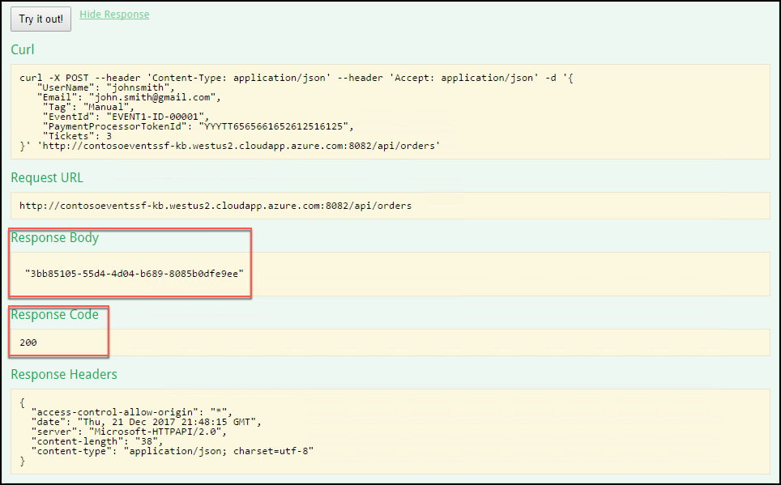
2. Verify that the order was persisted to the Orders collection.
3. In the Azure portal, navigate to your Cosmos DB account.
4. Perform a query against the Orders collection, as you did previously, to verify the order exists in the collection. Replace the id in the query with the order id you copied from the Response Body above.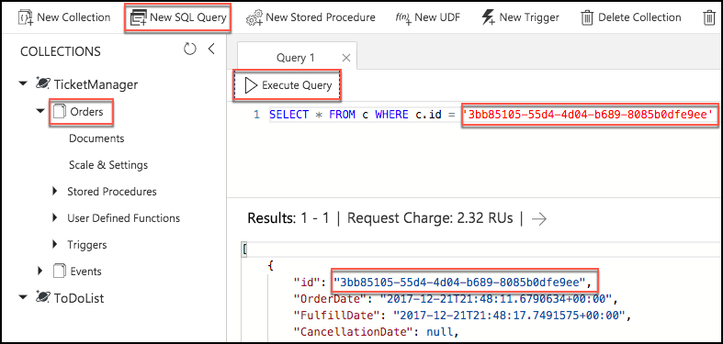

## Exercise 4: API Management

Duration: 15 minutes

In this exercise, you will configure the API Management service in the Azure portal.

#### Task 1: Import API

In this task, you will import the Web API description to your API Management service to create an endpoint.

1. In the Azure portal, navigate to the hands-on-labs resource group, and select your API Management Service from the list of resources.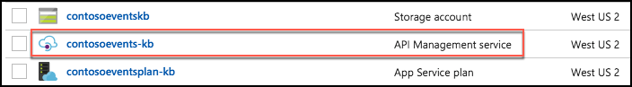
2. From the API Management blade, select Publisher portal from the toolbar. 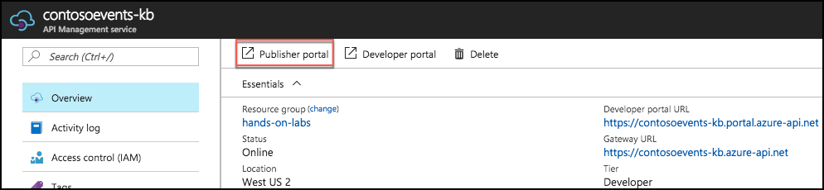
3. In the Publisher portal, select APIs from the left-hand menu, then select Import API. 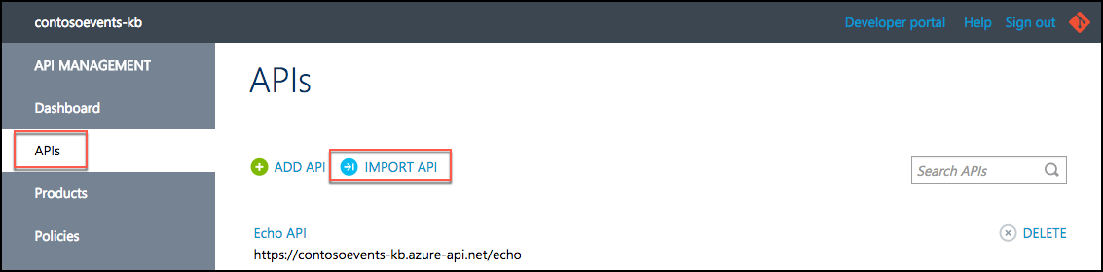
4. Return to your Swagger browser window, and copy the URL from the textbox at the top of the screen, next to the Swagger logo, as shown in the screen shot below. 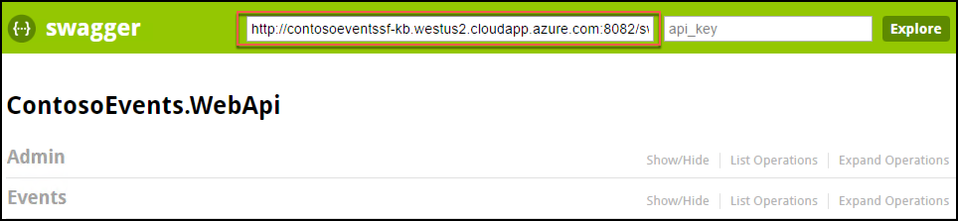
5. Return to the Import API page in the Publisher portal, and do the following:
   1. Select From URL
   2. Paste the URL copied from Swagger into the Specification document URL textbox
   3. Select Swagger for the Specification format
   4. Leave New API selected
   5. Enter events in the Web API URL suffix textbox
   6. Note the URL under “This is what the URL is going to look like.” You will use this URL in your website configuration in the next exercise.
   7. Enter Unlimited in the Products textbox.
   8. Select Save. 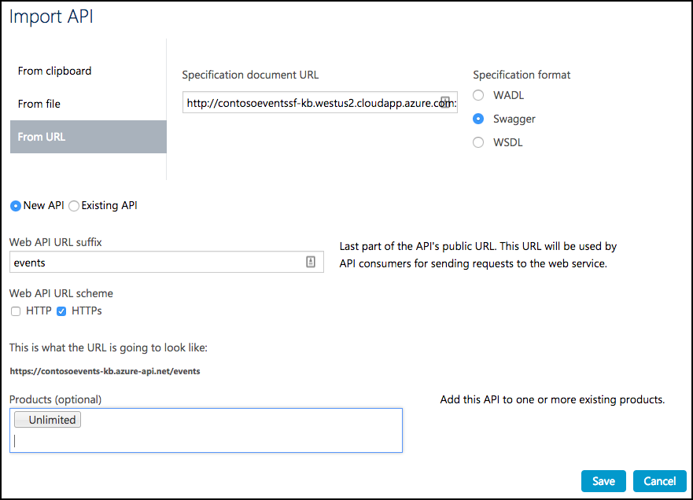

**Note**: You would typically create a new product for each environment in a scenario like this one. For example, Development, Testing, Acceptance and Production (DTAP) and issue a key for your internal application usage for each environment, managed accordingly.

1. You will see your API listed under APIs. 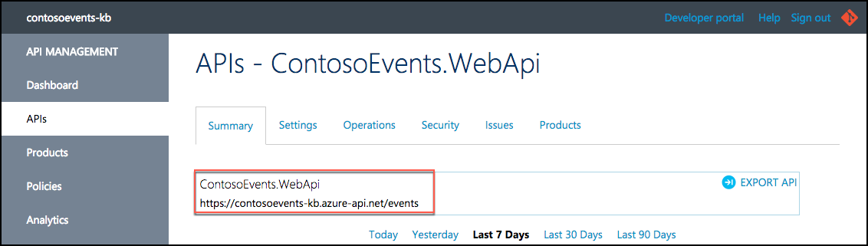

#### Task 2: Retrieve the user subscription key

In this task, you will retrieve the subscription key for the client applications to call the new API Management endpoint.

1. In the Azure portal, navigate to your API Management service, and from the Overview blade, select Developer portal from the toolbar. This will open a new browser tab, and log you into the Developer portal as an administrator, giving you the rights you need to complete the following steps.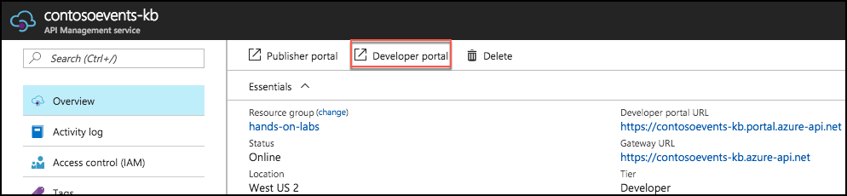
2. In the Developer portal, expand the Administrator menu, and then select Profile. 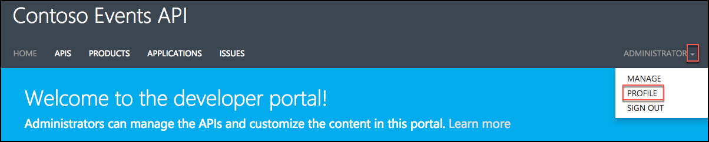
3. Select Show for the Primary Key of the Unlimited subscription to reveal it. 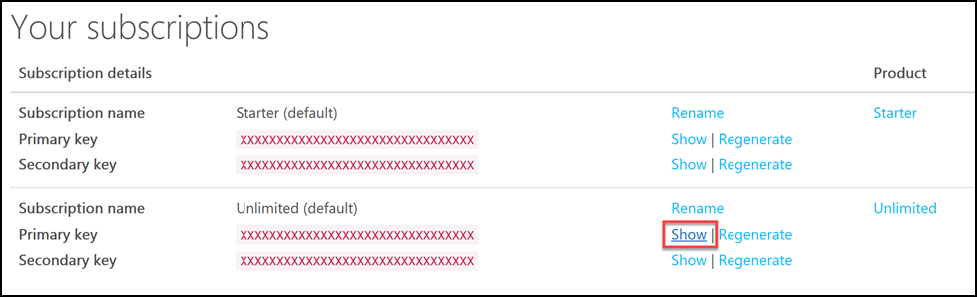
4. Save this key for next steps. 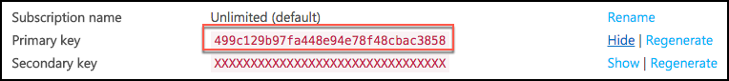
5. You now have API Management application key you will need to configure the Function App settings for order load test simulation.

#### Task 3: Configure the Function App with the API Management key

In this task, you will provide the API Management key in a setting for the Function App, so it can reach the Web API through the API Management service.

1. From the Azure Portal, browse to the Function App.
2. You will create an Application setting for the function to provide it with the API Management consumer key.
3. Select your Function App in the left-hand menu, then select Application settings under Configured features. 
4. Scroll down to the Application settings section, select +Add new setting, and enter contosoeventsapimgrkey into the name field, and paste the API key you copied from the Developer portal above into the value field. 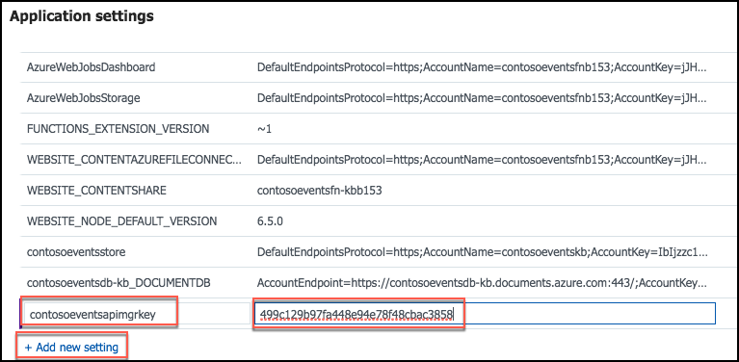
5. Scroll back to the top of the Application Settings tab, and select Save to apply the change. 
6. You will be able to issue a load test from the website in Exercise 8, and see that orders have been processed through the function – because it will have successfully called the API and you will see results in the load test status page.

## Exercise 5: Configure and publish the web application

Duration: 15 minutes

In this exercise, you will configure the website to communicate with the API Management service, deploy the application, and create an order.

#### Task 1: Configure the Web App settings

In this task, you will update configuration settings to communicate with the API Management service. You will be guided through the instructions to find the information necessary to populate the configuration settings.

1. Within Visual Studio Solution Explorer on your Lab VM, expand the Web folder, then expand the ContosoEvents.Web project, and open Web.config. You will update these appSettings in this file:

<add key="apimng:BaseUrl" value="" />

<add key="apimng:SubscriptionKey" value="" />

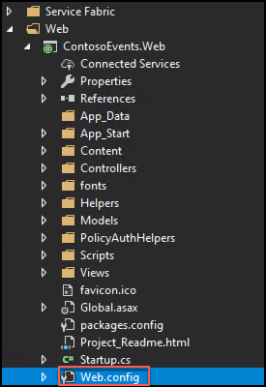

1. For the apimng:BaseUrl key, enter the base URL of the API you created in the API Management Publisher Portal (Exercise 5, Task 1, Step 7), such as <https://contosoeventsSUFFIX.azure-api.net/events/>.

**Note**: Make sure to include a trailing “/” or the exercise will not work.

1. For the apimng:SubscriptionKey key, enter the subscription key you revealed in API Management developer portal (Exercise 5, Task 2, Step 4).
2. Save Web.config. You should have values for two of the API Management app settings. 

#### Task 2: Running the web app and creating an order

In this task, you will test the web application calls to API Management by creating an order through the UI.

1. Using Solution Explorer in Visual Studio, expand the Web folder, then right-click the ContosoEvents.Web project, select Debug, and then Start new instance. 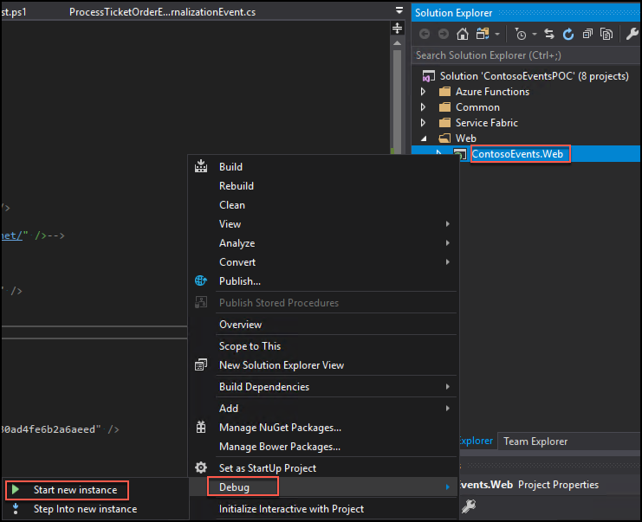
2. If prompted about whether you would like to trust the IIS Express SSL certificate, select Yes, then select Yes again at the Security Warning prompt. 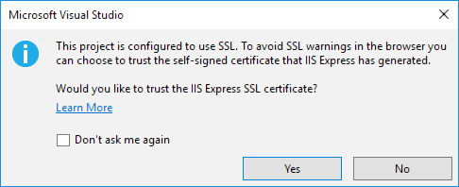
3. If you receive a warning in the browser that “Your connection is not private,” select Advanced.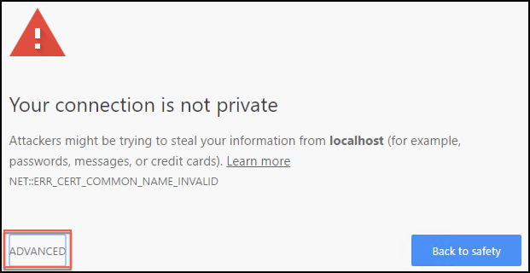
4. Under Advanced, select Proceed to localhost (unsafe). 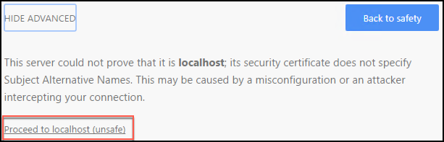
5. When the application launches you will see the website home page as shown in the following screen shot.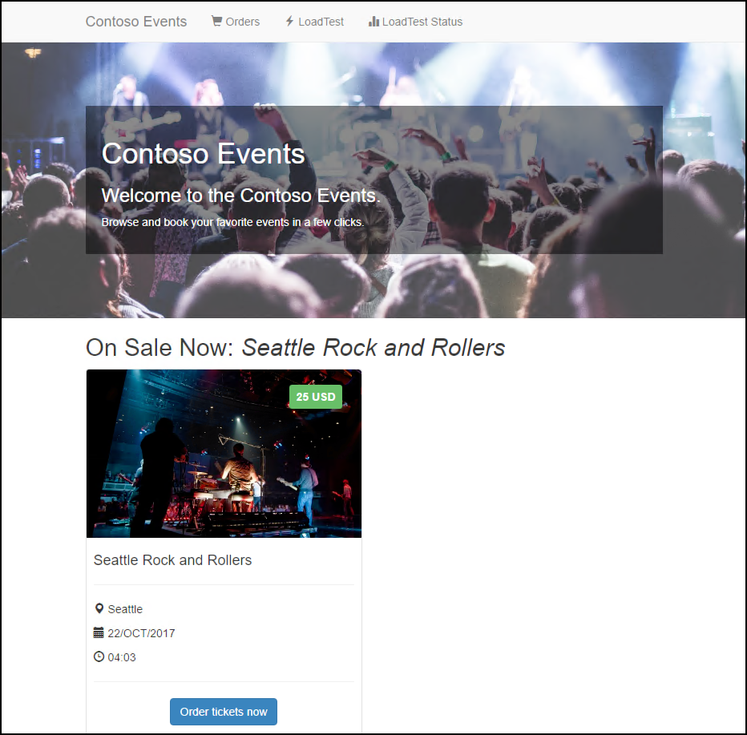
6. Note the event presented on the home page has an Order Tickets Now button. Click that to place an order.
7. Choose the number of tickets for the order, and then scroll down to see the billing fields. 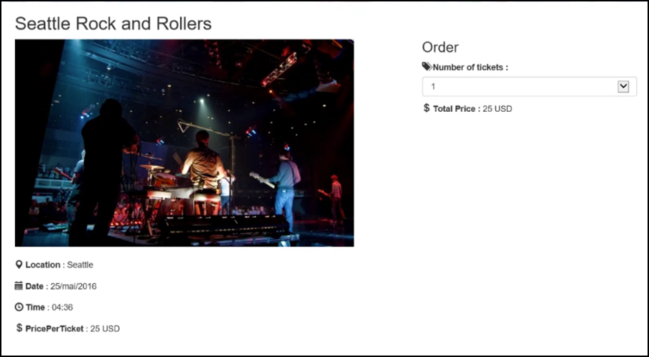
8. Since you have not yet integrated Azure Active Directory B2C, the application does not know who you are. You will have to enter the empty fields for your email, first name, last name, and Cardholder name. 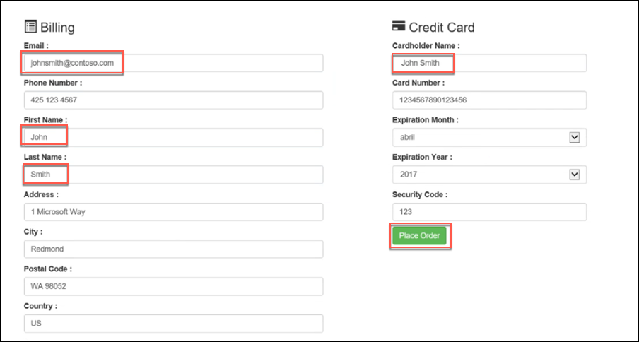
9. Select Place Order.
10. Once the order is queued for processing, you will be redirected to a results page as shown in the following screen shot. It should indicate Success and show you the order id that was queued as confirmation. 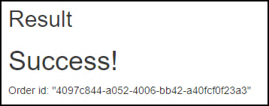
11. Close the web browser to stop debugging the application.

#### Task 3: Publish the web app

In this task, you will publish the web application to Azure.

1. From the Visual Studio Solution Explorer, right-click ContosoEvents.Web, and select Publish. 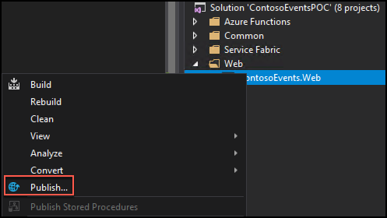
2. Select the Microsoft Azure App Service tile, choose Select Existing, then select Publish. 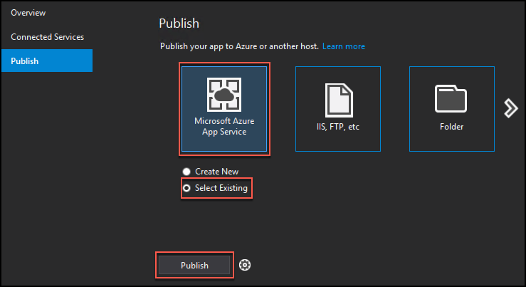
3. You may be prompted to log in to your Microsoft Account with access to the subscription where you created the resources for this hands-on lab. After logging in, you can select the subscription in the App Service screen.
4. From the list below, expand the Resource Group you created previously (hands-on-labs), and select the web app contosoeventsweb-SUFFIX. Select OK. 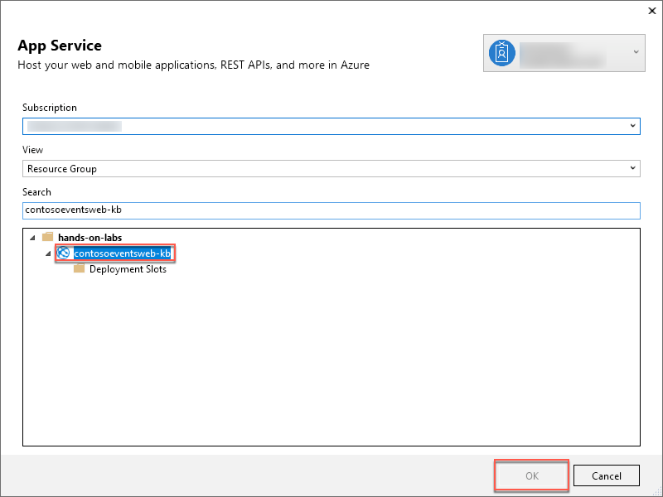
5. If the Publish does not start automatically, select Publish next to the Web Deploy publishing profile. 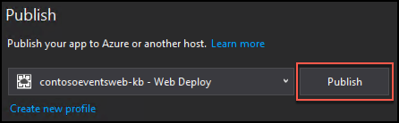
6. When publishing is complete, your browser will launch, and navigate to the deployed web app home page. You can optionally submit another order to validate functionality works as in Task 2.

## Exercise 6: Upgrading

Duration: 30 minutes

In this task, you will make changes to the code, and deploy an update to the application to enhance functionality. Specifically, the update addresses the area of concern related to changes in the ticket order model, and the impact on the system.

This task will illustrate the mechanism that Service Fabric provides for upgrading an application in production.

#### Task 1: How upgrade works

In Service Fabric, deployments can be either regular or upgrade. A regular deployment erases any previous deployment data while the upgrade deployment preserves it. There are advantages to upgrades:

* Stateful service data will not be lost during upgrade
* Availability remains during the upgrade

The following figure illustrates the deployment hierarchy:

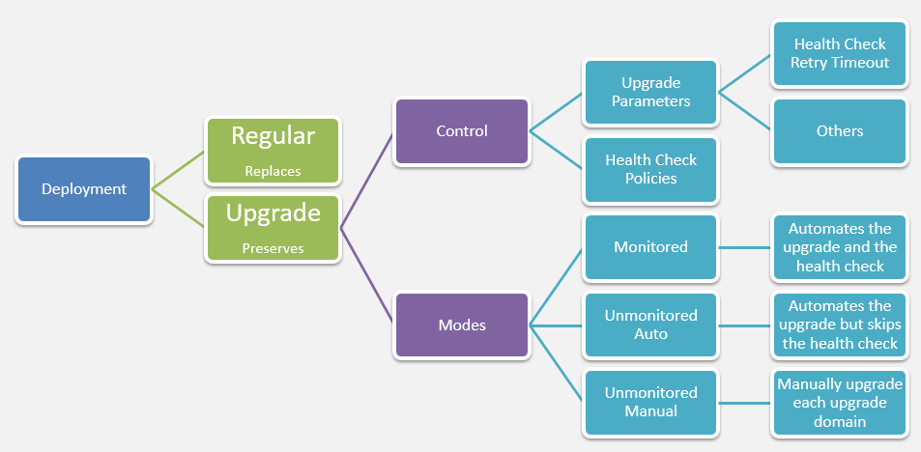

If you set the upgrade mode to Monitored, Service Fabric will be in full control of the upgrade process. There is a configurable time to wait after the upgrade has finished before Service Fabric evaluates the health of the application. This value defaults to 600 seconds.

#### Task 2: Update an actor state

Currently, the TicketOrderActor does not have a status property to make it easier to check on the actor order status quickly. In this task, you will modify the Ticket Order State model to add a new status property.

1. In Visual Studio on the Lab VM, open TicketOrder.cs in the ContosoEvents.Models project, under the Common folder.

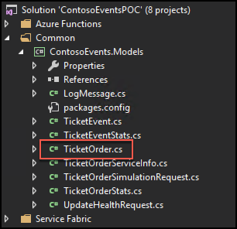

1. Edit the TicketOrder type to include a status field based on an Enum. Uncomment all TODO: Exercise 6 – Task 1 – there are two places as shown below:

//TODO: Exercise 6 - Task 1

[DataMember]

public OrderStatuses Status { get; set; }

and

//TODO: Exercise 6 - Task 1

public enum OrderStatuses

{

Fufilled,

TicketsExhausted,

CreditCardDenied,

Cancelled,

Invalid

}

1. Save TicketOrder.cs.
2. From Solution Explorer, open TicketOrderActor.cs in the ContosoEvents.TicketOrderActor project, under the Service Fabric folder.
3. Edit the TicketOrderActor to add the new order status. Uncomment all TODO: Exercise 6 – Task 1. The change will uncomment several lines that set the new Status field to one of the OrderStatuses enumeration values. Be sure to find all of the following comments (there are 6 total):

//TODO: Exercise 6 - Task 1

state.Status = OrderStatuses.Invalid;

//TODO: Exercise 6 - Task 1

state.Status = OrderStatuses.Fufilled;

//TODO: Exercise 6 - Task 1

state.Status = OrderStatuses.CreditCardDenied;

//TODO: Exercise 6 - Task 1

state.Status = OrderStatuses.TicketsExhausted;

//TODO: Exercise 6 - Task 1

state.Status = OrderStatuses.Invalid;

//TODO: Exercise 6 - Task 1

state.Status = OrderStatuses.Cancelled;

1. Save TicketOrderActor.cs.
2. After adding this field, the actor will now save it with each ticket order.
3. After making this change, rebuild the solution (Build menu, Rebuild solution), and verify that there are no errors.

#### Task 3: Perform a smooth upgrade

In this task, you will configure settings for the Service Fabric application to perform an upgrade.

1. From the Visual Studio Solution Explorer, expand the Service Fabric folder, then right-click ContosoEventsApp, and select Publish.
2. In the Public Service Fabric Application dialog, select PublishProfiles\Cloud.xml for the target profile, and check Upgrade the Application. 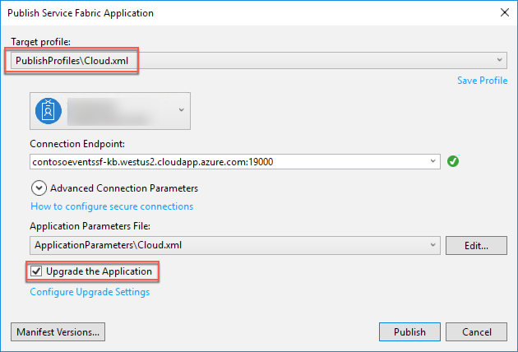
3. Select Configure Upgrade Settings, under Upgrade the Application. Select Monitored for the upgrade mode, then select OK.

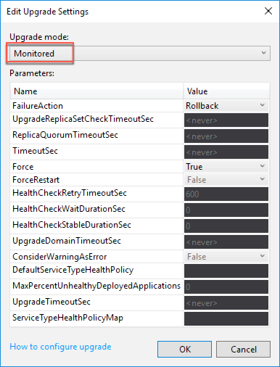

1. From the Publish Service Fabric Application dialog, select Manifest Versions.
2. Change the TicketOrderActorPkg\Code New Version to 1.1.0. This change will force the actor package and the app to change to 1.1.0 as well.

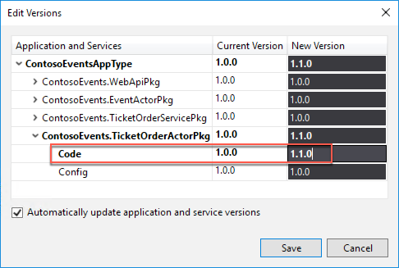

1. Select Save.
2. Now that the upgrade configuration is set, select Publish.
3. Observe the Visual Studio Output window going through the upgrade process, which can take 5 minutes or more.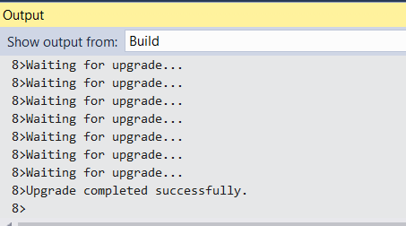
4. Navigate to the Service Fabric Explorer for the deployment using your URL, something like: <http://contosoeventssf-SUFFIX.eastus.cloudapp.azure.com:19080/Explorer/index.html>. You can retrieve this from the Azure portal, by navigating to your Service Fabric cluster’s blade by selecting the Explorer button on the toolbar, or selecting the Service Fabric Explorer link in the Essentials area. 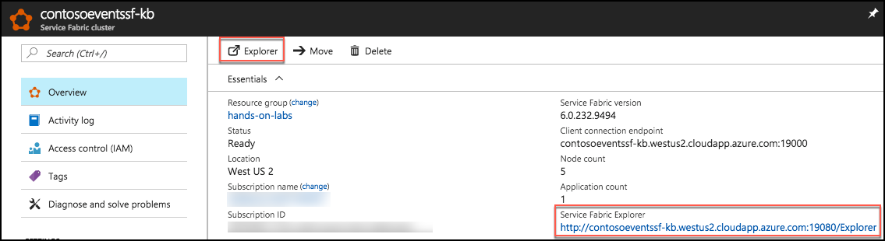
5. It will show the app being upgraded one upgrade domain at a time.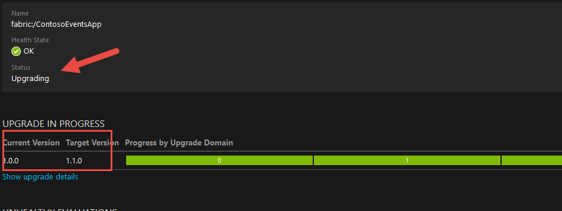
6. When the upgrade is complete, from Service Fabric Explorer observe the new application version number.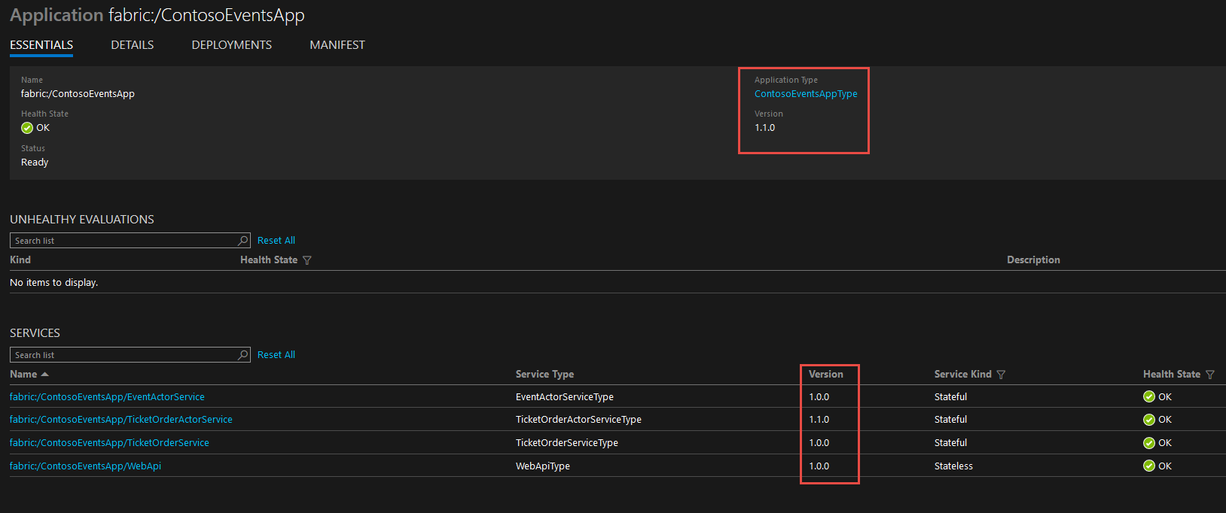

#### Task 4: Submit a new order

Now that the upgrade is completed successfully, you will submit a new order, and make sure that the newly submitted order has the extended state.

1. This time, you will post an order using the Web API for the deployed service. The order can be something like this:

{

"userName": "testupgrade",

"email": "test.upgrade@gmail.com",

"eventId": "EVENT1-ID-00001",

"paymentProcessorTokenId": "ggashwh565-uiewuu87-ujdsk",

"tickets": 3

}

1. Access the Swagger UI for your published Service Fabric Web API at a URL that looks like this: <http://contosoeventssf-SUFFIX.eastus.cloudapp.azure.com:8082/swagger/ui/index>
2. Access the Orders API and select the POST method for the /api/orders endpoint. From there you can submit a new order using the JSON above. 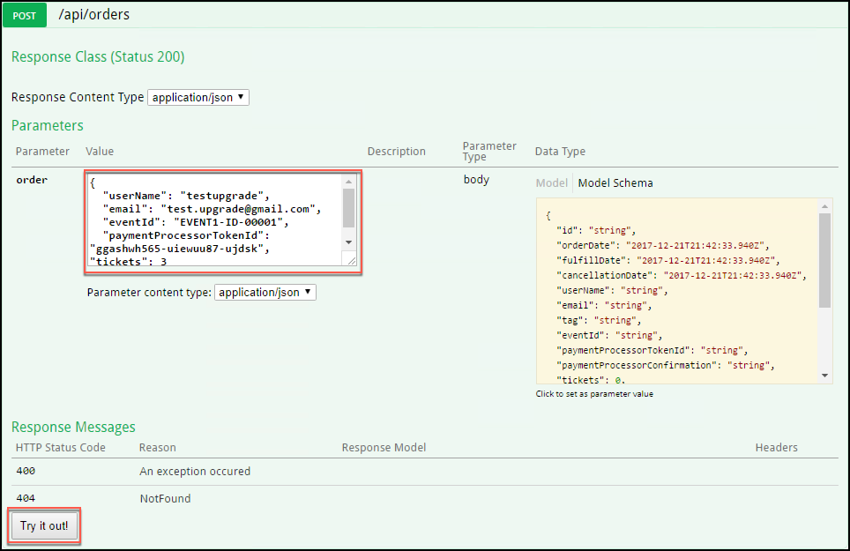
3. Once you get back a 200 response code, the order id will be returned in the Response Body. 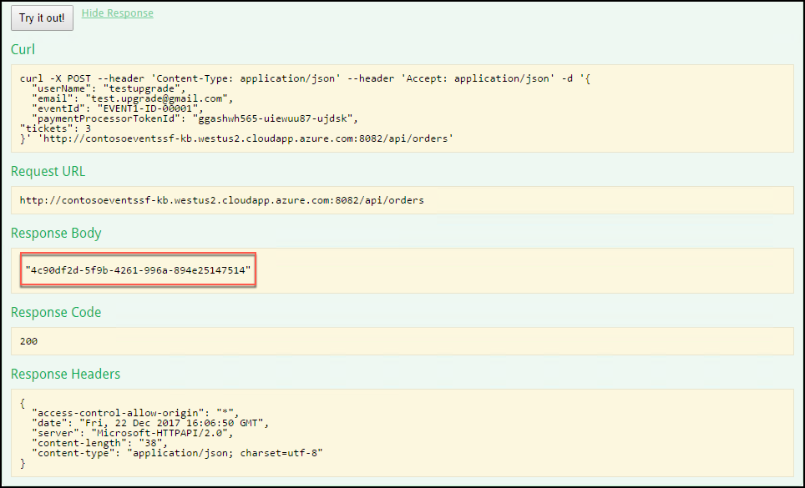
4. In the Azure portal, navigate to your Cosmos DB account.
5. Go to Cosmos DB Data Explorer, and query for the order id to see the new extended state actually persisted to the database, as you did in Exercise 3, Task 6, Steps 7-9. 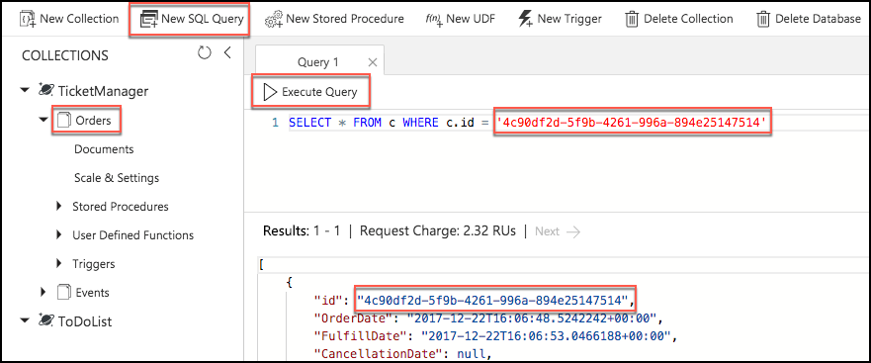

## Exercise 7: Rollback

Duration: 30 minutes

In this exercise, you will deploy an update that causes issues with the application, and will trigger an automatic rollback of the deployment. This exercise will illustrate the mechanism Service Fabric provides for preserving application health and availability in production.

#### Task 1: Add health checks

In this task, you will add code to produce health checks that force the monitored upgrade to roll back to the original version of the service.

1. In Visual Studio, open TicketOrderService.cs located in the ContosoEvents.TicketOrderService project in the Service Fabric folder.
2. Locate TODO: Exercise 7 – Task 1 and uncomment:

//TODO: Exercise 7 - Task 1

this.HealthReporterService.SendReportForService(HealthState.Error, "Simulated Error");

1. Compile the code to ensure there are no issues with the changes.

#### Task 2: Perform a troubled upgrade

In this task, you will perform an upgrade, and watch a rollback of the upgrade.

1. From Solution Explorer in Visual Studio the ContosoEventsApp project, under the Service Fabric folder, and select Publish.
2. From the Publish Service Fabric Application dialog, check Upgrade the Application, and click Manifest Versions.
3. Change the TicketOrderServicePkg\code New Version to 1.1.0. This will also require that the service package be changed to 1.1.0 and the application to 1.2.0.
4. Select Save.

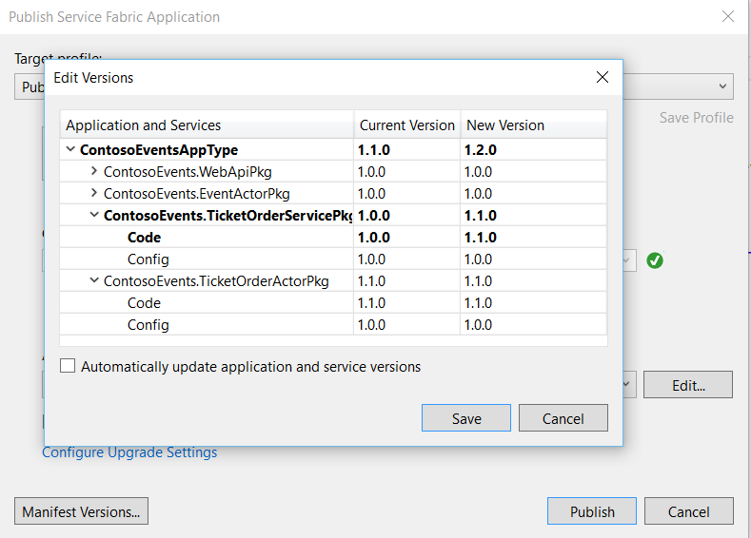

1. Select Publish, and return to Service Fabric Explorer.
2. Observe the time it is taking to upgrade in Visual Studio and the errors that are now occurring in Service Fabric Explorer.
3. Notice that the simulated error message ‘Simulated error’ appears in the event as shown in the following screen shot: 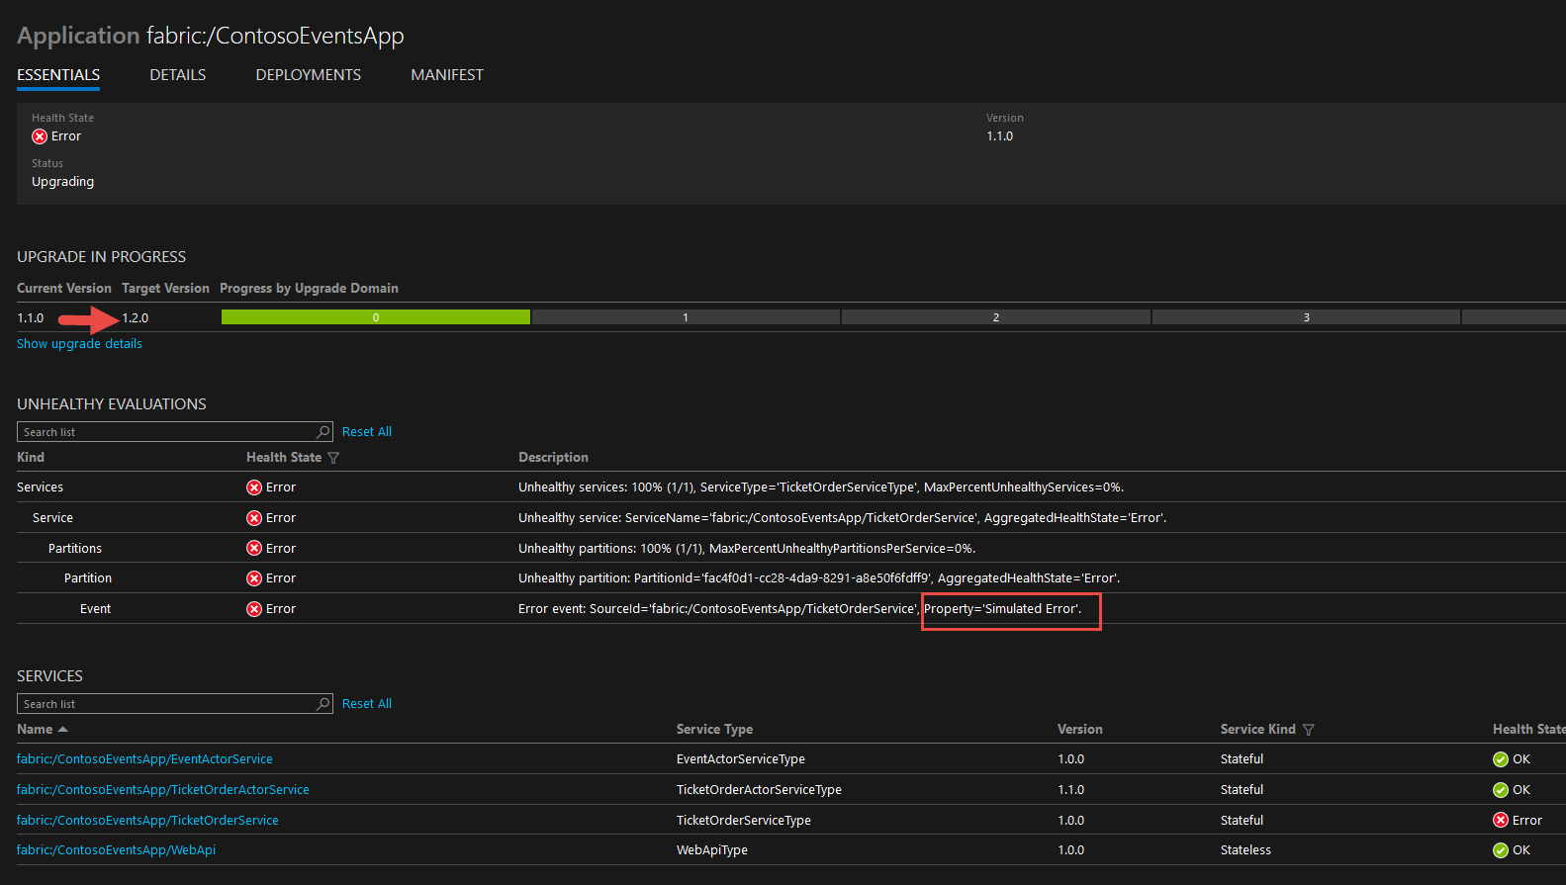

**Note**: Service Fabric is attempting to upgrade, and it is waiting for the service to report healthy status. Because this will not happen, eventually Service Fabric rolls back the upgrade.

1. In the meantime, observe that the application is still responsive. In the Swagger UI for your Service Fabric Web API, access the Events API and select GET /api/events to see a list of events as shown in the following screen shot: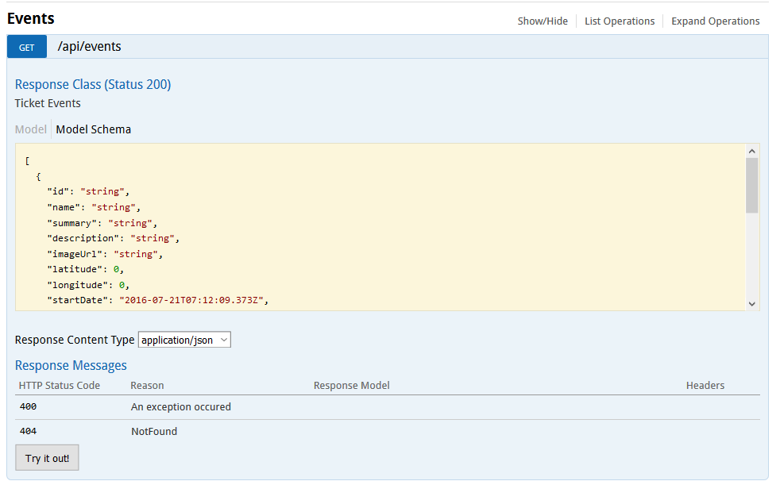
2. So that you do not forget, return to the code and re-comment the failure report so that you can do the next exercise without rollback!

//TODO: Exercise 7 - Task 1

//this.HealthReporterService.SendReportForService(HealthState.Error, "Simulated Error");

1. Look at the Visual Studio output window and note that after some time (600 seconds by default, and this is configurable) Service Fabric gives up on the app and rolls back the upgrade as shown in the following screen shot: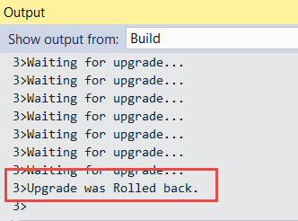
2. Return to Service Fabric Explorer note that version 1.2.0 (that contained the simulated error) was rolled back to version 1.1.0 the version that was running in your cluster before the attempted upgrade.
3. Also, note that the error remains until it is time to live expires or it is replaced by another health state. Until then, the unhealthy state will remain in the cluster, but the cluster will be running normally. You can proceed without clearing this for now.
4. The subsequent exercises (i.e. 8 and beyond) will be executed using version 1.1.0 and while the cluster shows unhealthy state. You can ignore this for now.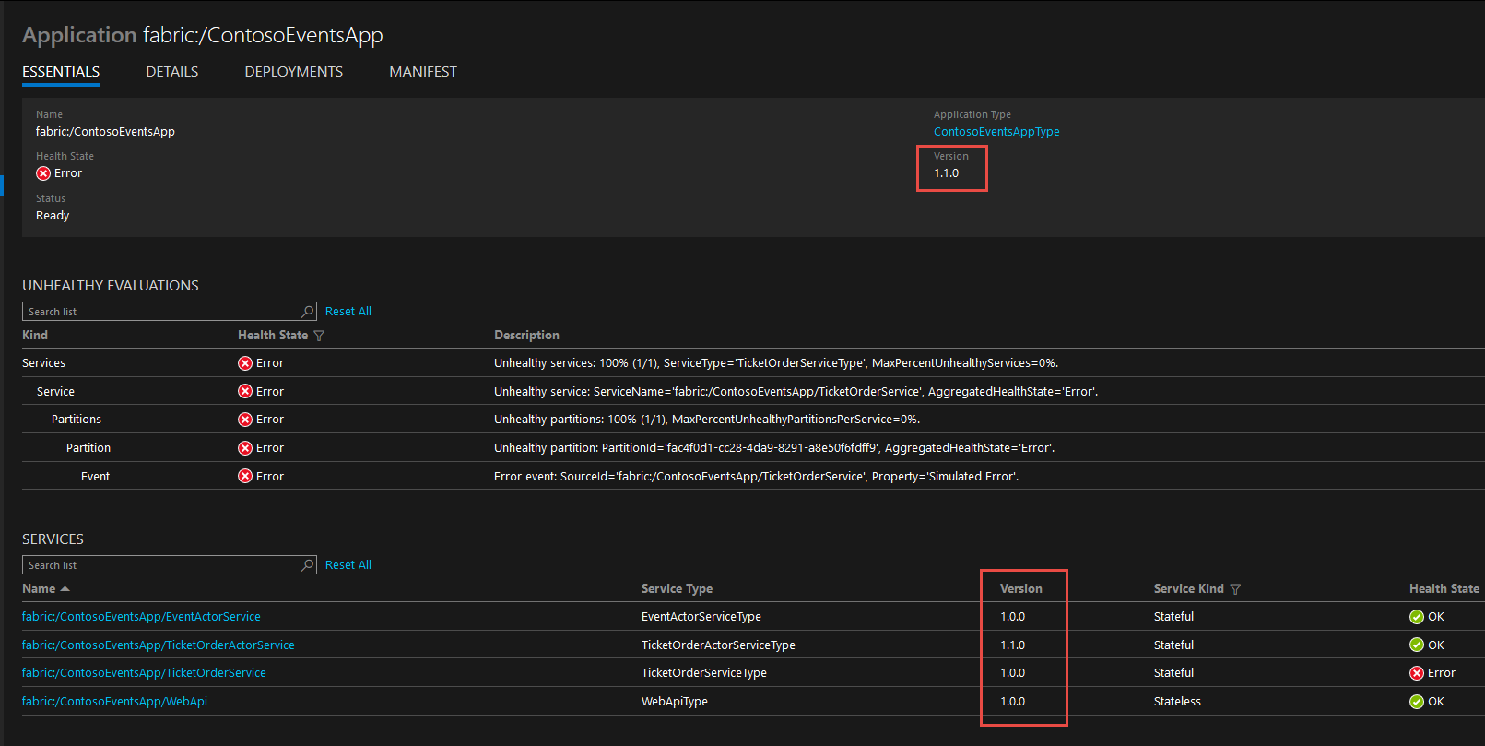
5. Optionally, from the Swagger endpoint for the deployed application, you can request health statistics at the following relative URL: /api/admin/applicationhealth.

## Exercise 8: Load testing

Duration: 15 minutes

In this exercise, you will perform a load test against the Service Fabric Cluster and observe how messages are distributed across partitions.

#### Task 1: Simulate a 50-order request

In this task, you will simulate a load test of 50 orders against the cluster using the Web application to submit the load test and monitor partitions.

1. Navigate to the published Web application at a URL like <https://contosoeventsweb-SUFFIX.azurewebsites.net>.
2. Click the Load Test menu. Optionally give a new name to the tag for tracking. Set load to 50 requests. Click Start Load Test.

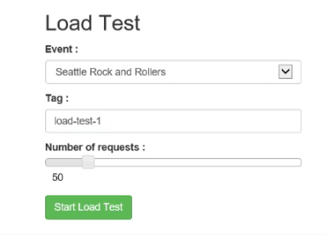

1. Navigate to the Load Test Status menu. It shows you the partitions that were created for the ticket order service (reliable queue). 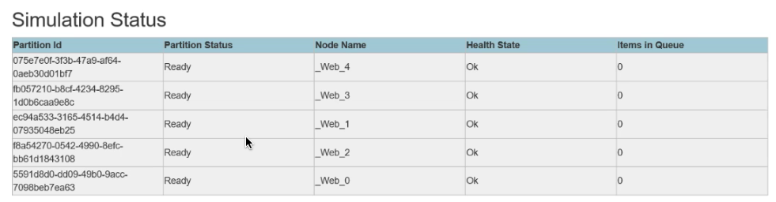
2. While the load test is running, refresh this page and watch the changes to the Items in queue across partitions. It will fill while processing completes and then eventually drain.
3. After a few minutes you will see that the queues are drained, and the orders were processed.

**Note**: If you still have more time, run this again with additional iterations progressively such as 100, 150, 200, 250. Or, take a look at Exercise 9 which takes you through a much more comprehensive load test and partition analysis process using the API endpoint.

## BONUS Exercise 9: Load testing w/ partitions

**Note**: If you completed the other work in good time and still have another 50 minutes free, have some load testing and partitioning fun! Otherwise, skip to After the hands-on lab.

Duration: 50 minutes

In this task, you will perform several load tests against the Cluster using different partitions. This experimentation is crucial to get an idea of how many partitions you will really need. It is important to note that the number of partitions in your service cannot be changed after you have created the service. The main measure you are going to rely on is the average number of seconds it takes an order to be processed.

#### Task 1: Setting up for load testing

In this task, you will clean the existing orders from the Cosmos DB, so you can start with clean slate. This step is optional but because we are going to rely on reporting about orders in the database, it is much better to keep in the database only the orders that were simulated for load testing.

1. In the Swagger UI for your Service Fabric Web API, please access the admin APIs DELETE /api/admin/orders and issue the API. When you get back a 200-response code, the orders will have been deleted from the Cosmos DB.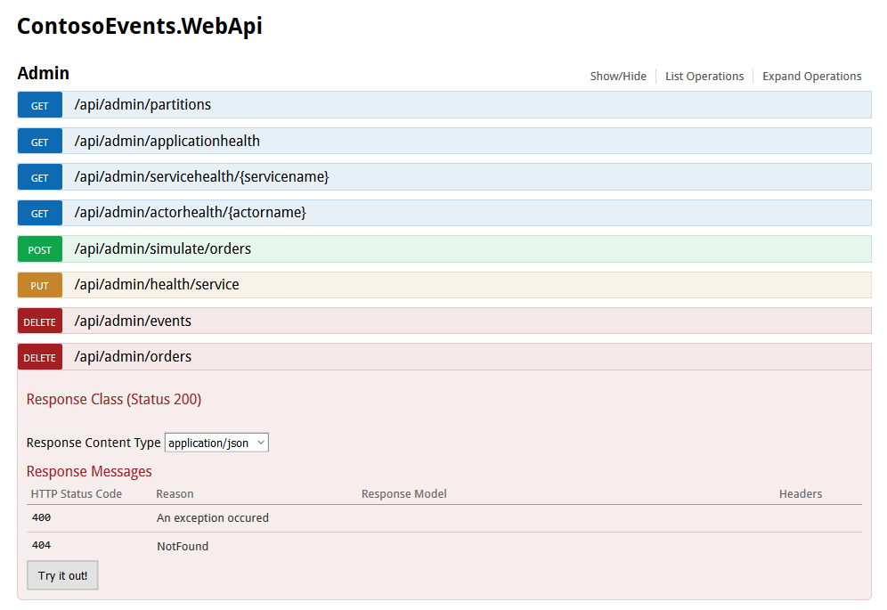
2. Because you have previously performed an upgrade to the Service Fabric application, and we want to play with partition sizes in this exercise, you will unprovision the application type using Service Fabric Explorer. Navigate to the explorer.
3. Delete the application.

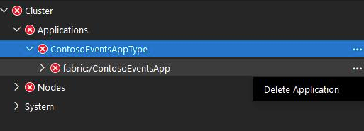

1. Unprovision the application type.

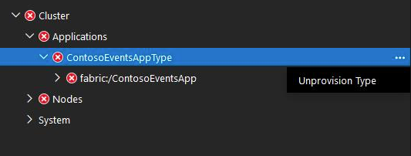

1. In the tasks that follow in this exercise you will not be upgrading when you publish the application. You will be re-publishing. Make sure Upgrade the application checkbox is unchecked each time you publish.

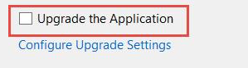

1. Service Fabric Explorer shows no application types or applications deployed.
2. You can verify from Cosmos DB Orders Document Explorer that there are no more orders in the database: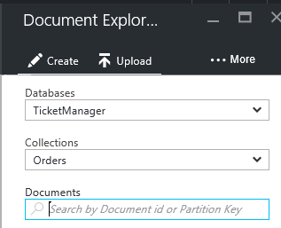

#### Task 2: Using the current partition count, simulate 100 orders

In this task, you will simulate a load test against the Cluster using the current partition count (that is, 5) of the Ticket Order Service.

1. Using the Service Fabric Web API Swagger UI, please issue a POST request against /api/admin/simulate/orders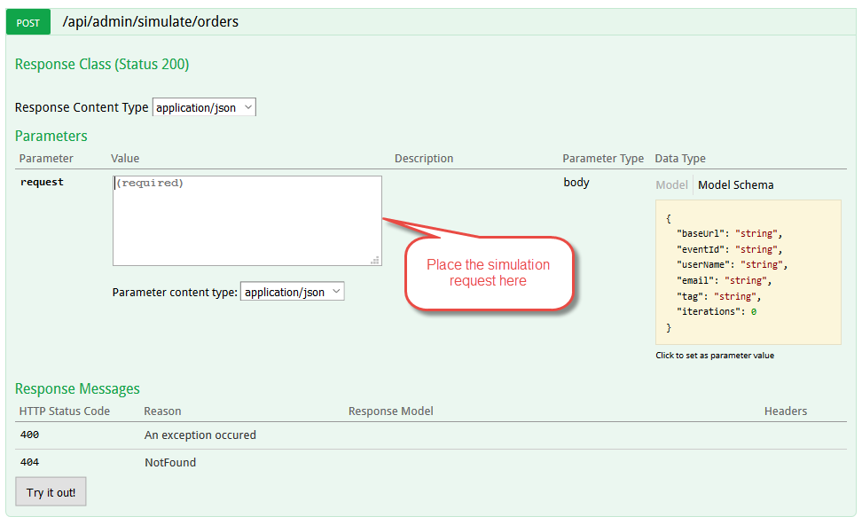
2. A sample simulation order request can be formed as follows. The tag identifies the simulation run so we can report on it later. Be sure to replace the values in the baseUrl property:

{

"baseUrl": "http://<your-cluster-name>.<your-region>.cloudapp.azure.com:8082",

"eventId": "EVENT1-ID-00001",

"userName": "tester",

"email": "load.tester@gmail.com",

"tag": "partitions-5-100",

"iterations": 100

}

1. As the simulation request is processed, please issue a GET request against /api/admin/partitions to see how the different partitions are functioning. This returns partition info, health, and the number of items in each partition queue. You should notice that the queues fill up with order requests and are drained.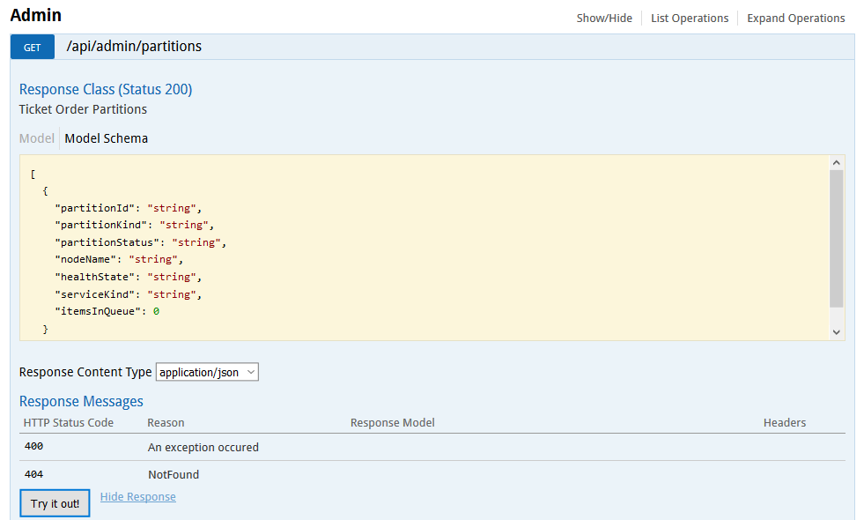
2. The response might look like this.

[

{

"partitionId": "856b5048-bb35-45fb-b804-f91f4fb48ccf",

"partitionKind": "Int64Range",

"partitionStatus": "Ready",

"nodeName": "_Node_4",

"healthState": "Ok",

"serviceKind": "Stateful",

"itemsInQueue": 10

},

{

"partitionId": "f912eb50-bf89-4be9-8d39-61dfc3b69a01",

"partitionKind": "Int64Range",

"partitionStatus": "Ready",

"nodeName": "_Node_3",

"healthState": "Ok",

"serviceKind": "Stateful",

"itemsInQueue": 8

},

{

"partitionId": "acefa86e-c57c-4a84-b6cb-230d6c8a9e23",

"partitionKind": "Int64Range",

"partitionStatus": "Ready",

"nodeName": "_Node_2",

"healthState": "Ok",

"serviceKind": "Stateful",

"itemsInQueue": 6

},

{

"partitionId": "2c6c7dd9-8ff4-4303-bd1f-fb48ed51952d",

"partitionKind": "Int64Range",

"partitionStatus": "Ready",

"nodeName": "_Node_1",

"healthState": "Ok",

"serviceKind": "Stateful",

"itemsInQueue": 6

},

{

"partitionId": "1da411e7-577f-4440-a3ab-257962051b0c",

"partitionKind": "Int64Range",

"partitionStatus": "Ready",

"nodeName": "_Node_0",

"healthState": "Ok",

"serviceKind": "Stateful",

"itemsInQueue": 0

}

]

1. Wait for 2-3 minutes to make sure that queues are drained and that orders are processed before completing this task.

#### Task 3: Using a partition count of 10, simulate 100 orders

In this task, you will repeat the same load test you performed in Task 2 but using a partition count of 10.

1. Change the service and actor partition count to 10 in the Cloud.xml Application Parameters file.
2. Double-click the document in Visual Studio and make the following changes:

<Parameter Name="TicketOrderService_PartitionCount" Value="10" />

<Parameter Name="TicketOrderService_MinReplicaSetSize" Value="3" />

<Parameter Name="TicketOrderService_TargetReplicaSetSize" Value="3" />

<Parameter Name="WebApi_InstanceCount" Value="5" />

<Parameter Name="TicketOrderActorService_PartitionCount" Value="10" />

<Parameter Name="EventActorService_PartitionCount" Value="1" />

1. Using Visual Studio Publish command, redeploy the app to the cluster (as shown in a previous task).
2. Repeat the same test load you did in Task 2 but with a different tag:

{

"baseUrl": "http://<your-cluster-name>.<your-region>.cloudapp.azure.com:8082",

"eventId": "EVENT1-ID-00001",

"userName": "tester",

"email": "load.tester@gmail.com",

"tag": "partitions-10-100",

"iterations": 100

}

1. Wait for 2-3 minutes until to make sure that queues are drained and that orders are processed before completing this task.

#### Task 4: Using a partition count of 15, simulate 100 orders

In this task, you will repeat the same load test you performed in Task 2 but using a partition count of 15.

1. Change the service and actor partition count to 15 in the Cloud.xml Application Parameters file.
2. Double-click the document in Visual Studio and make the following changes:

<Parameter Name="TicketOrderService_PartitionCount" Value="15" />

<Parameter Name="TicketOrderService_MinReplicaSetSize" Value="3" />

<Parameter Name="TicketOrderService_TargetReplicaSetSize" Value="3" />

<Parameter Name="WebApi_InstanceCount" Value="5" />

<Parameter Name="TicketOrderActorService_PartitionCount" Value="15" />

<Parameter Name="EventActorService_PartitionCount" Value="1" />

1. Using the Visual Studio Publish command, redeploy the app to the cluster (as shown in a previous task).
2. Repeat the same test load you did in Task 2 but with a different tag:

{

"baseUrl": "http://<your-cluster-name>.<your-region>.cloudapp.azure.com:8082",

"eventId": "EVENT1-ID-00001",

"userName": "tester",

"email": "load.tester@gmail.com",

"tag": "partitions-15-100",

"iterations": 100

}

1. Wait for 2-3 minutes until to make sure that queues are drained and that orders are processed before completing this task.

#### Task 5: Using a partition count of 20, simulate 100 orders

In this task, you will repeat the same load test you performed in Task 2 but using a partition count of 20.

1. Change the service and actor partition count to 20 in the Cloud.xml Application Parameters file.
2. Double-click the document in Visual Studio and make the following changes:

<Parameter Name="TicketOrderService_PartitionCount" Value="20" />

<Parameter Name="TicketOrderService_MinReplicaSetSize" Value="3" />

<Parameter Name="TicketOrderService_TargetReplicaSetSize" Value="3" />

<Parameter Name="WebApi_InstanceCount" Value="5" />

<Parameter Name="TicketOrderActorService_PartitionCount" Value="20" />

<Parameter Name="EventActorService_PartitionCount" Value="1" />

1. Using Visual Studio Publish command, redeploy the app to the cluster (as shown in a previous task).
2. Repeat the same test load you did in Task 2 but with a different tag:

{

"baseUrl": "http://<your-cluster-name>.<your-region>.cloudapp.azure.com:8082",

"eventId": "EVENT1-ID-00001",

"userName": "tester",

"email": "load.tester@gmail.com",

"tag": "partitions-20-100",

"iterations": 100

}

1. Wait for 2-3 minutes until to make sure that queues are drained and that orders are processed before completing this task.

#### Task 6: Determine the performance variations among the different load tests

In this task, you will find out how each load test performed and plot the result.

1. Using the Service Fabric Web API Swagger UI, please issue a GET request against /api/orders/stats. 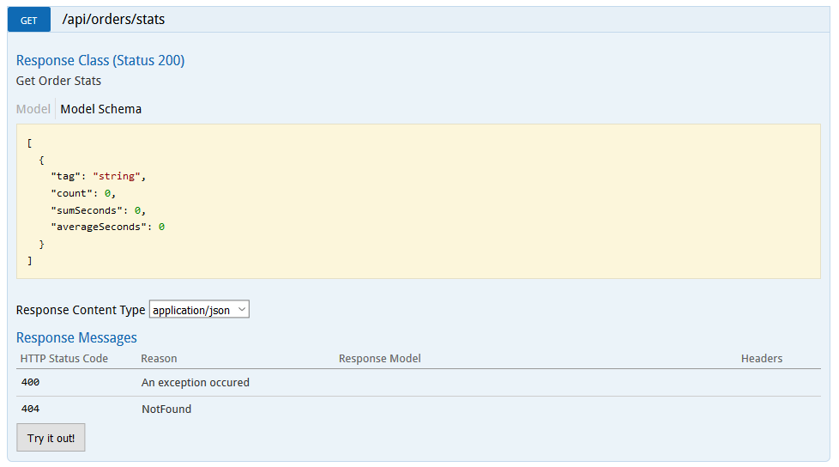
2. The command returns stats about each load test you performed in JSON that looks like this:

[

{

"tag": "partitions-5-100",

"count": 100,

"sumSeconds": 879.2576443999999,

"averageSeconds": 8.792576443999998

},

{

"tag": "partitions-10-100",

"count": 100,

"sumSeconds": 340.0996231000001,

"averageSeconds": 3.400996231000001

},

{

"tag": "partitions-15-100",

"count": 100,

"sumSeconds": 162.2106096,

"averageSeconds": 1.622106096

},

{

"tag": "partitions-20-100",

"count": 100,

"sumSeconds": 165.14757820000003,

"averageSeconds": 1.6514757820000003

}

]

1. Scale out the VMs count to 10, for example, in your cluster and repeat tasks 2, 3, 4, and 5. This step is out of scope and is shown here only to complete the picture.
2. Given the load test results for each Cluster configuration, produce an Excel sheet from the data you collected. A sample may look like this: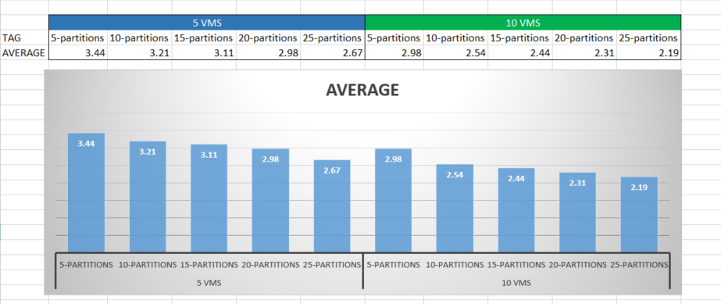
3. Armed with an average number of seconds it takes to process orders for different partition and VMs count, you are in a better situation to recommend a partition count for your application.

## BONUS Exercise 10: Secure the web application

If you completed the other work in good time and still have another 30 minutes, do this exercise and integrate Azure Active Directory B2C with the application. Otherwise, skip to After the hands-on lab.

Duration: 30 minutes

In this exercise, you will configure the Azure Active Directory B2C tenant and configure the Web front end to integrate with it for user login. Once all the settings are in place, you will be able to run the website, register as a user, and login.

#### Task 1: Configure the Azure Active Directory B2C

In this task, you will set up the Azure Active Directory B2C directory for your application to integrate with it.

1. From the Azure Portal browse to Azure B2C. Select it to navigate to the Azure AD B2C Settings blade. 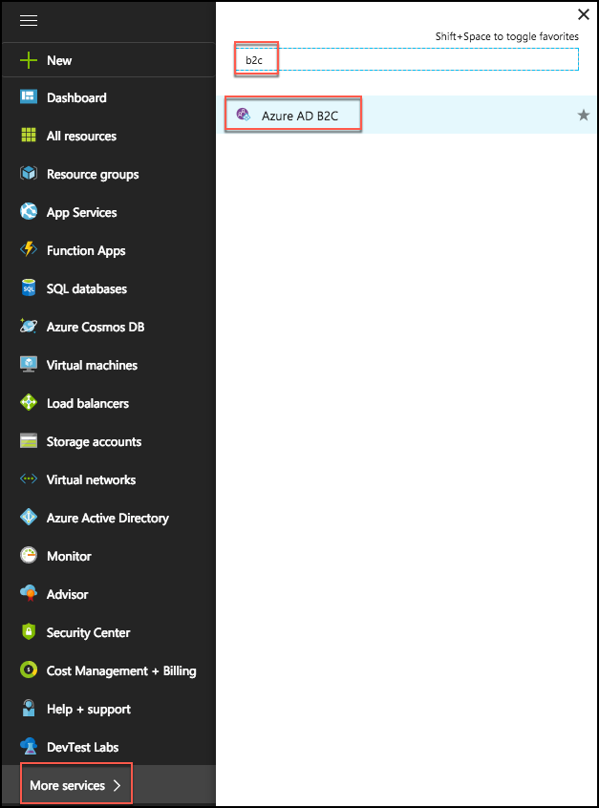
2. You should see the domain name you created earlier for your B2C directory.

**Note**: If you see an authorization error, you may have to select the directory from your profile menu and then repeat steps 1 and 2. Further, if your directory does not yet appear in the profile list, you should refresh the portal page to see it in the list.

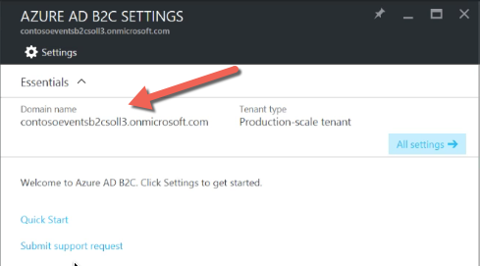

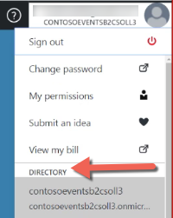

1. From the Settings blade, select Applications.

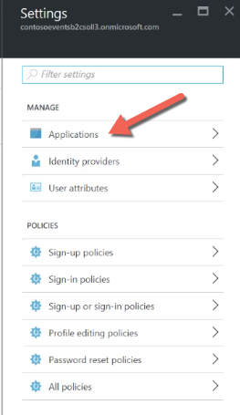

1. Click +Add.
2. Set the application name to WebApp.
3. Select Yes for include Web App / Web API.
4. Select Yes for Allow implicit flow.
5. Add a reply URL for local testing: <https://localhost:44327/>
6. Add a reply URL for the hosted Web App as you named it, for example: https://contosoeventsweb-SUFFIX.azurewebsites.net/

**Note**: Make sure to include the closing / or the configuration will not work.

1. Click Create.

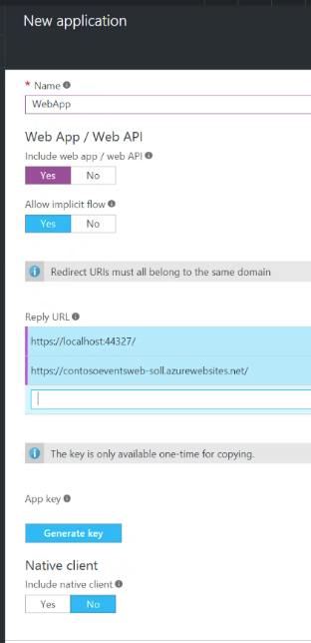

1. In the Settings blade, select Identity providers.
2. Select Username for Local accounts.
3. Click Save.

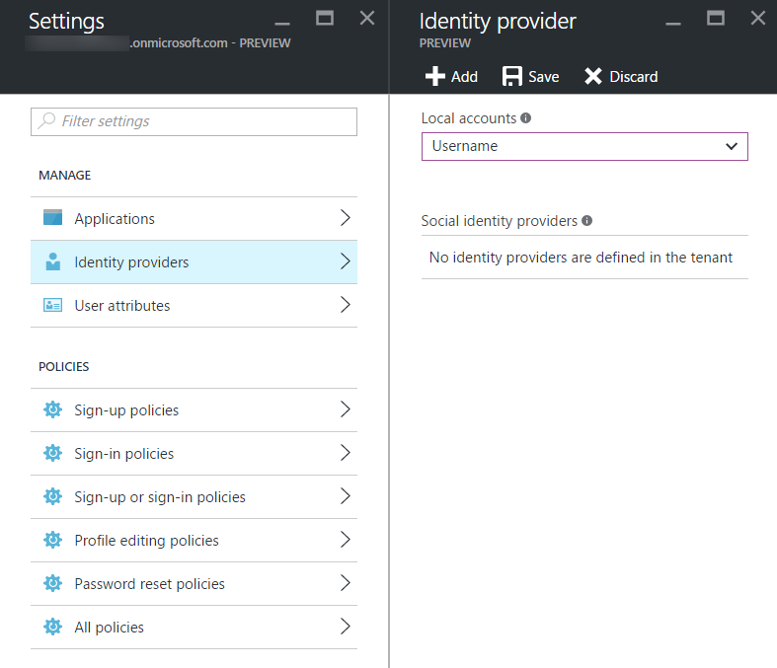

1. In the Settings blade, select Sign-up policies.
2. Click + Add.
3. Set the policy name to ‘signup’.

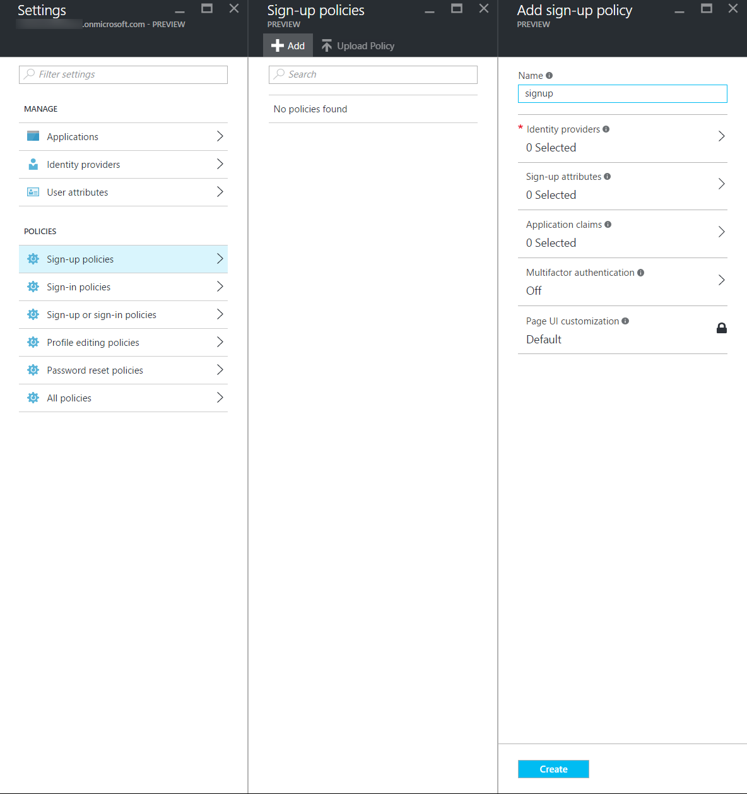

1. Select Identity providers.
2. Select User ID signup.
3. Click OK.

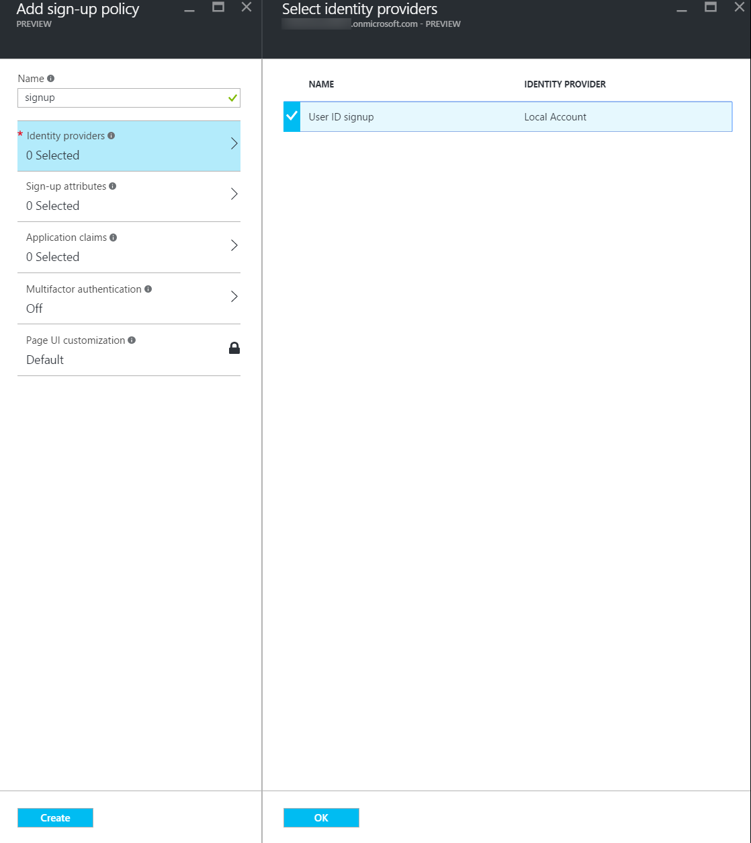

1. Select Sign-up attributes.
2. Select Email Address, Given Name, and Surname.
3. Click OK.

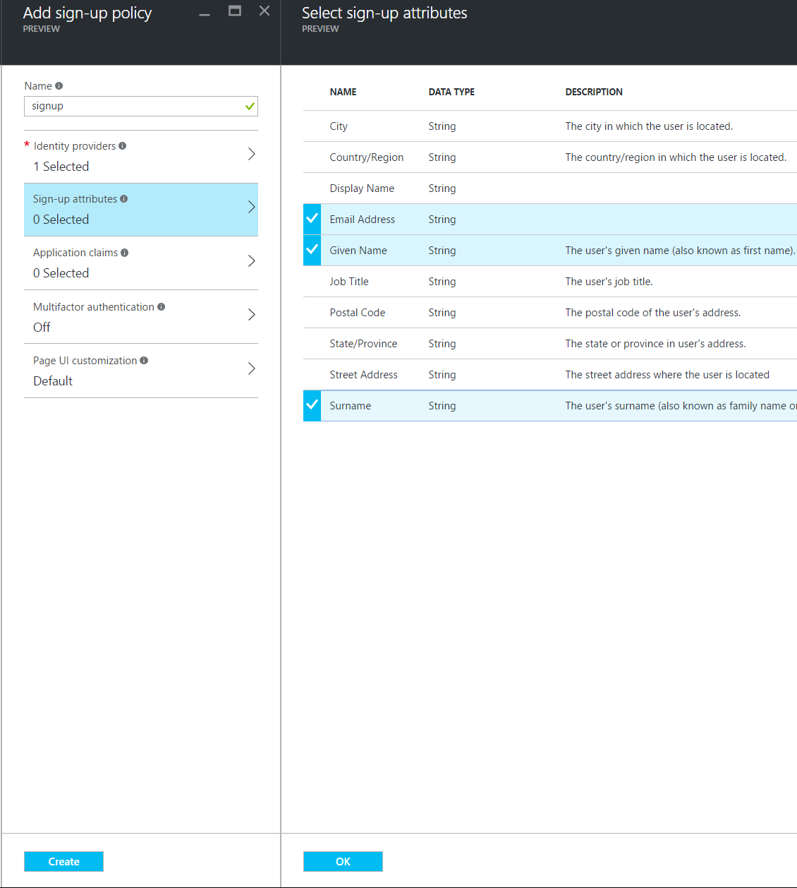

1. Select Application Claims.
2. Select Email Addresses, Given Name, Surname, and User’s Object ID.
3. Click OK.

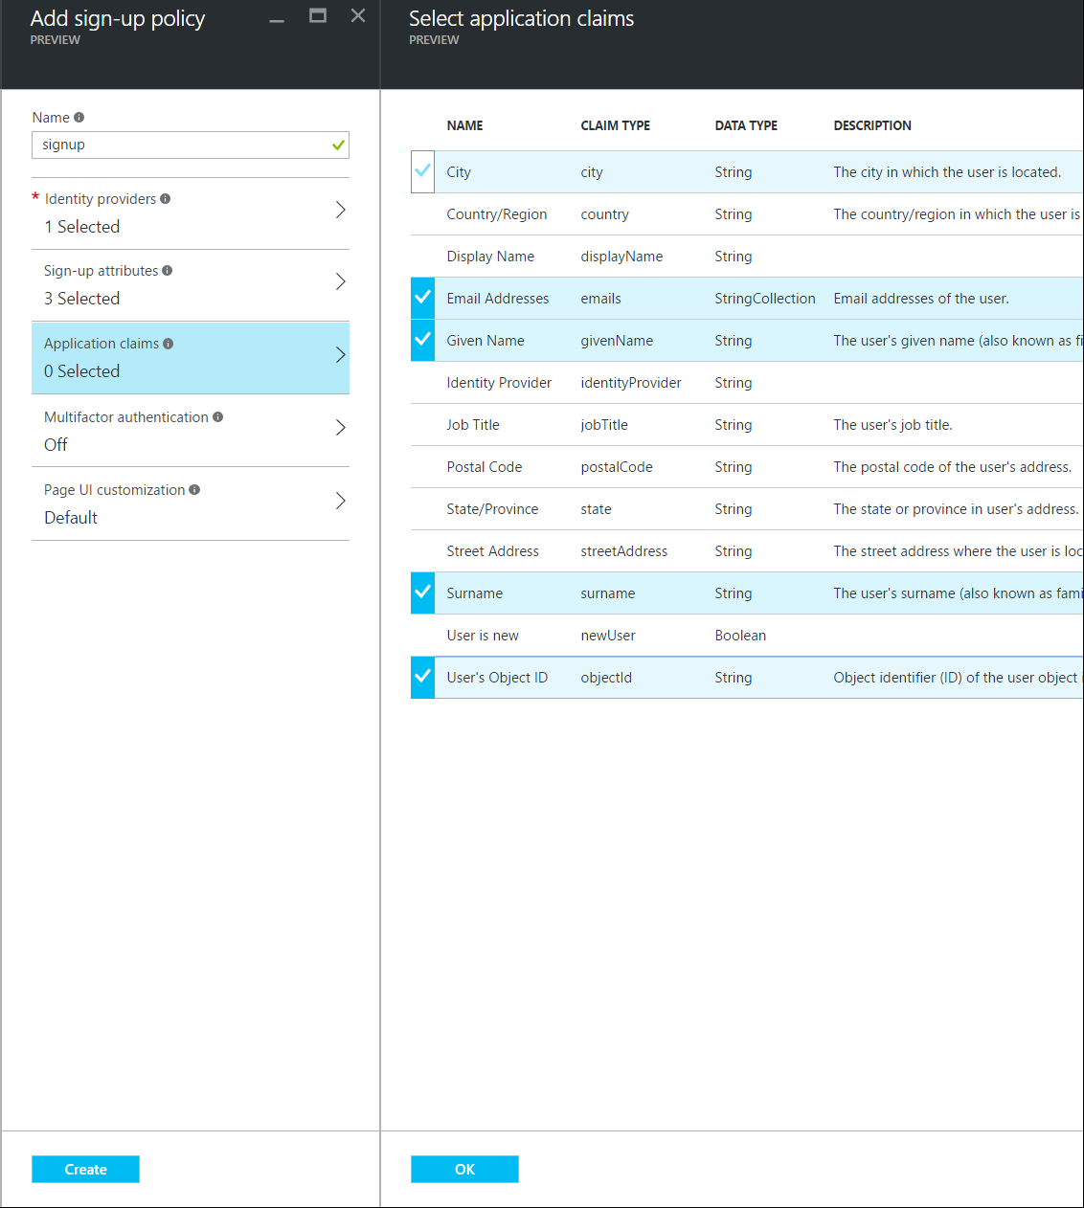

1. Select Token, session & SSO config.
2. Select acr under Claim representing policy ID.
3. Click OK.  
   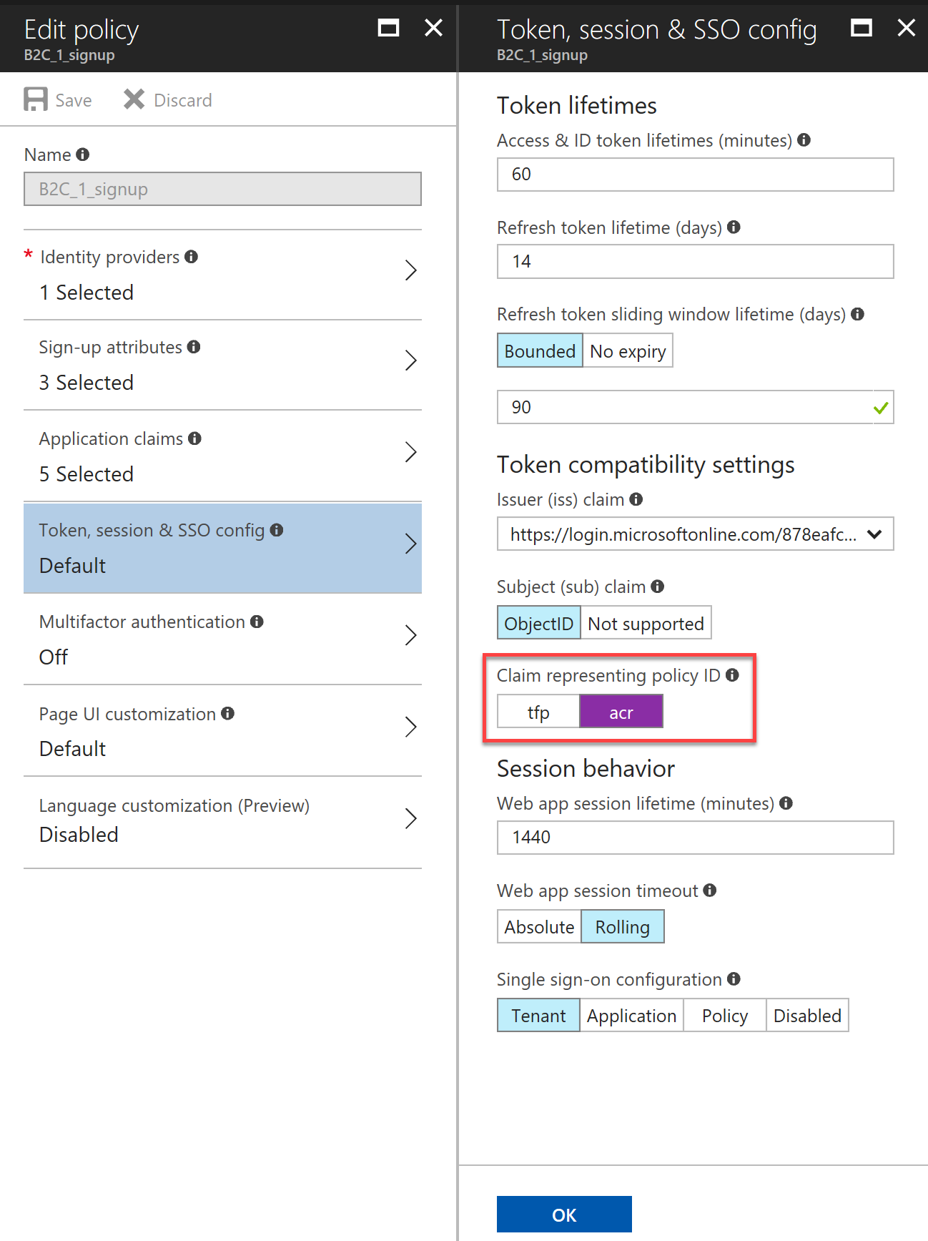
4. Click Create.
5. In the Settings blade, select Sign-in policies.
6. Click + Add.
7. Set the policy name to ‘signin’.

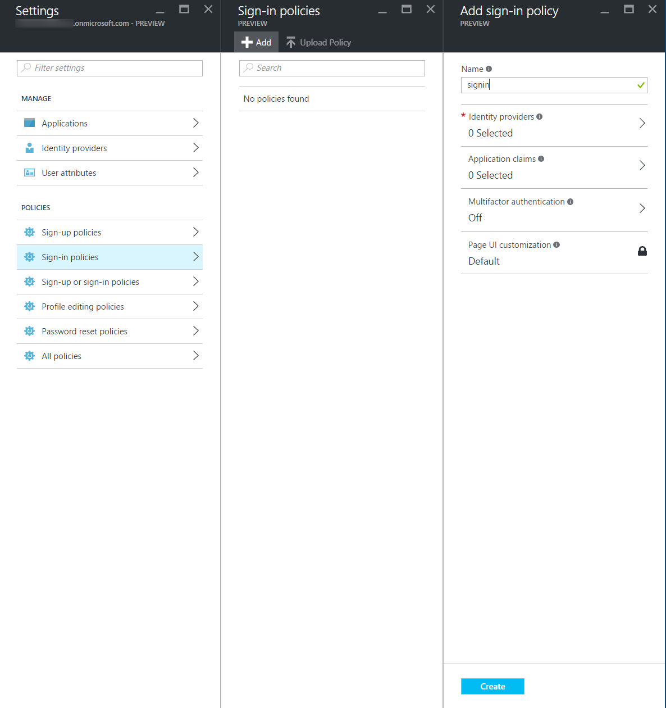

1. Select Identity providers.
2. Select Local Account Signin.
3. Click OK.

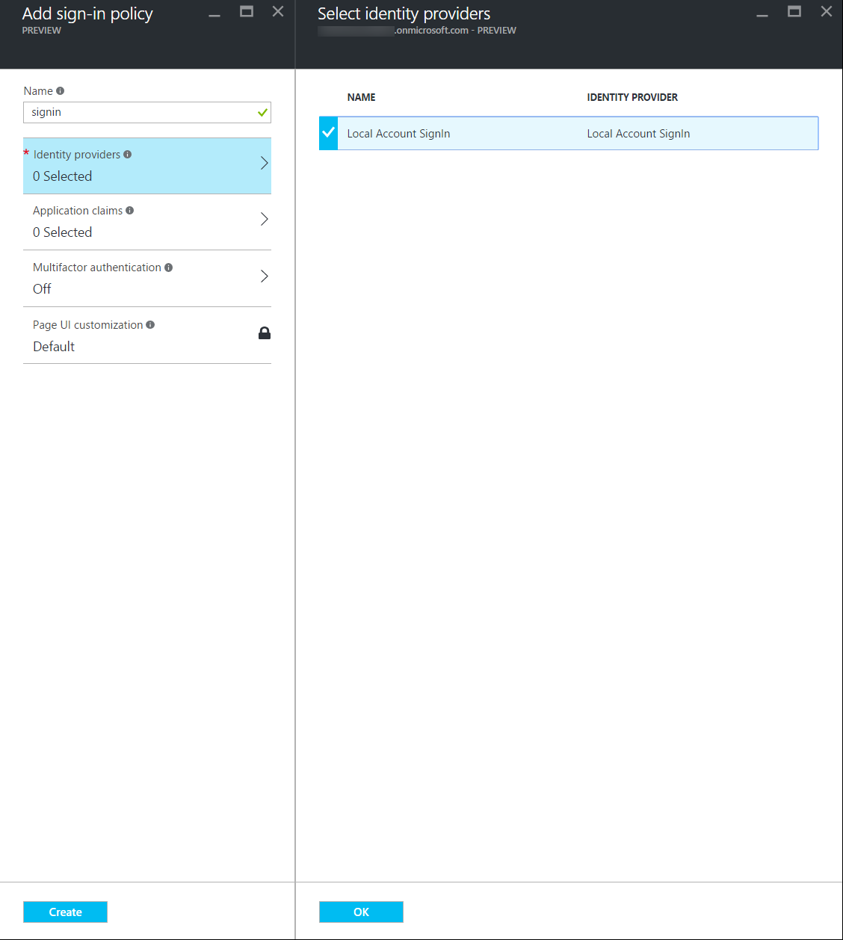

1. Select Application Claims.
2. Select Email Addresses, Given Name, Surname, and User’s Object ID.
3. Click OK.

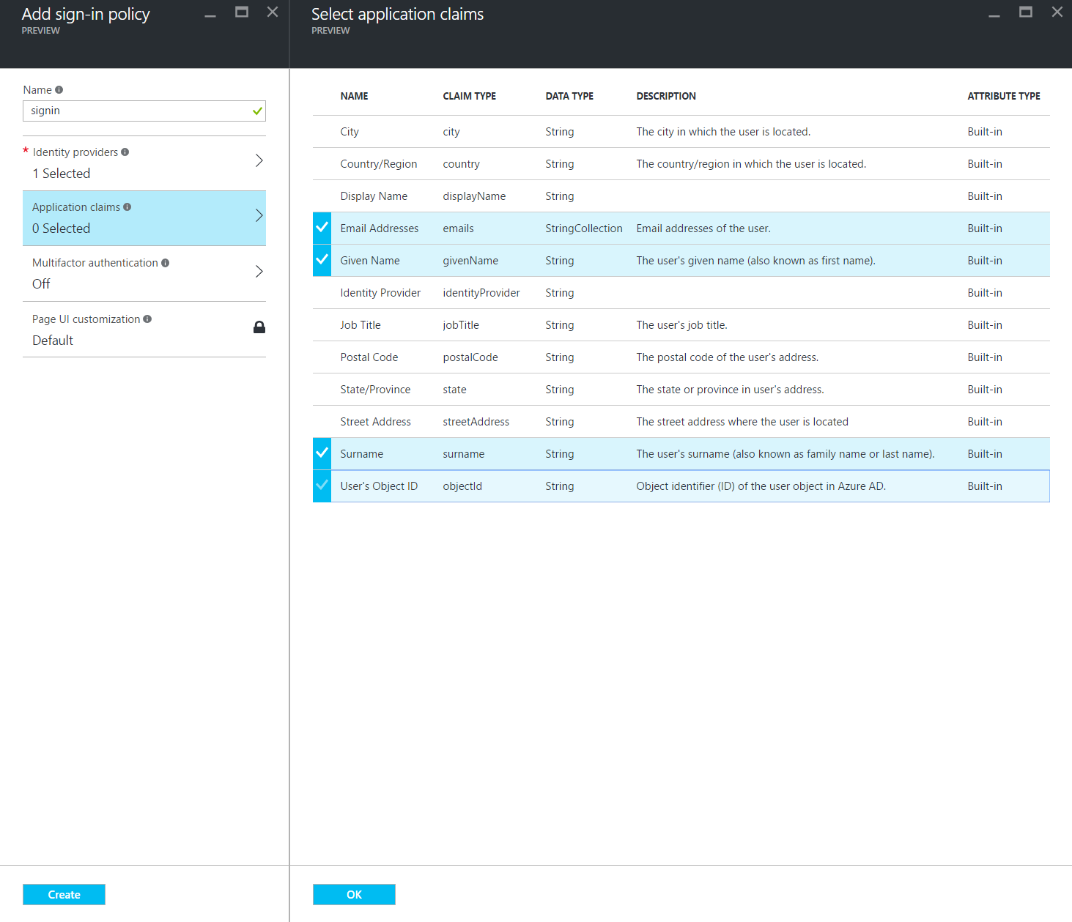

1. Select Token, session & SSO config.
2. Select acr under Claim representing policy ID.
3. Click OK.  
   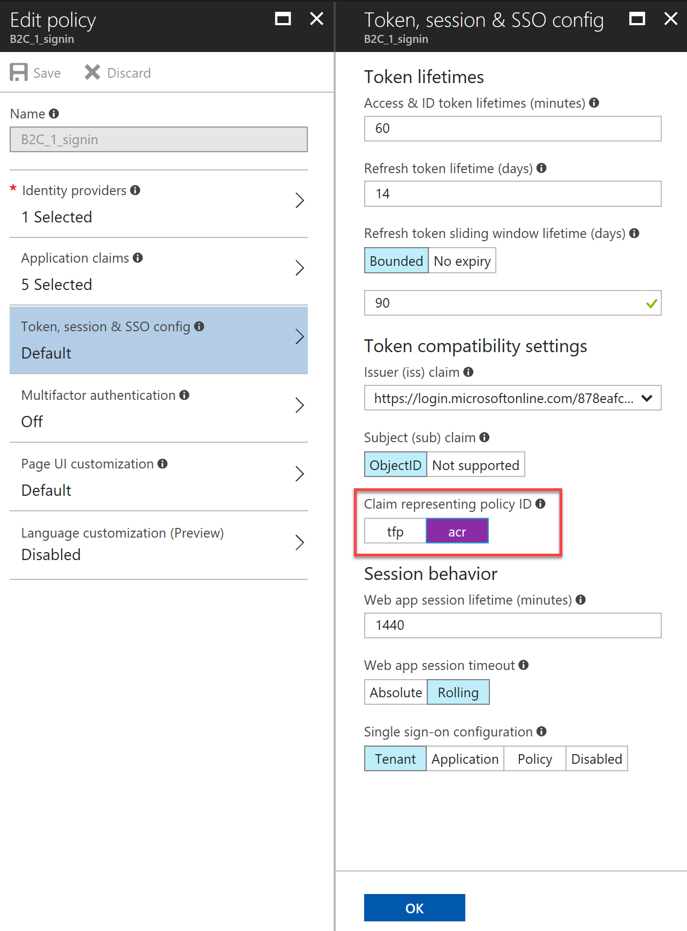
4. Click Create.
5. In the Settings blade, select Profile editing policies.
6. Click + Add.
7. Set the policy name to ‘profileedit’.

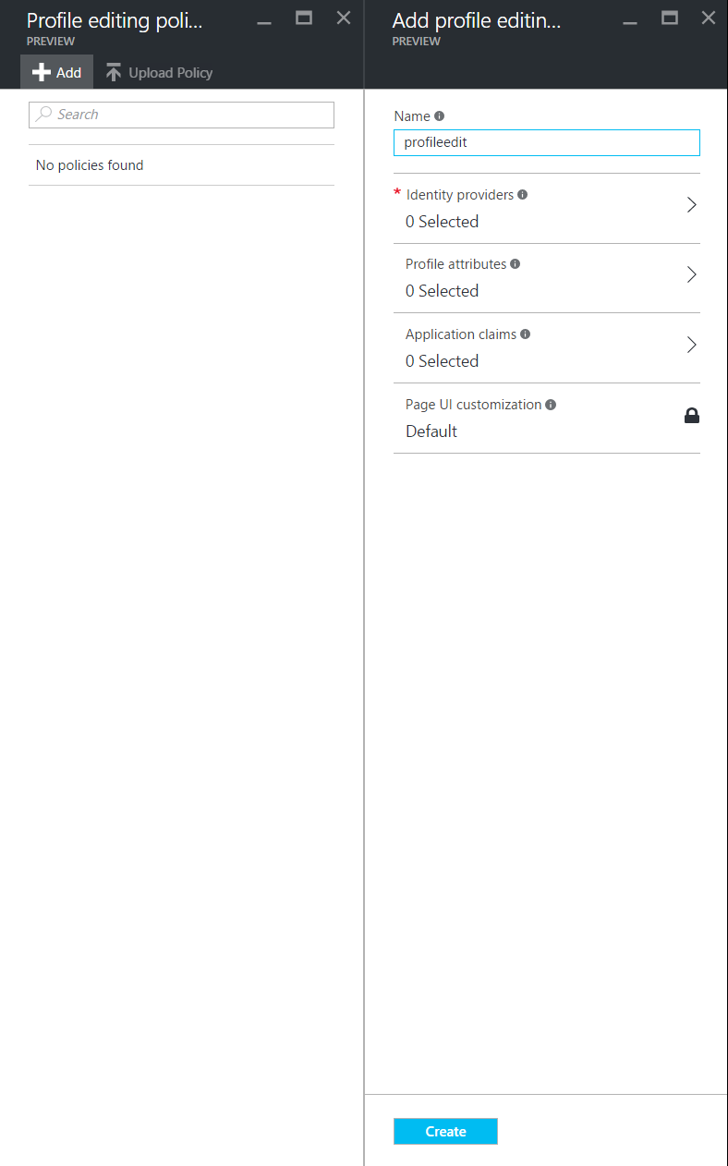

1. Select Identity providers.
2. Select Local Account Signin.
3. Click OK.

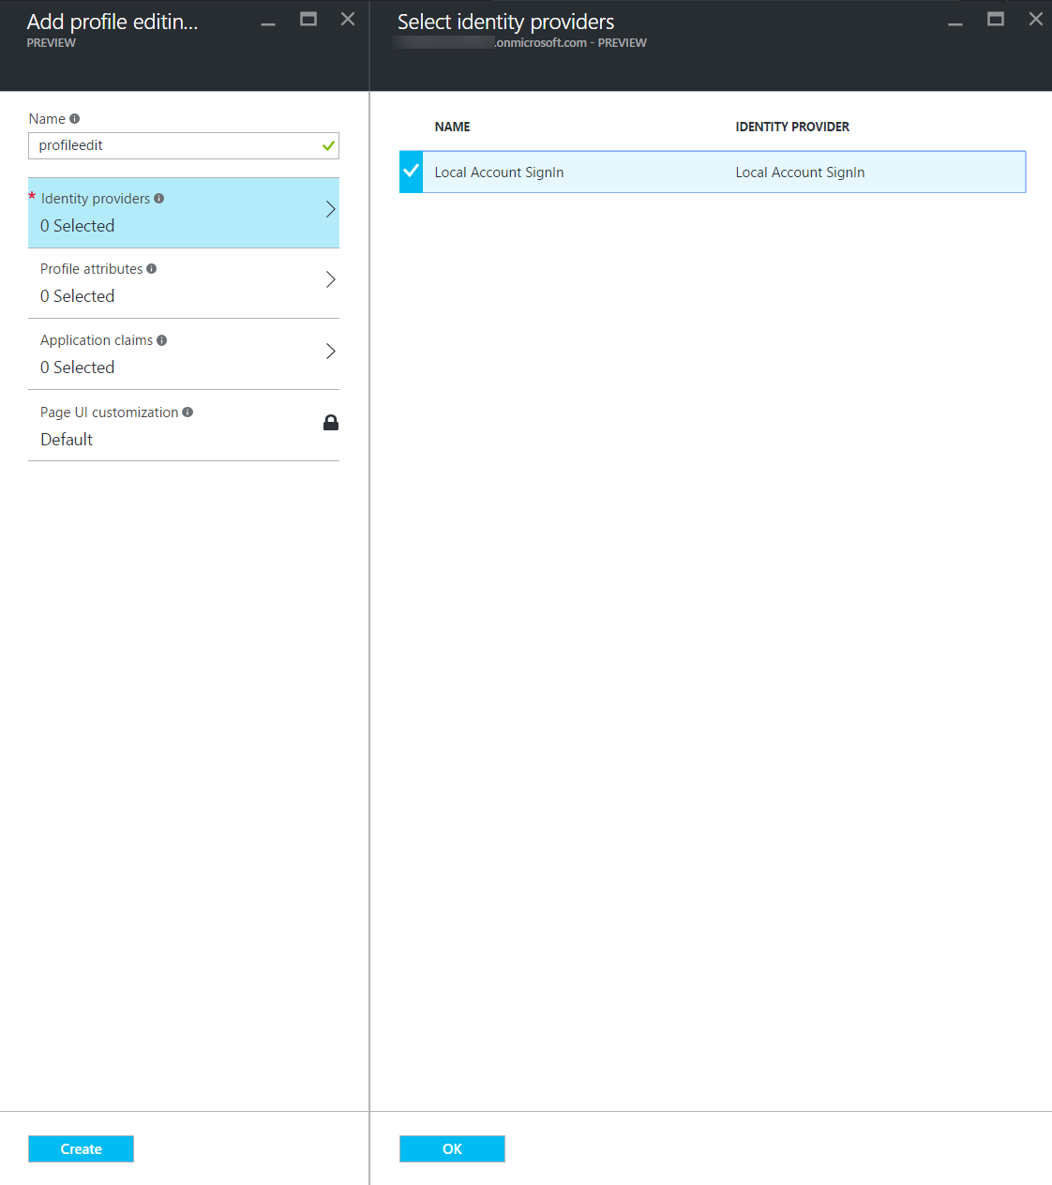

1. Select Profile attributes.
2. Select Given Name and Surname.
3. Click OK.

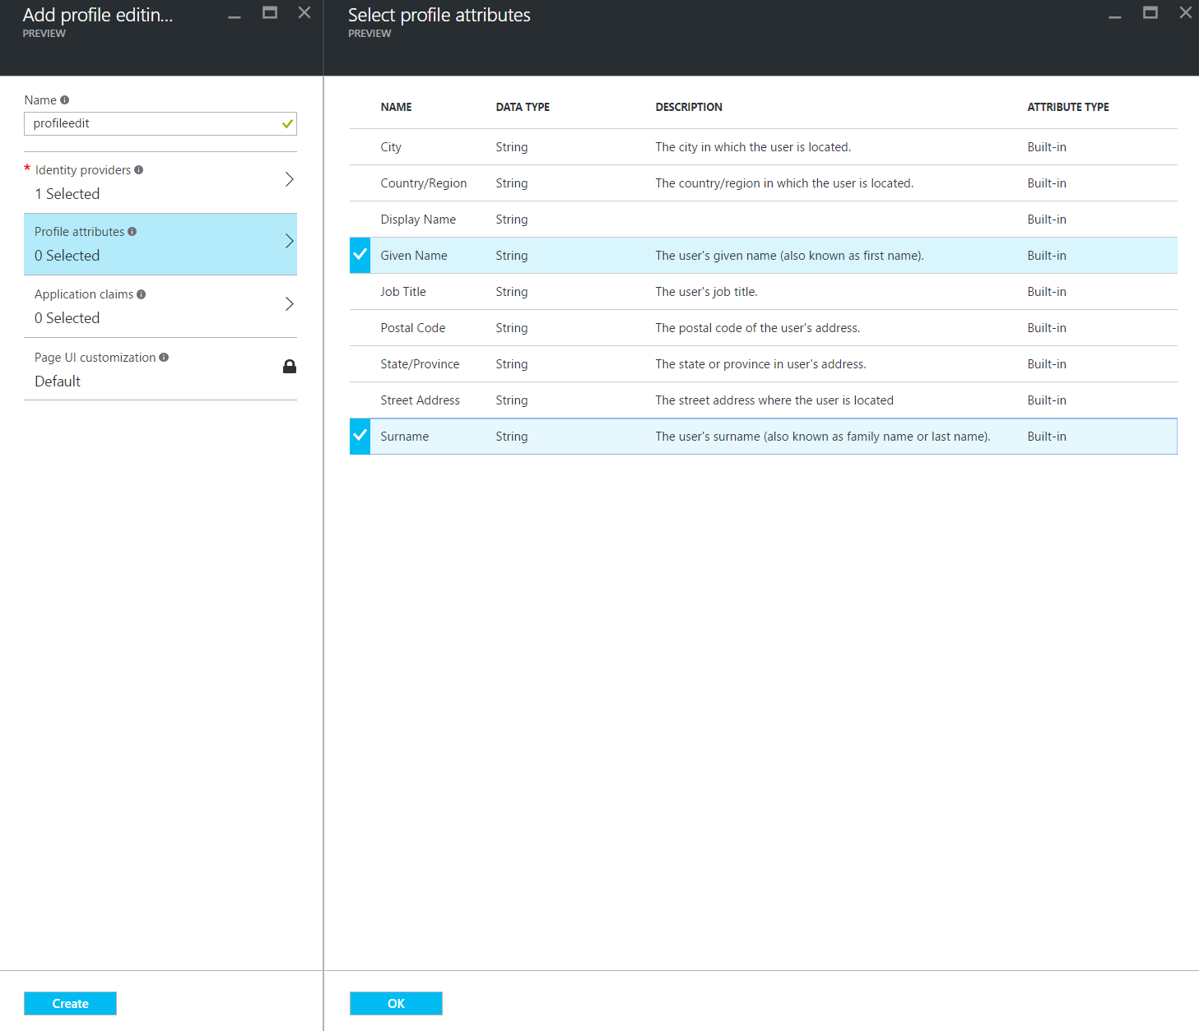

1. Select Application Claims.
2. Select Email Addresses, Given Name, Surname, and User’s Object ID.
3. Click OK.

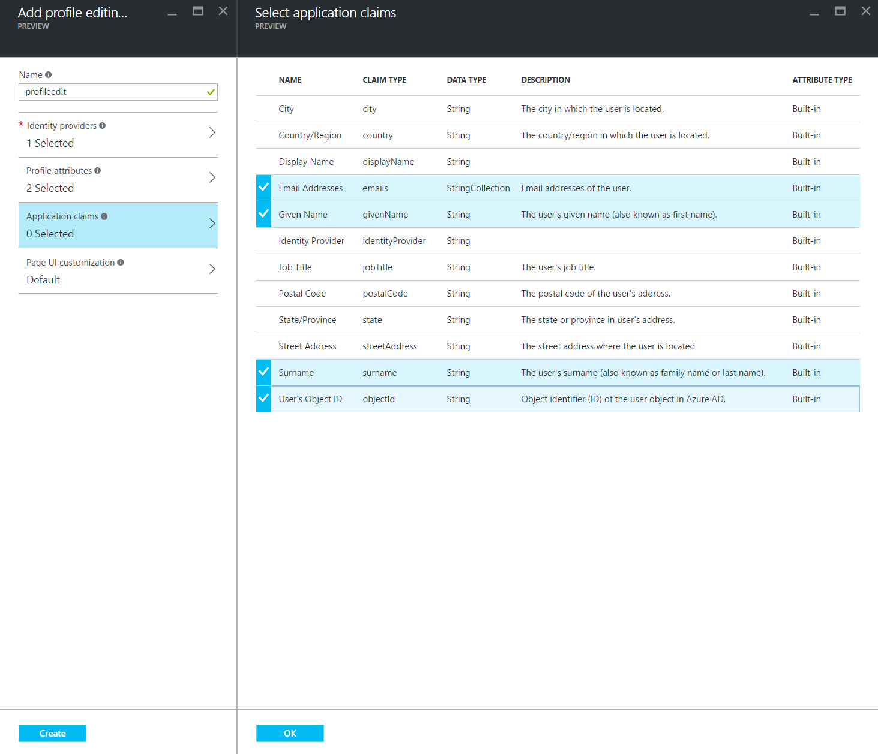

1. Click Create.
2. In the Settings blade, select Applications.
3. Select the created app.
4. Take note of the Application ID as you will need this for the next Task. 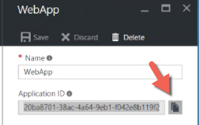
5. In the Settings blade, select All Policies. You should see three policies and the B2C instance. Take note of the names for these policies with the prefix ‘B2C’ as these names will be used in the next task.

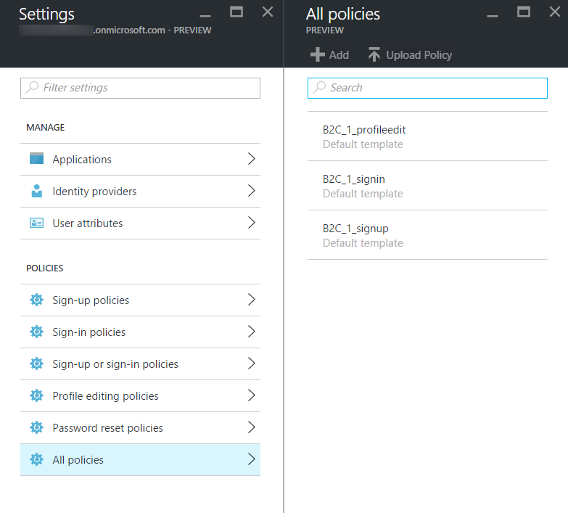

1. Your B2C directory is ready for use and after Task 2 is complete, you will be able to exercise it.

#### Task 2: Configure the web app Settings

In this task, you will update configuration settings in preparation for Azure AD B2C integration.

You will be guided through the instructions to find the information necessary to populate the configuration settings.

1. Within Visual Studio Solution Explorer, expand the Web folder, then expand the ContosoEvents.Web project, and open Web.config. You will update these appSettings in this file:

<add key="ida:Tenant" value="" />

<add key="ida:ClientId" value="" />

<add key="ida:SignUpPolicyId" value="" />

<add key="ida:SignInPolicyId" value="" />

<add key="ida:UserProfilePolicyId" value="" />

###### Azure Active Directory B2C:

1. For the ida:Tenant enter the domain of the Azure Active Directory B2C you created such as ‘contosoeventsb2cSUFFIX.onmicrosoft.com’.
2. For the ida:ClientId enter the Application ID generated for your B2C application created in the previous task.
3. For the ida:SignUpPolicyId enter the name of the sign-up policy you created in the tenant (e.g., B2C_1_signup).
4. For the ida:SignInPolicyId enter the name of the sign in policy you created in the tenant (e.g., B2C_1_signin).
5. For the ida:UserProfilePolicyId enter the name of the profile editing policy you created in the tenant (e.g., B2C_1_profileedit).

#### Task 3: Add security features to the web application

In this task, you will enable security features that will leverage the configuration you just applied.

1. From Solution Explorer, expand the website folder ContosoEvents.Web.
2. Open Startup.cs in the root folder and uncomment the line of code below the TODO item. This will set up the authentication middleware so that users are redirected to authenticate to Azure AD B2C when they access protected resources.

//TODO Exercise 10 - Task 3

ConfigureAuth(app);

1. Open FilterConfig.cs from the App_Start folder, and uncomment the line below the TODO item. This will provide default protection for all routes so that authentication is required unless the route allows anonymous callers.

//TODO Exercise 10 - Task 3

filters.Add(new Policies.PolicyAuthorize { Policy = Startup.SignInPolicyId });

1. Open _Layout.cshtml under Views\Shared and remove the 3 lines following the TODO item, and uncomment area below it. This will prevent the menu items to be hidden unless the user is authenticated. It will look like this when you complete the change.

@*TODO Exercise 10 - Task 3 *@

@if (Request.IsAuthenticated)

{

<li><a href="@Url.Action("Index", "Orders")"><span class="glyphicon glyphicon-shopping-cart"></span> Orders</a></li>

<li><a href="@Url.Action("Index", "LoadTest")"><span class="glyphicon glyphicon-flash"></span> LoadTest</a></li>

<li><a href="@Url.Action("Status", "LoadTest")"><span class="glyphicon glyphicon-stats"></span> LoadTest Status</a></li>

}

1. Open _LoginPartial.cshtml under Views\Shared and uncomment the area below the TODO item. This will enable the menus for user sign in and sign out.

@*TODO Exercise 10 - Task 3 *@

@if (

Request.IsAuthenticated)

{

<text>

<ul class="nav navbar-nav navbar-right">

<li>

<a id="profile-link"><span class="glyphicon glyphicon-user"></span> @User.Identity.Name</a>

<div id="profile-options" class="nav navbar-nav navbar-right">

<ul class="profile-links">

<li class="profile-link">

<a href="@Url.Action("Profile", "Account")"><span class="glyphicon glyphicon-pencil"></span> Edit Profile</a>

</li>

</ul>

</div>

</li>

<li>

<a href="@Url.Action("SignOut", "Account")"><span class="glyphicon glyphicon-log-out"></span> Sign out</a>

</li>

</ul>

</text>

}

else

{

<ul class="nav navbar-nav navbar-right">

<li><a id="signUpLink" href="@Url.Action("SignUp", "Account")"><span class="glyphicon glyphicon-user"></span> Sign up</a></li>

<li><a id="loginLink" href="@Url.Action("SignIn", "Account")"><span class="glyphicon glyphicon-log-in"></span> Sign in</a></li>

</ul>

}

1. Compile the application and ensure no errors before the next step.

#### Task 4: Running the web app and signing in

In this task, you will test the web application and register yourself as a user to log in to the Azure AD B2C tenant.

1. Using Solution Explorer in Visual Studio, open the Web folder.
2. Right click the ContosoEvents.Web project, select Debug, and then Start new instance.
3. When the application launches you will see the website home page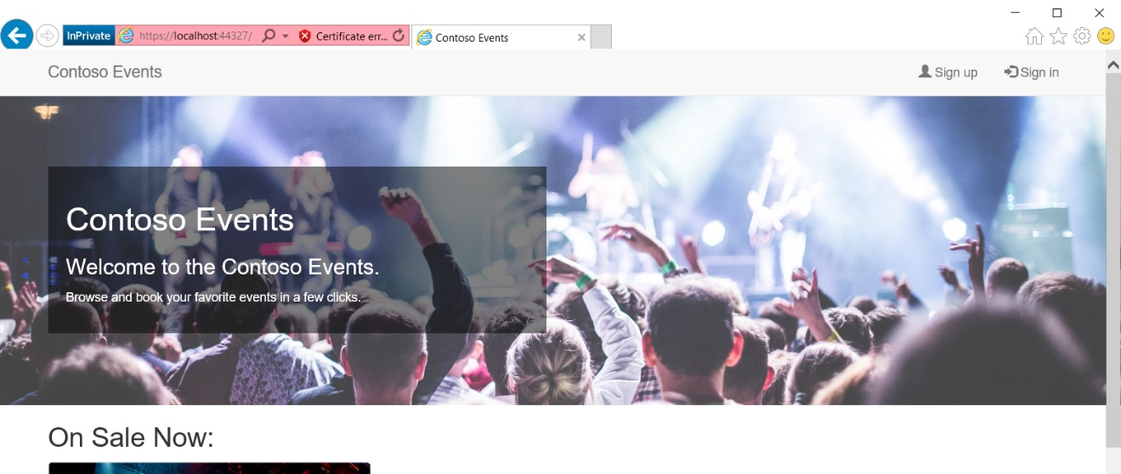
4. Click Sign up and complete a new user registration. After that, you will be returned to the website. Note that your username is shown in the menu bar.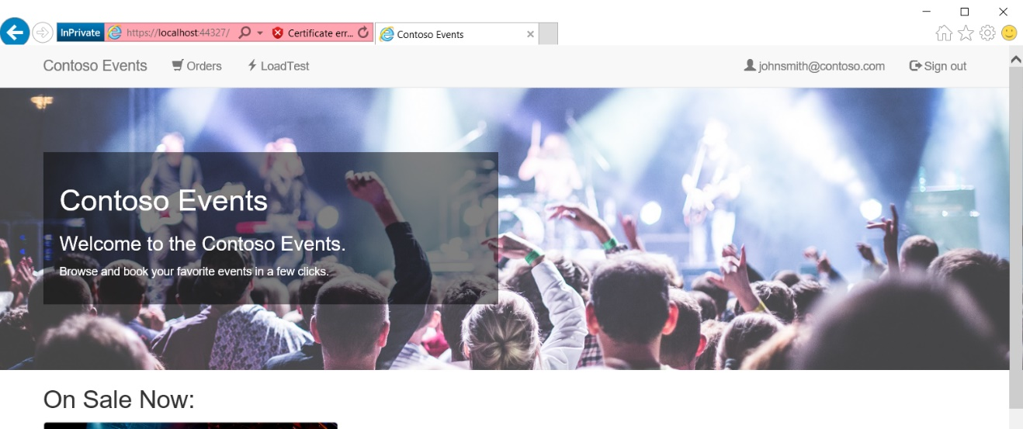
5. You will be redirected back to the web app
6. You can now sign in, sign out, and register users to the website.

**Note**: You can optionally publish this application to Azure and test sign in, sign out continues to work from the deployed URL.

## After the hands-on lab

Duration: 10 minutes

In this exercise, attendees will deprovision any Azure resources that were created in support of the lab.

#### Task 1: Delete the resource group

You should follow all steps provided *after* attending the hands-on lab.

1. Using the Azure portal, navigate to the Resource group you used throughout this hands-on lab by selecting Resource groups in the left menu.
2. Search for the name of your research group, and select it from the list.
3. Select Delete in the command bar, and confirm the deletion by re-typing the Resource group name, and selecting Delete.
4. In the Management portal, from the left-hand menu, select Active Directory. 
5. Select the tenant to delete, and delete it.